**SPLUNK**

**Splunk Beginner to Architect**

**Section 6: Post Installation Activities:**

1. **Understanding Regular Expressions:**

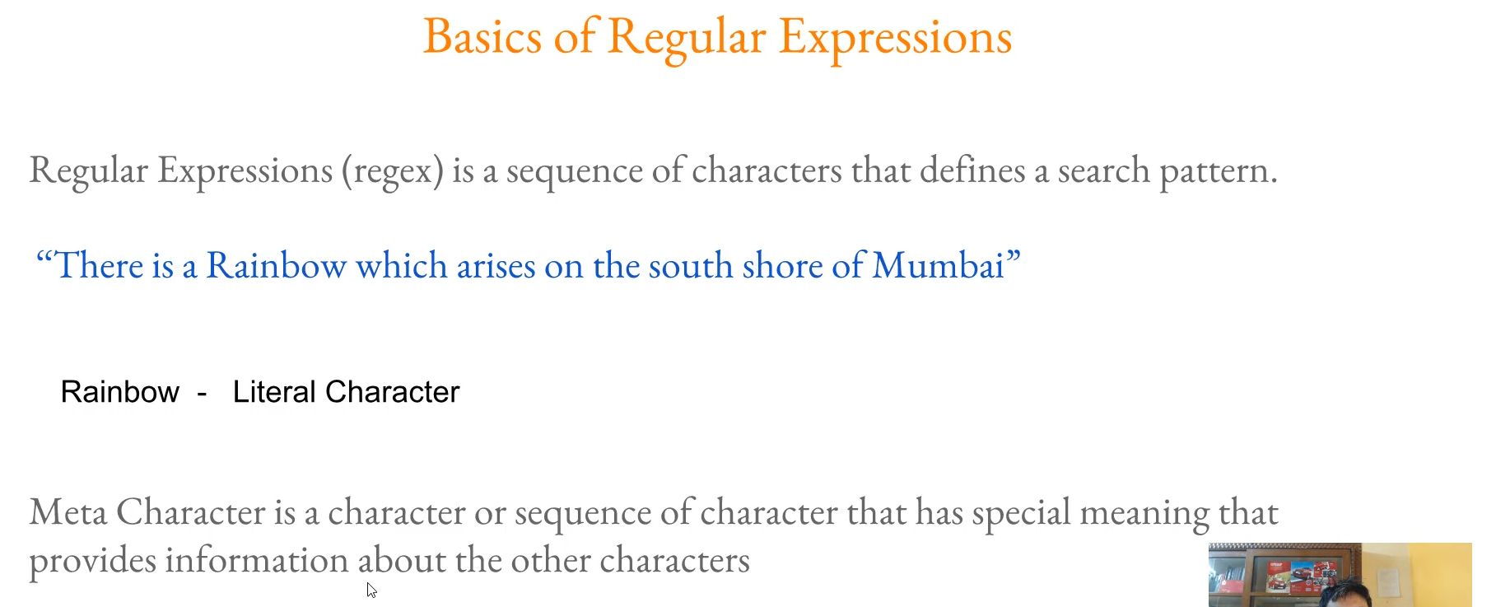

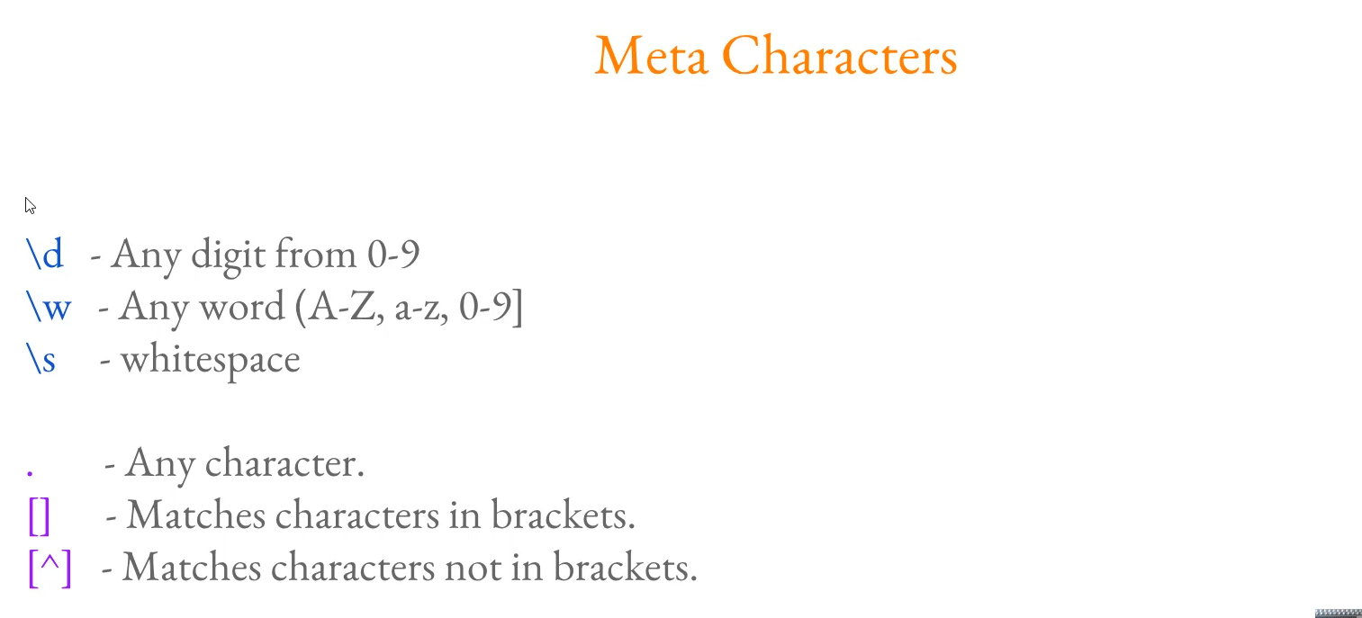

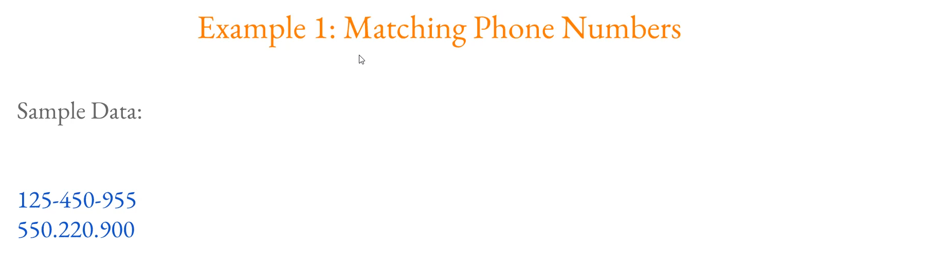

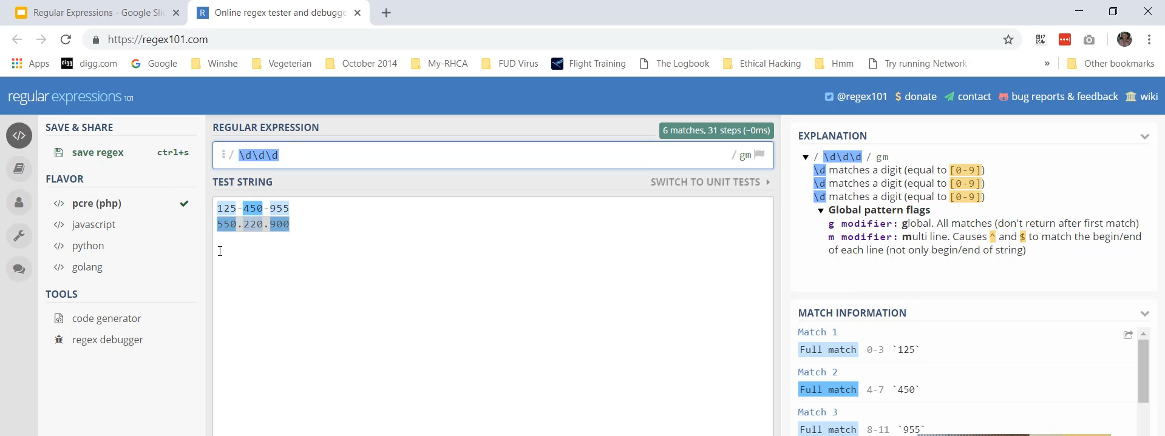

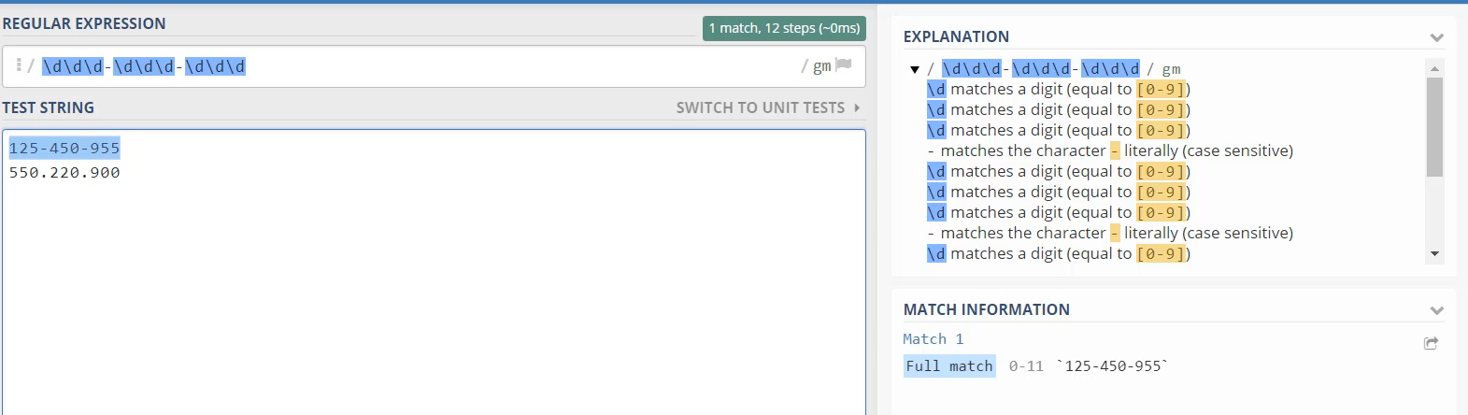

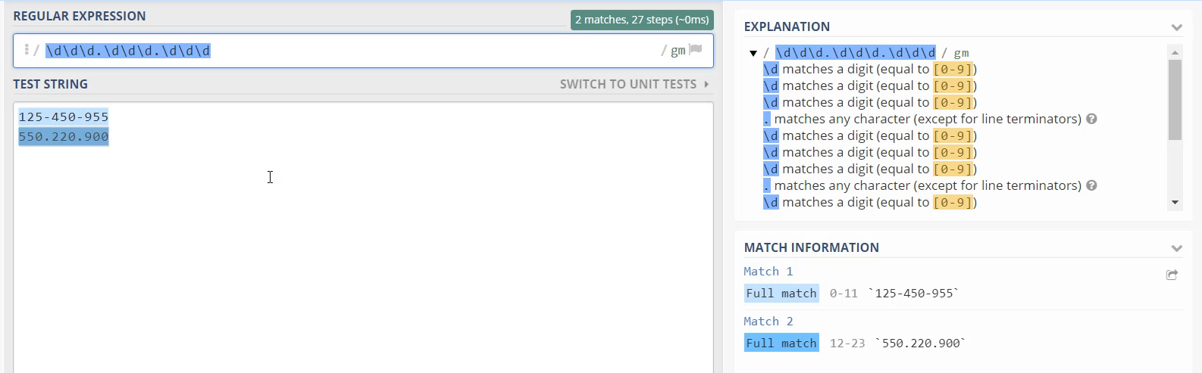

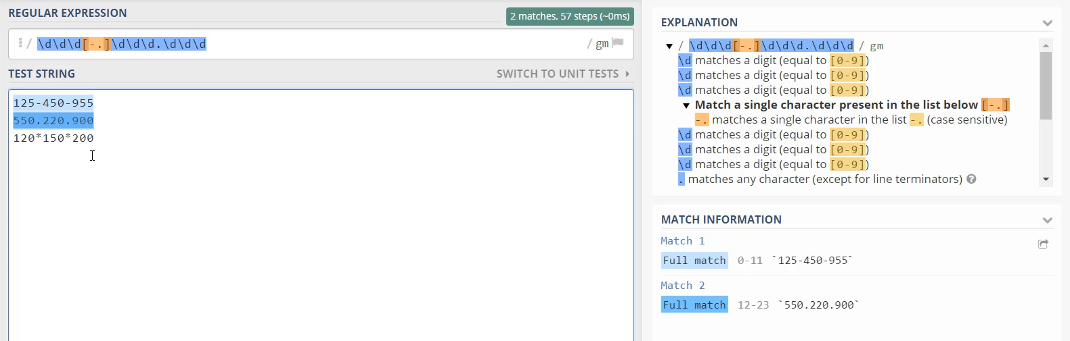

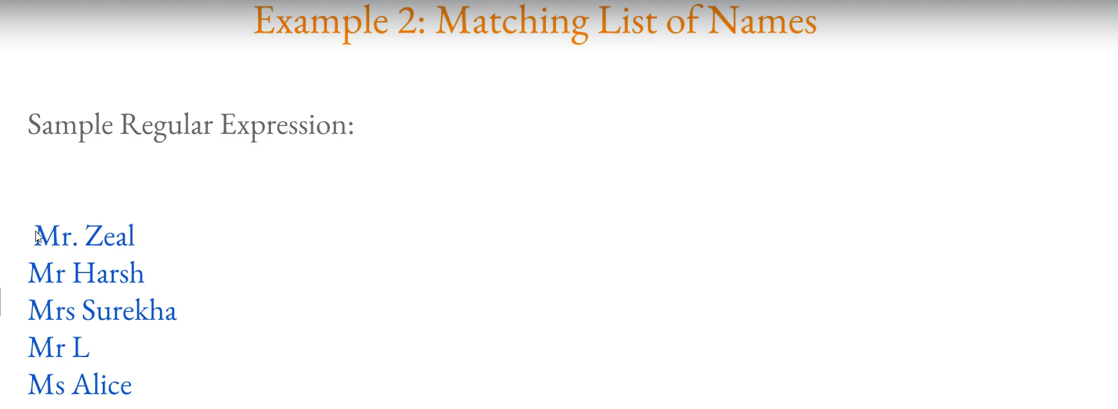

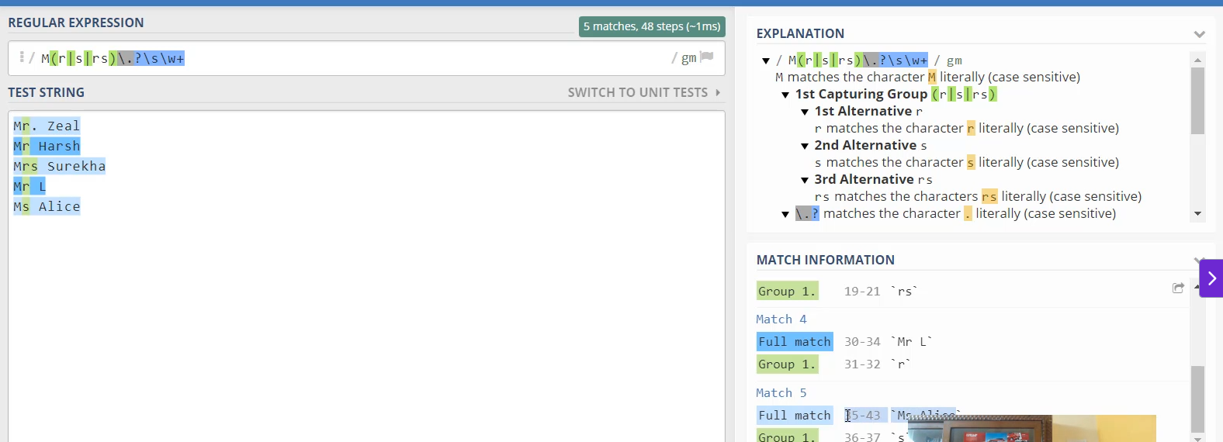

**Understanding Regular Expressions (Regex) for Splunk**

**1. Importance of Regex in Log Parsing**

* **Necessity:** Regular expressions (Regex) are **critical** for parsing logs and performing proper **field extractions** in Splunk.
* **Goal:** Without proper field extraction, logs are "meaningless," and finding specific data ("a needle in a haystack") becomes impossible.

**2. Foundational Concepts**

* **Definition:** Regex is a **sequence of characters that defines a search pattern**.
* **Literal Character:** A sequence that matches the characters exactly as typed (e.g., typing rainbow matches the word "rainbow").
* **Meta Character:** A character or sequence of characters that has a **special meaning** and provides information about other characters (e.g., \d, +, ?, . etc.).
* **Tool Used:** The demonstration utilizes the website **regex101.com** for testing and visual matching.

**3. Key Meta Characters and Sequences**

The video introduced several fundamental meta characters:

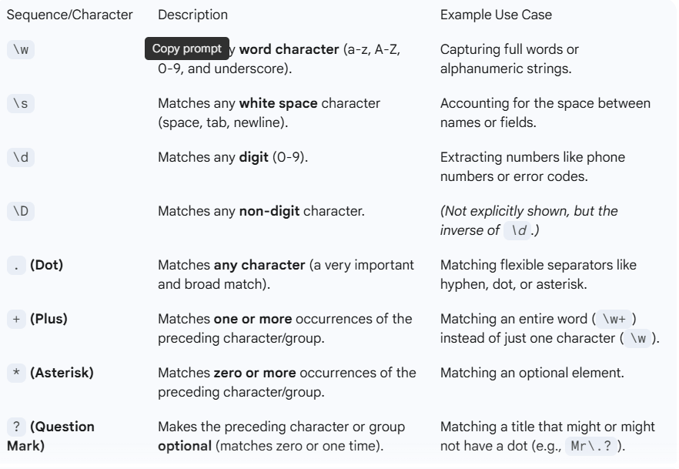

**4. Quantifiers and Grouping**

* **Curly Braces {} (Quantifier):** Used to specify the **exact number of occurrences**.
  + Example: \w{5} matches any word sequence that is exactly 5 characters long.
* **Square Brackets [] (Character Class):** Matches **any single character** within the brackets.
  + Example: [A-Z] matches any capital letter.
  + Example: [a-z] matches any lowercase letter.
  + Example: [A-Za-z0-9] combines multiple ranges.
* **Caret ^ inside [] (Negation):** Matches any character **NOT** in the brackets.
  + Example: [^A-Z] matches everything except a capital letter.
* **Parentheses () (Capturing Group):** Used to **group** elements and define multiple optional choices using the pipe | operator (OR).
  + Example: (R|RS|S) matches R, RS, or S.

**5. Practical Example Walkthroughs**

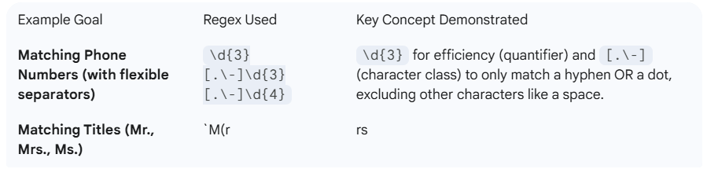

========================================================================================

1. **Parsing web server logs:**

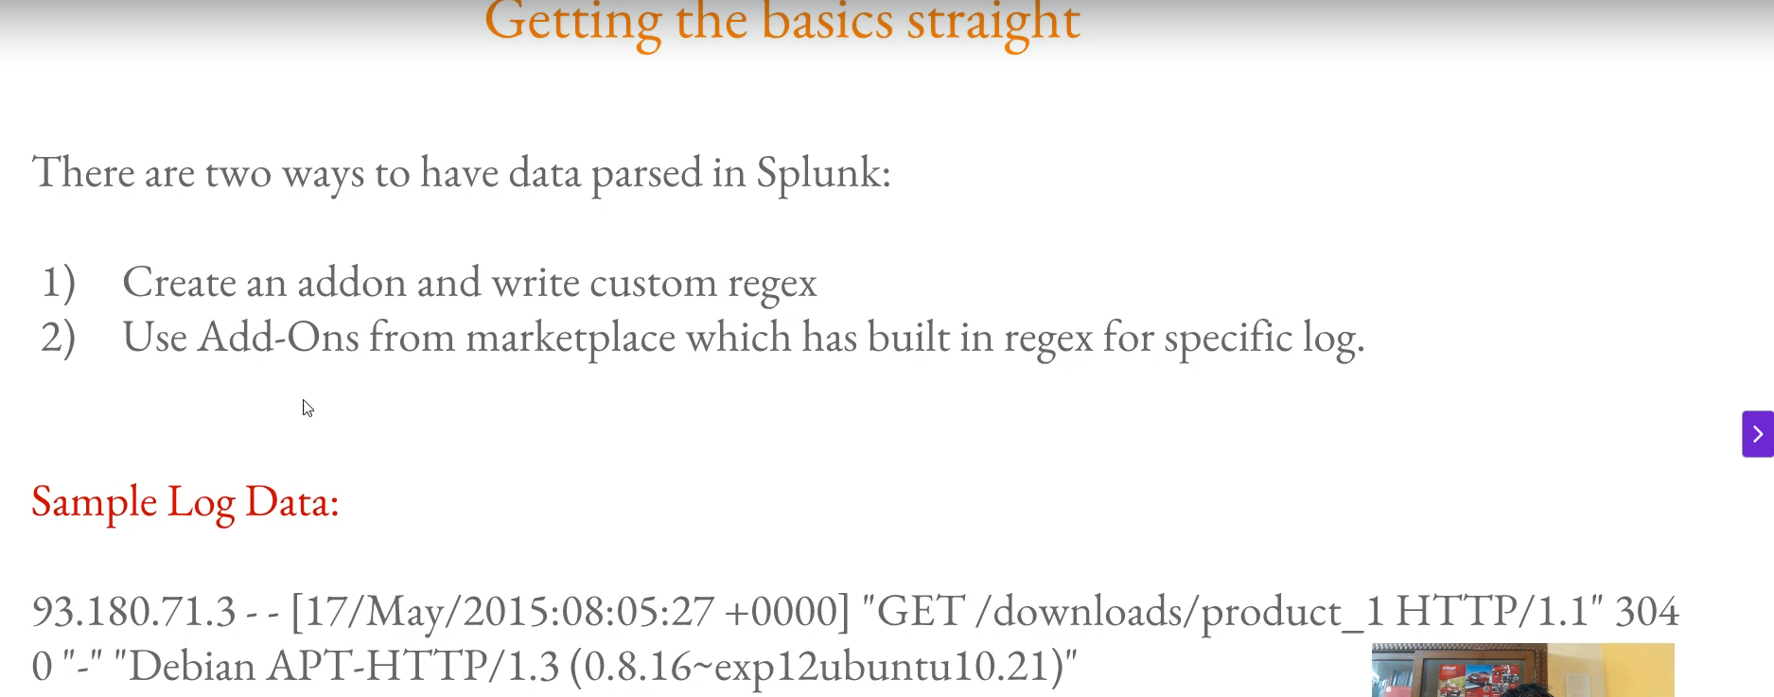

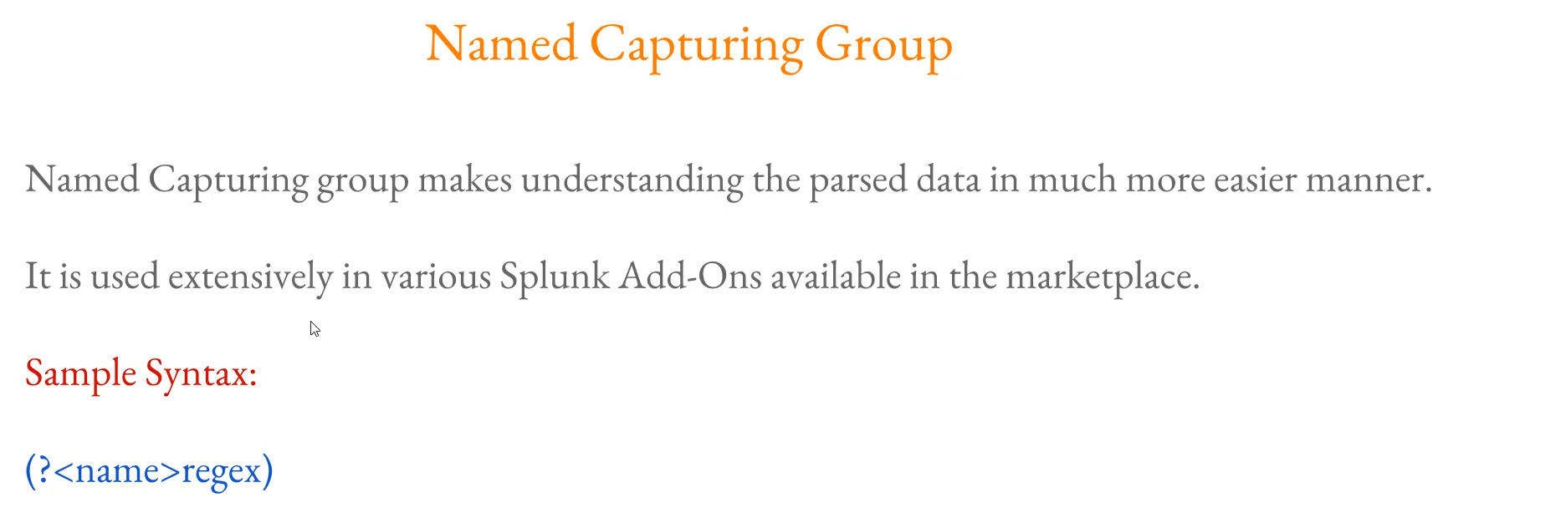

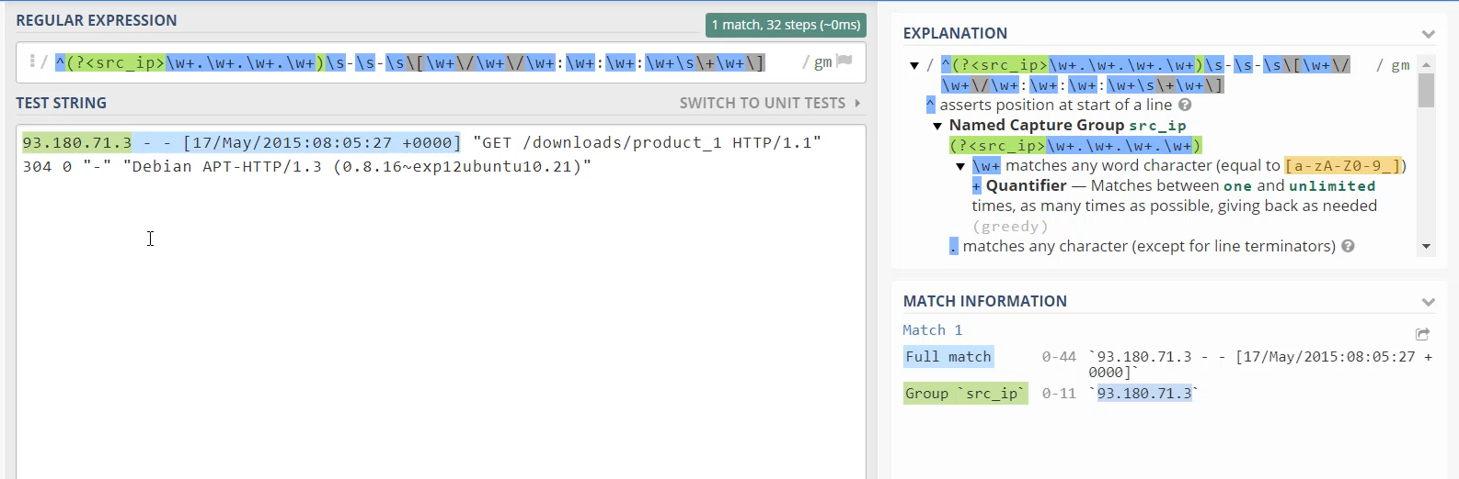

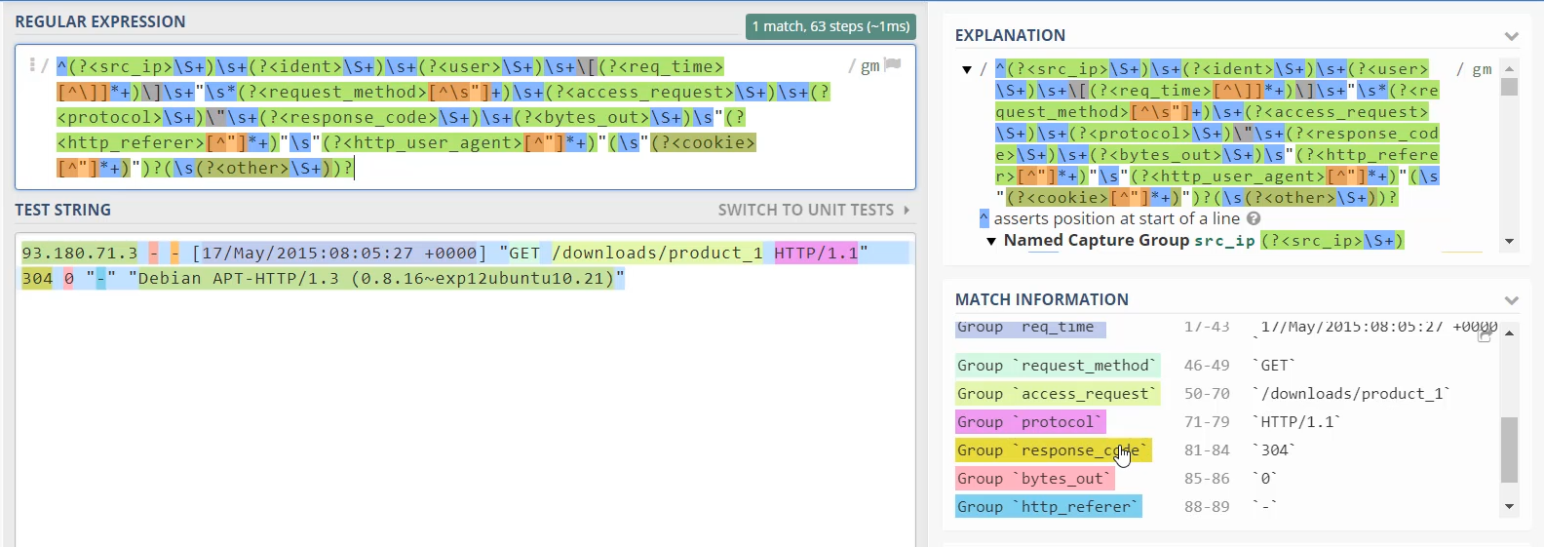

**Parsing Web Server Logs with Regex and Splunk Add-ons**

**1. Methods for Data Parsing in Splunk**

When importing data into Splunk, there are two primary ways to handle log parsing:

* **Custom Add-on:** Writing a custom Splunk Add-on that contains tailor-made regular expressions (Regex) to parse the specific data format.
* **Splunkbase Add-on (Recommended):** Searching on **Splunkbase** for existing Add-ons (built by Splunk or third parties) that already contain the necessary built-in Regex for common log types (e.g., NGINX, Apache, Windows logs).

**2. The Goal of the Demonstration**

The video's objective was not to manually parse an entire web log, but to demonstrate:

1. How **Add-ons** use built-in Regex for log parsing.
2. The benefit and structure of **Named Capturing Groups** in Regex.

**3. Manual Regex Construction (Initial Attempt)**

The educator started by manually building a Regex for a sample web server log's IP address and timestamp:

* **IP Address Parsing:** Started with \w+\.\w+\.\w+\.\w+ and refined it to match the four segments of the IP.
* **Start of Line Anchor:** Used the caret ^ to **assert a position at the start of the line**, ensuring the IP address is matched only at the beginning.
* **Escaping Special Characters:** Used the backslash \ to **escape** meta characters like the square bracket [ and the slash / so they are treated as literal characters in the log string.
* **Result Limitation:** While the full pattern was matched, the output was just one continuous string, lacking meaningful field separation.

**4. Named Capturing Groups (Best Practice)**

* **Purpose:** Named capturing groups make the output and the Regex itself **much easier to read and understand**. They are essential for turning raw matches into meaningful fields.
* **Syntax:** The syntax is: (?P<Group_Name>regex_pattern)
  + ?P<...>: The indicator for a named group.
  + Group_Name: The custom, meaningful name (e.g., src_ip).
  + regex_pattern: The actual regex that matches the desired data.
* **Demonstration:** The IP address Regex was converted to a named group: (?P<src_ip>\d{1,3}\.\d{1,3}\.\d{1,3}\.\d{1,3})
* **Benefit:** This convention is used **extensively** in professional Splunk Add-ons.

**5. Splunk Add-on for NGINX Example**

The educator explored a pre-built Splunk Add-on to demonstrate best-practice Regex:

* **Location:** The NGINX Add-on was downloaded from **Splunkbase** (splunkbase.splunk.com).
* **Configuration File:** The relevant Regex is located in the **transforms.conf** file within the Add-on's default directory.
* **Reviewing the Add-on Regex:** The pre-built Regex in the transforms.conf file was copied and pasted into regex101.com.
* **Verification:** The Regex successfully parsed the sample web log into distinct, named fields:
  + src_ip
  + user
  + request_time
  + request_method (GET)
  + access_request (/download/product_1)
  + response_code (304)
  + user_agent (Debian)
* **Conclusion:** This confirmed that using named capturing groups is the **right way to write Regex** as it allows anyone to easily understand and utilize the extracted fields.

**Web Server Log:**

93.180.71.3 - - [17/May/2015:08:05:27 +0000] "GET /downloads/product_1 HTTP/1.1" 304 0 "-" "Debian APT-HTTP/1.3 (0.8.16~exp12ubuntu10.21)"

========================================================================================

1. **Importance of source types:**

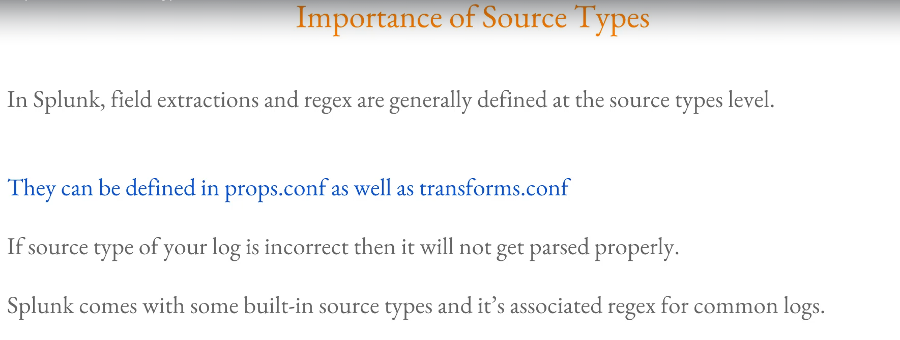

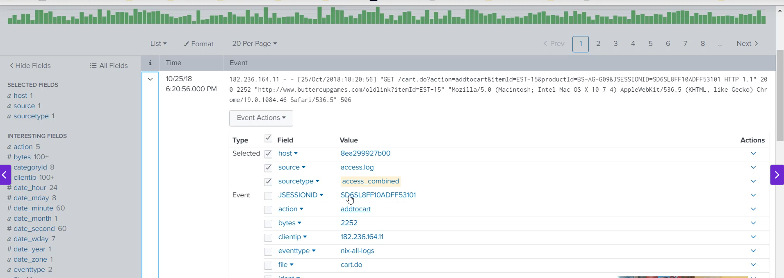

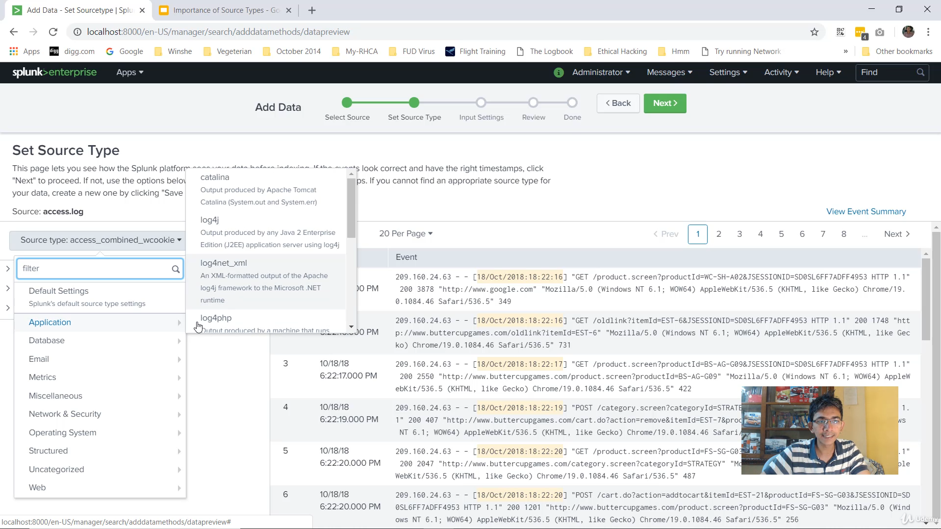

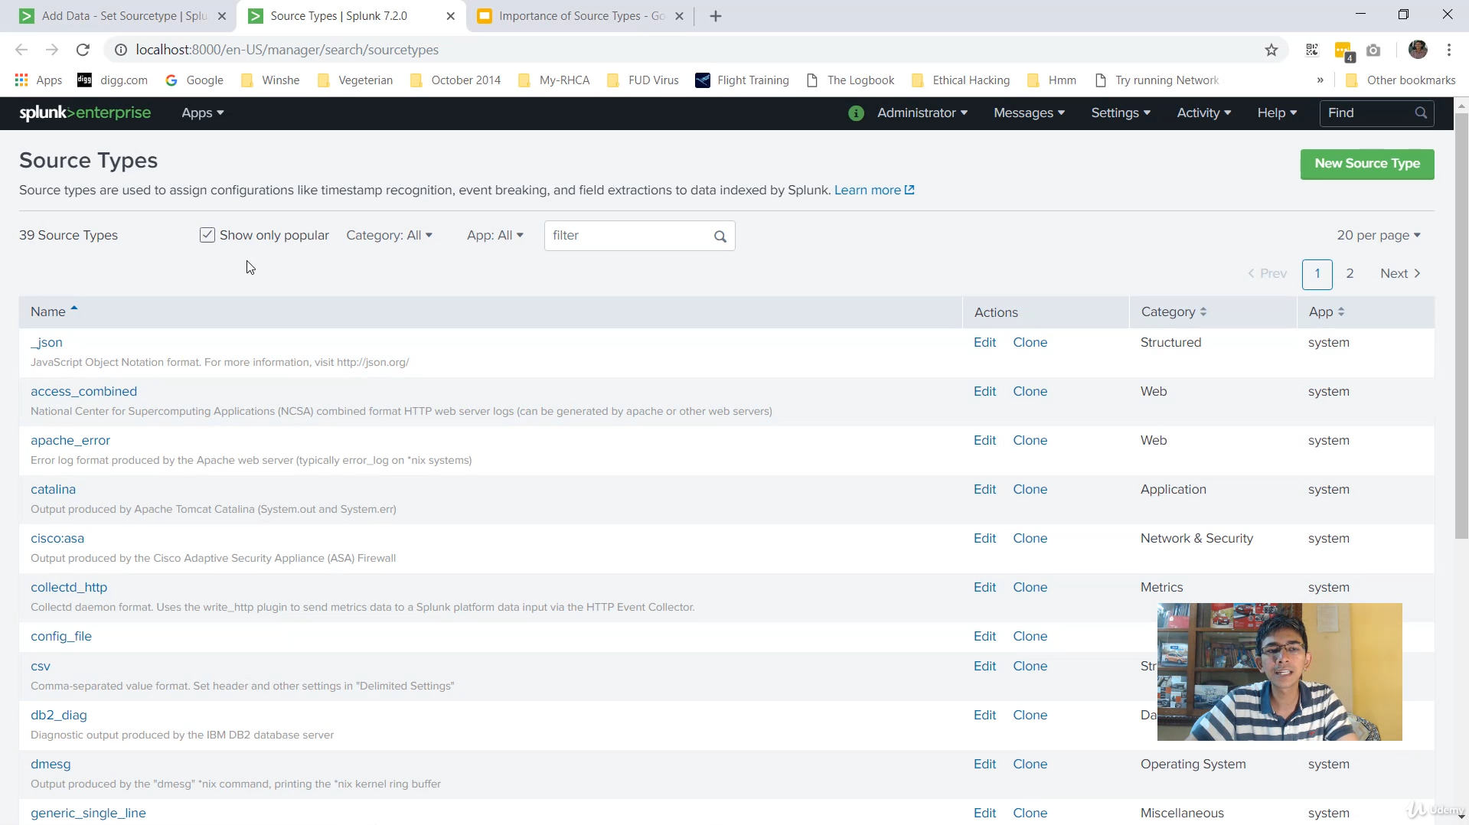

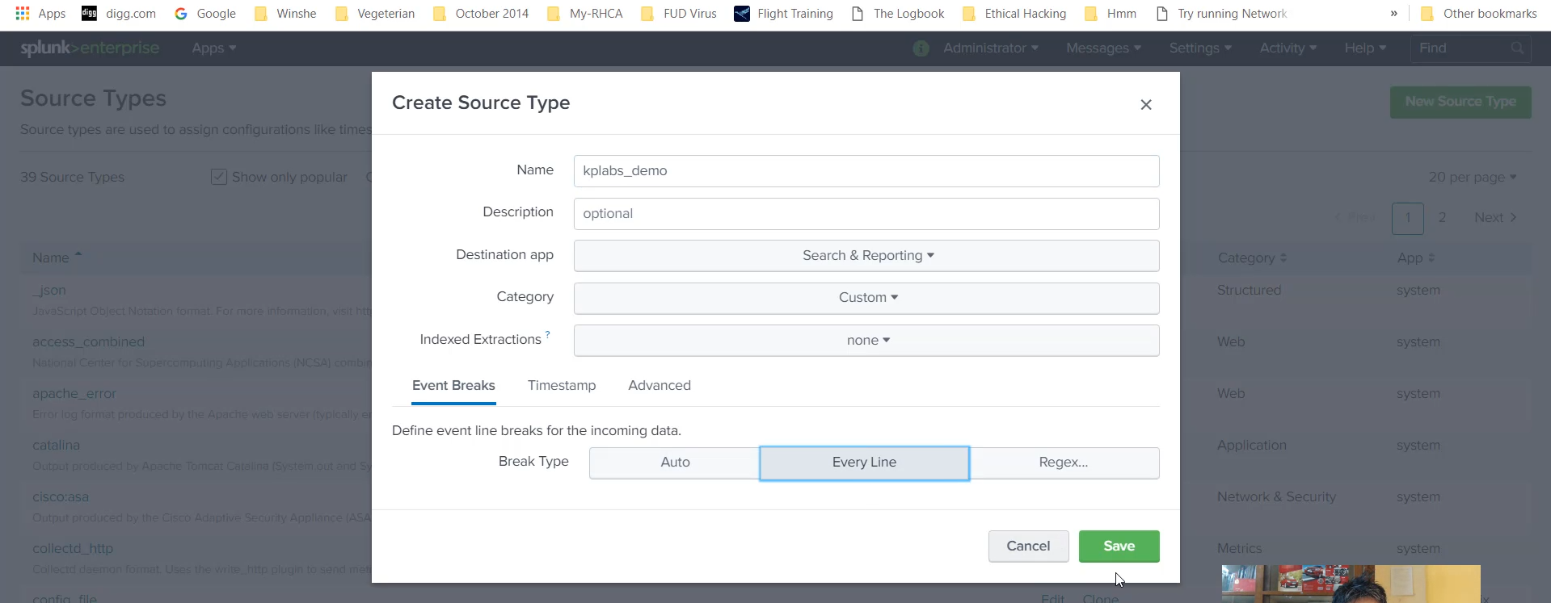

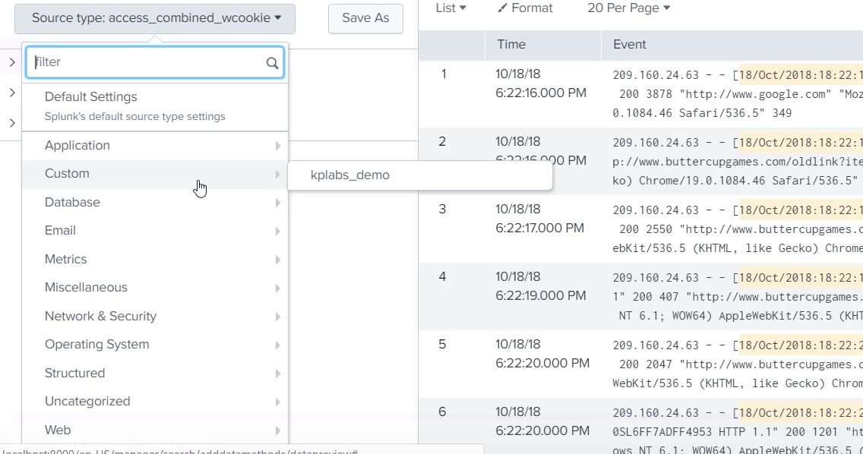

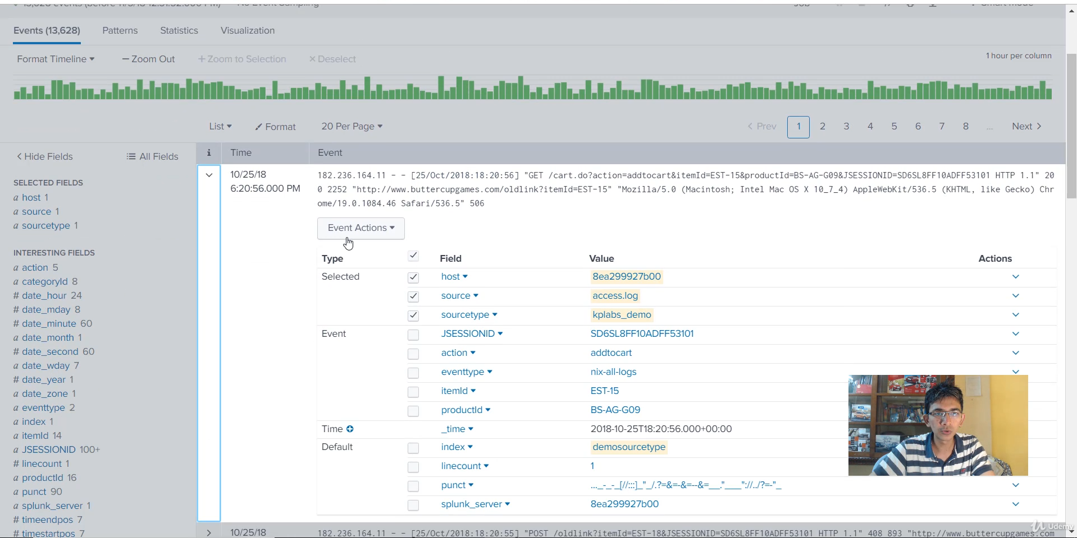

**The Importance of the sourcetype Field in Splunk**

**1. The Role of sourcetype**

* **Foundation for Field Extraction:** In Splunk, **field extractions are generally defined at a sourcetype level**.
* **Configuration Files:** These extractions are typically configured in two main files (which will be covered in detail later):
  + props.conf (Defines properties for the sourcetype).
  + transforms.conf (Contains the regular expressions used for extraction).
* **The Problem with Incorrect Sourcetype:** If the sourcetype for a log file is incorrect, the necessary parsing rules (Regex) are not applied, and the data will **not be extracted properly**.

**2. Splunk's Built-in Sourcetypes**

* **Default Support:** Splunk comes with **built-in sourcetypes** and associated Regex for common log files (e.g., Apache, NGINX).
* **Example:** The Apache log file used in the course is correctly recognized by the default sourcetype: **access_combined**.

**3. Practical Demonstration: Correct vs. Incorrect Sourcetype**

**Case 1: Correct Sourcetype (access_combined)**

* **Action:** Searching for logs with sourcetype=access_combined.
* **Result:** All logs are **extracted properly**. A full list of fields (like clientip, method, status, etc.) appears on the left, with corresponding values extracted from the raw events.

**Case 2: Incorrect/Custom Sourcetype (KP_Labs_demo)**

* **Action:** The exact same Apache access.log file was uploaded again, but this time a **custom, generic sourcetype** (KP_Labs_demo) was manually created and assigned.
* **Result:** When searching the index containing these logs, **very few fields were extracted**. The data appeared largely unparsed because the correct set of Regex rules was not applied.

**4. Tracing the Extraction Mechanism**

* **The Goal:** To understand *where* the access_combined sourcetype gets its extraction rules.
* **Mechanism:** The access_combined sourcetype points to a configuration stanza called **access-extractions**.
* **Location:** The access-extractions stanza is found inside the **transforms.conf** file in Splunk's default system directory ($SPLUNK_HOME/etc/system/default/transforms.conf).
* **Content:** This stanza contains the **appropriate Regex** designed specifically to parse the common Apache log format.
* **The Key takeaway:** This specific Regex is **only called** if the log file is assigned the correct sourcetype (access_combined). If a different sourcetype (like KP_Labs_demo) is used, these extraction rules are skipped, leading to unparsed data.

**Conclusion**

* **The main lesson:** It is **critically important** to define the **right sourcetype** for your log files upon ingestion into Splunk. A correct sourcetype ensures that the necessary extraction configurations are triggered, allowing you to use and analyze your data effectively.

===================================================================================

1. **Interactive field Extractor (IFX):**

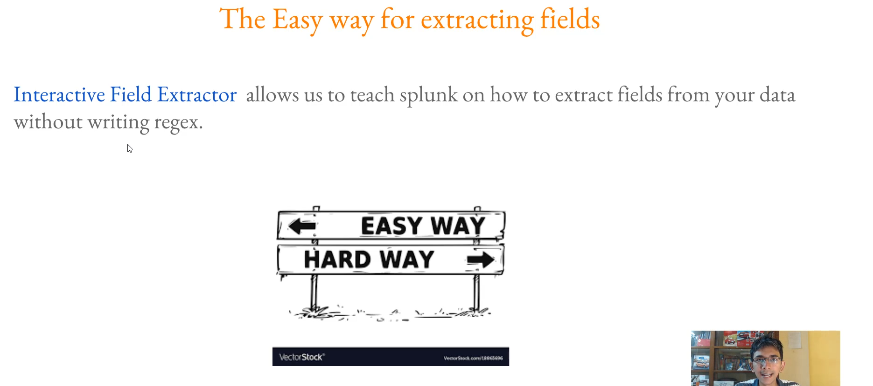

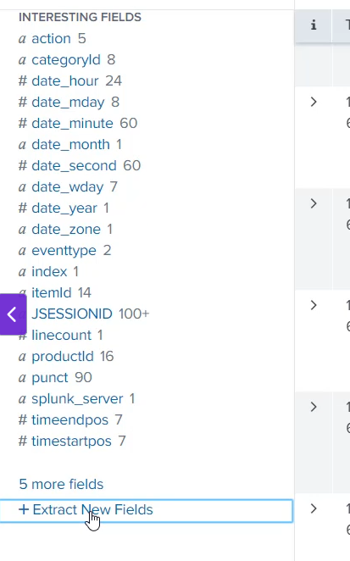

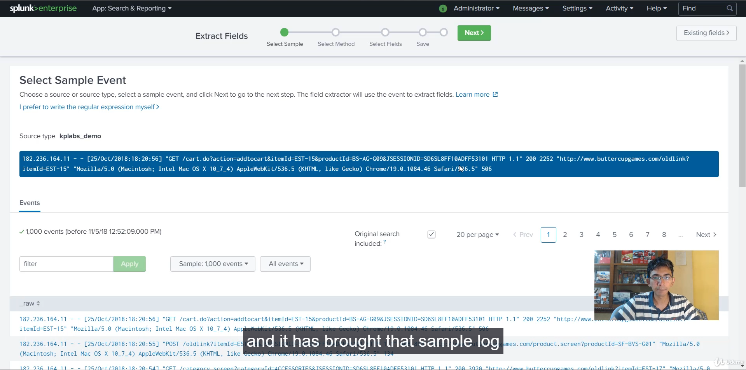

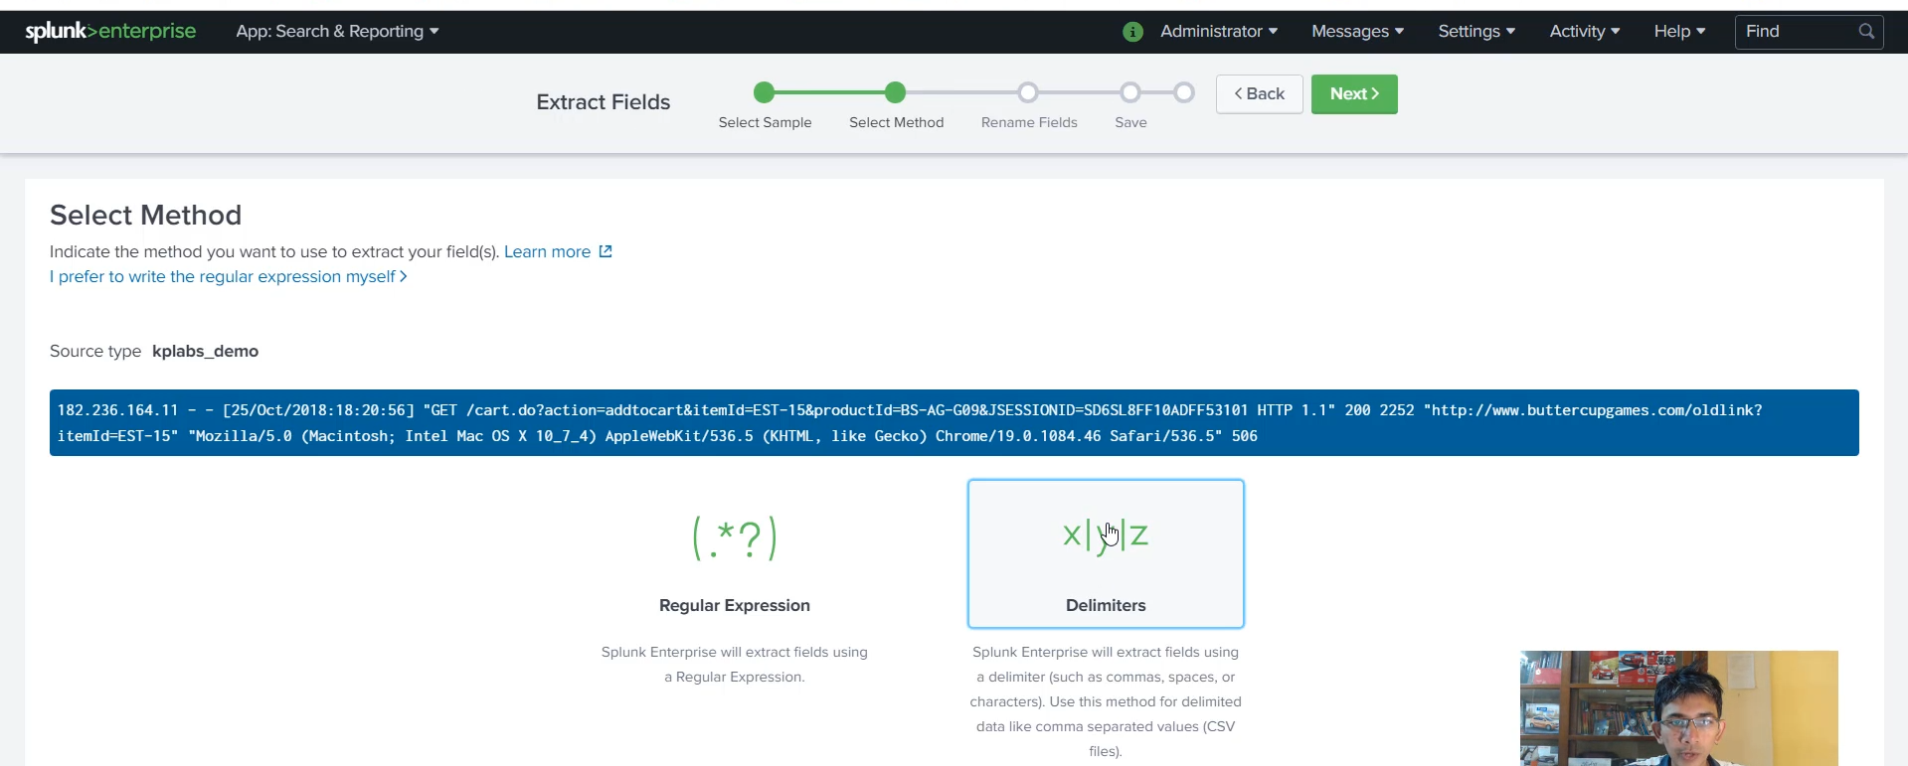

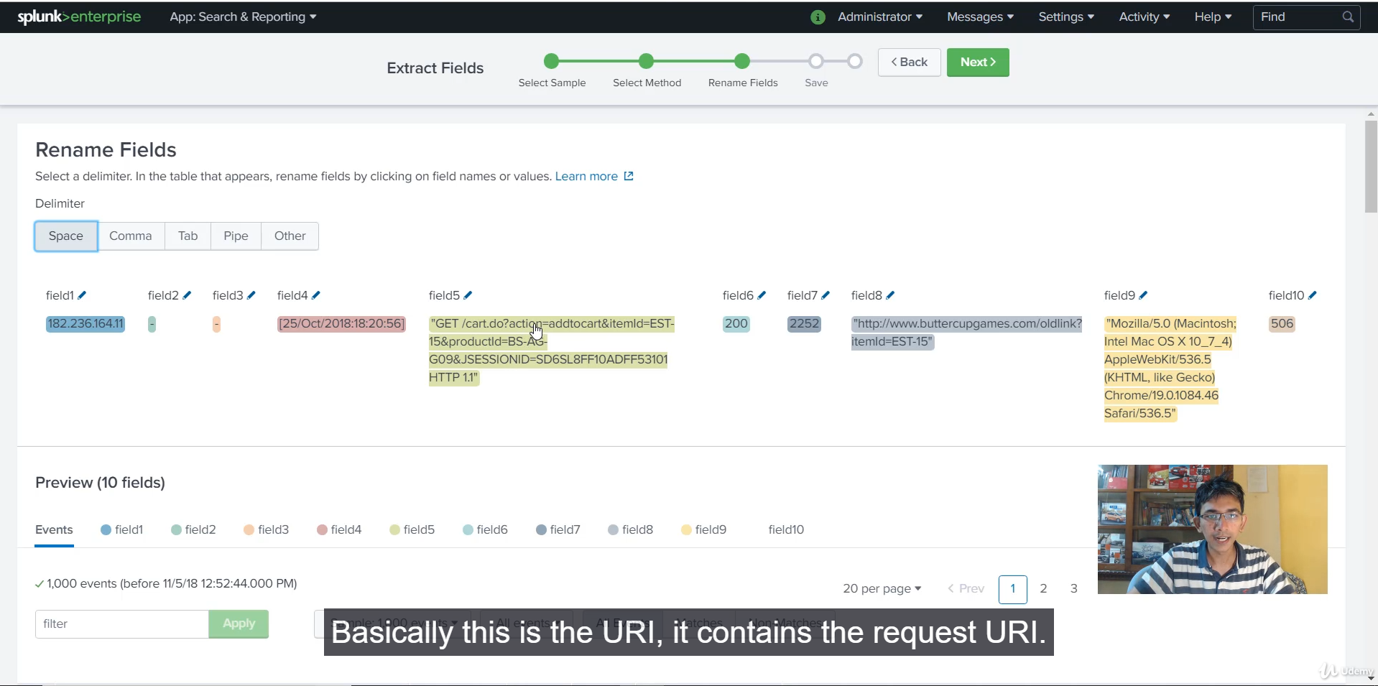

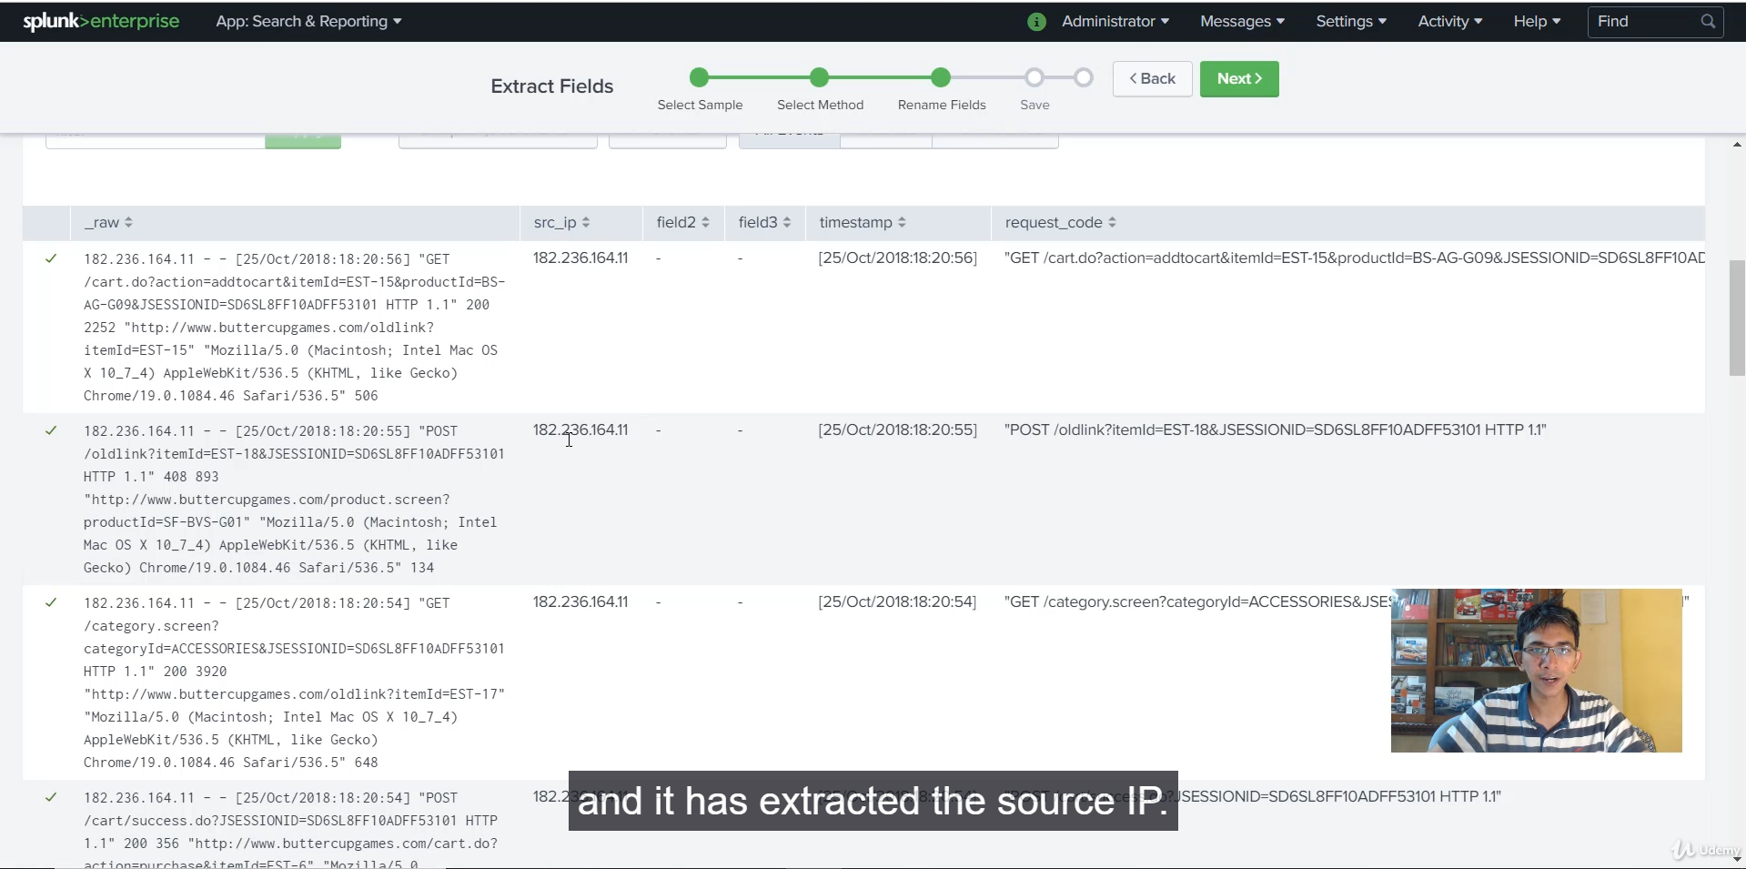

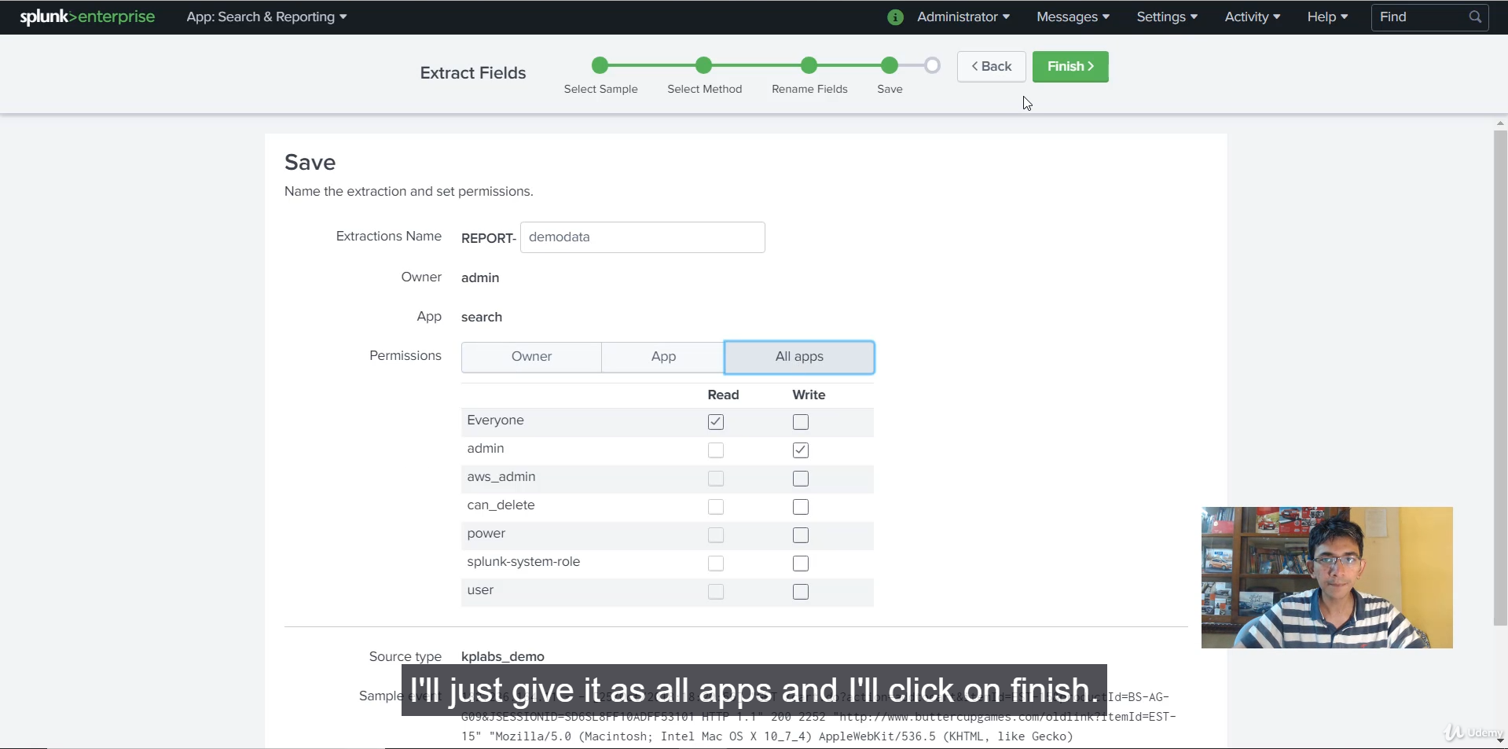

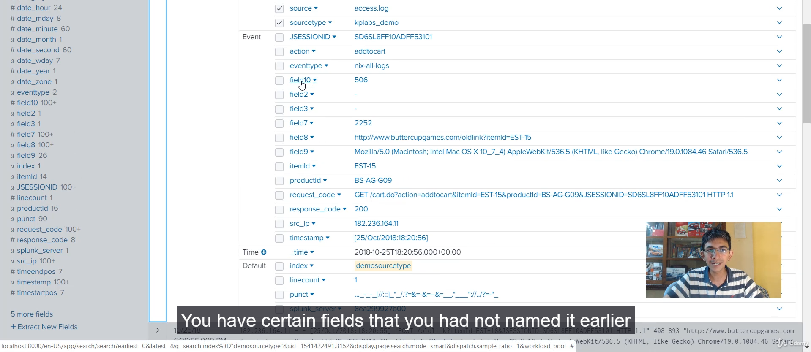

This video introduces the **Splunk Interactive Field Extractor (IFX)**, a tool designed to quickly create field extractions without manual Regular Expression (Regex) coding, particularly useful for logs with simple, consistent patterns.

Here is a summary of the demonstration and key takeaways:

**🎛️ Splunk Interactive Field Extractor (IFX)**

**1. What is the Interactive Field Extractor (IFX)?**

* **Function:** IFX allows users to "teach Splunk" how to extract fields from data without having to manually write complex Regular Expressions.
* **Use Case:** It is ideal for **quickly wrapping up things** or for analyzing log files that follow a **simple pattern**, such as logs where fields are separated by a consistent delimiter.
* **Alternative to Regex:** While writing Regex is the ideal and robust way, IFX offers a faster way to achieve basic field extraction.

**2. Demonstration Setup (The Problem)**

* **Log Data:** The demonstration uses the data previously uploaded to the **demo_sourcetype** index.
* **The Issue:** Because this index was assigned an **incorrect sourcetype** (and therefore lacked the appropriate Regex), the log data was largely **unparsed** (e.g., the IP address field was not extracted).
* **Goal:** Use IFX to quickly apply basic extractions to this unparsed data.

**3. Steps for Using the Interactive Field Extractor (IFX)**

1. **Initiate IFX:** Navigate to the search results page for the unparsed data and click **"Extract new fields."**
2. **Select Sample:** Choose one representative log event sample from which the extraction pattern will be learned.
3. **Select Method:** The user has two options for extraction:
   * **Regex:** For complex, pattern-based extractions.
   * **Delimiter (Chosen Method):** For simple logs where fields are separated by a consistent character.
4. **Define Delimiter:** Select the character separating the fields. In this case, **space** was selected.
   * **Result:** As soon as space was selected, the log event was immediately broken into numbered fields (field 1, field 2, etc.).
5. **Rename Fields:** The user renamed the important numbered fields to be more meaningful:
   * Field 1 $\rightarrow$ **src_IP**
   * Field 4 $\rightarrow$ **timestamp**
   * Field 6 $\rightarrow$ **response_code**
6. **Save Extraction:** The extraction was given a name (**demo_data**) and saved.

**4. Verification and Results**

* **Improved Parsing:** After saving the IFX configuration, searching the **demo_sourcetype** index showed **much better field extraction**.
* **New Fields:** The newly named fields (src_IP, response_code, etc.) now appeared on the sidebar.
* **Analysis:** The user was immediately able to run a Splunk Search Processing Language (SPL) command using the new field: stats count by src_IP to see a count of all unique source IP addresses.

**5. Conclusion and Best Practices**

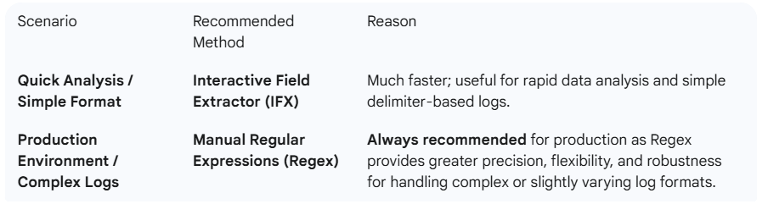

===================================================================================

1. **Props.conf and transforms.conf:**

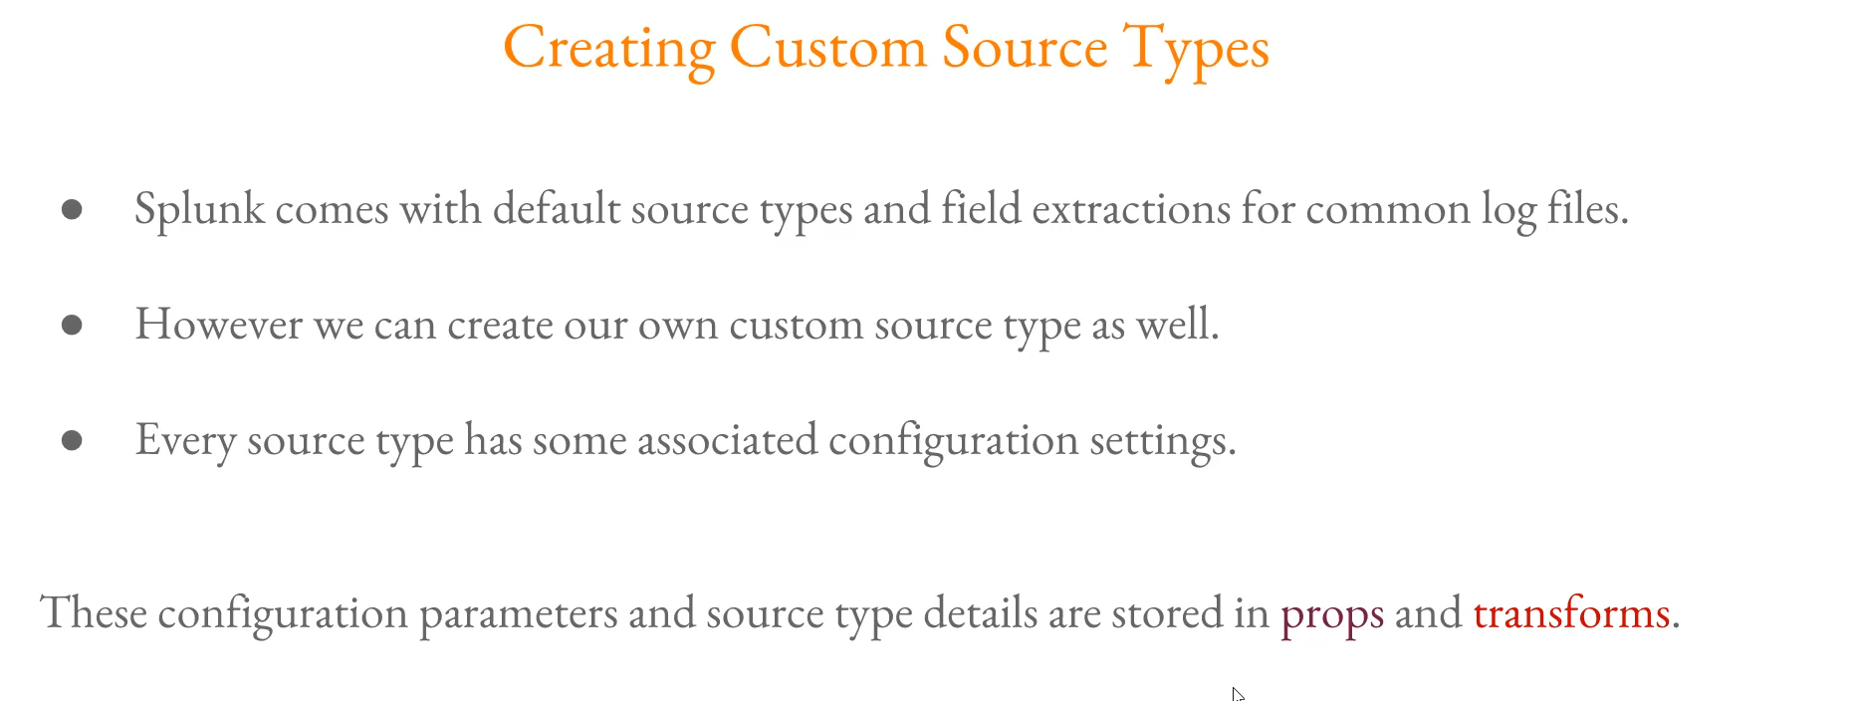

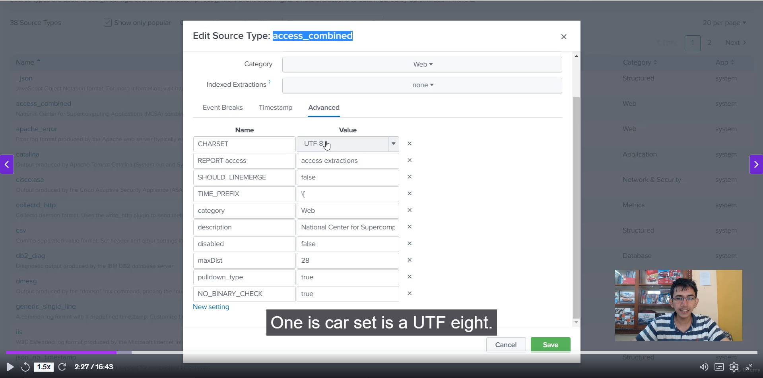

**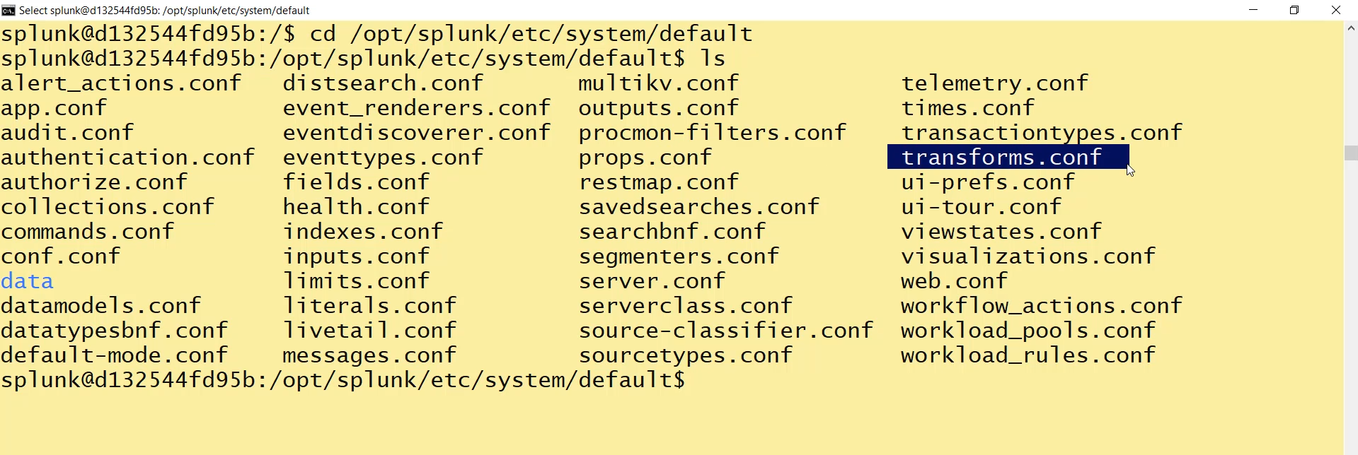  
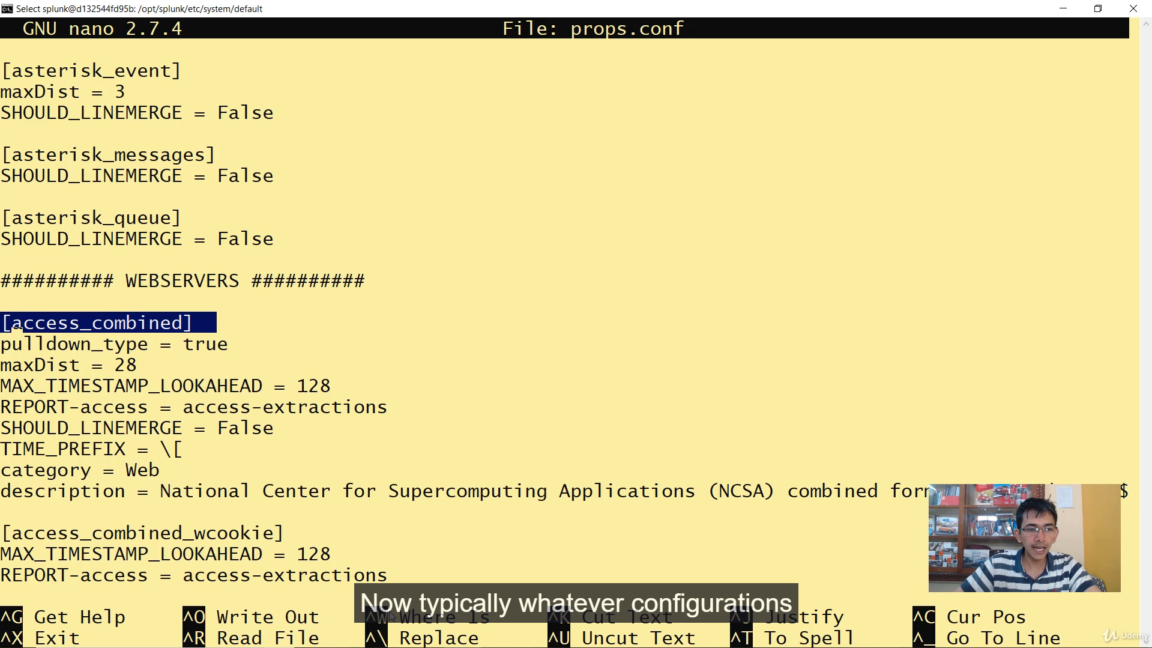**

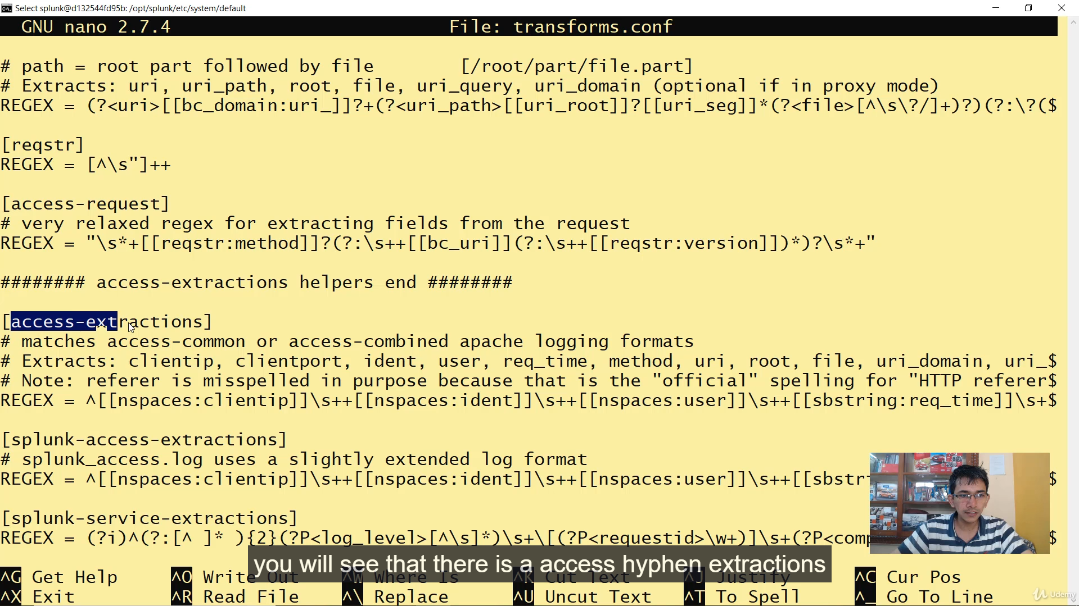

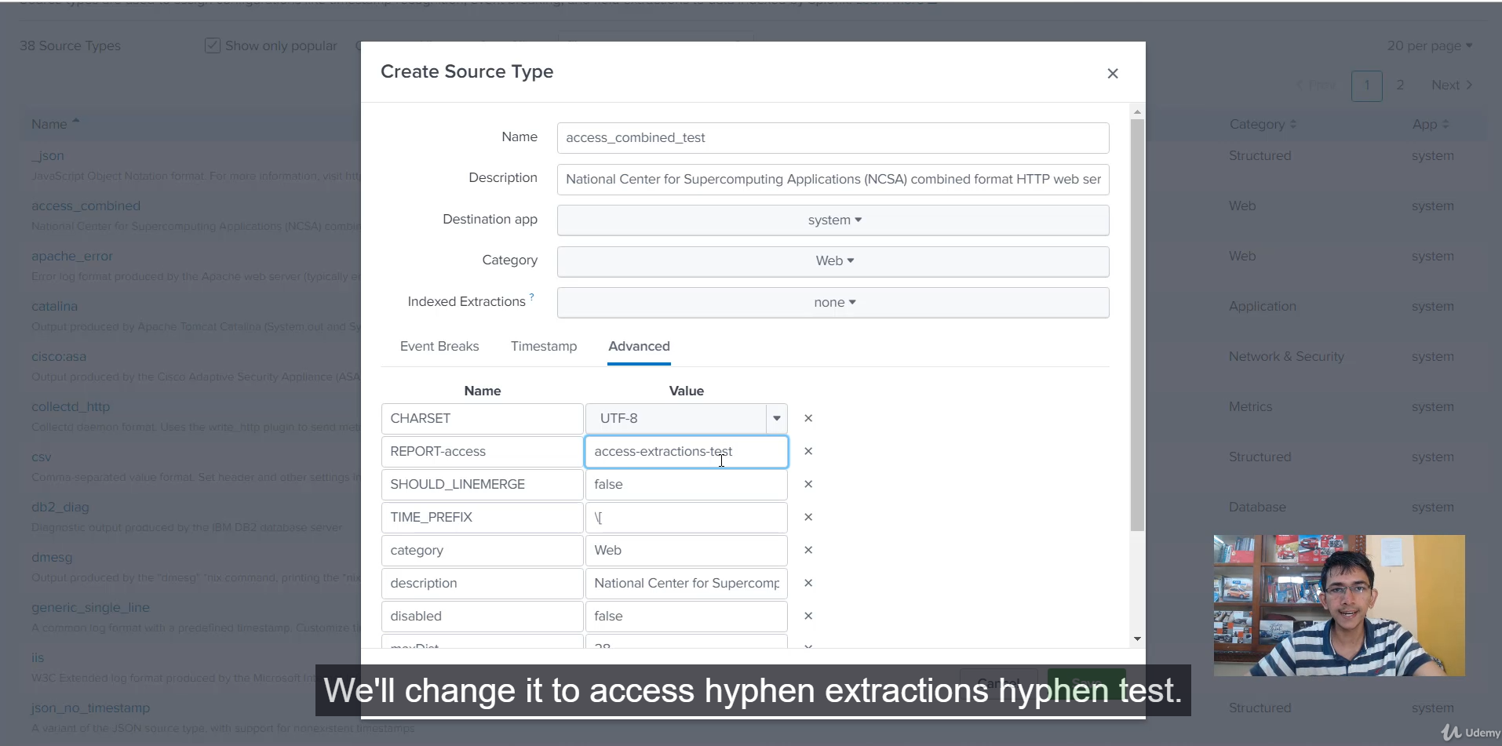

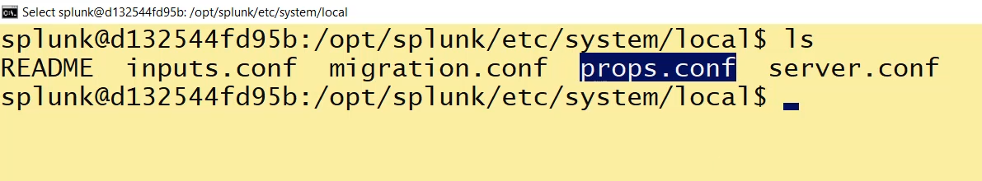

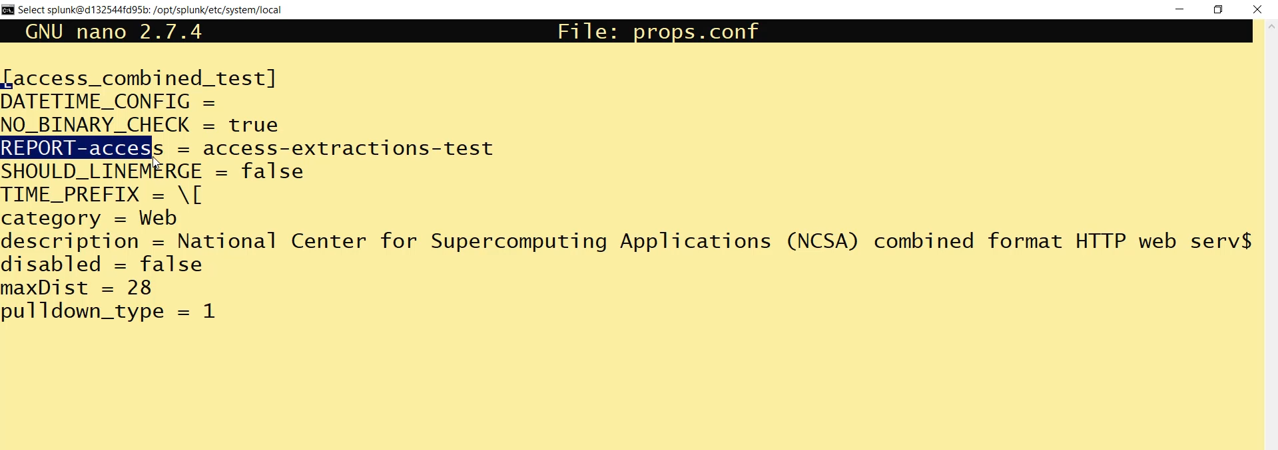

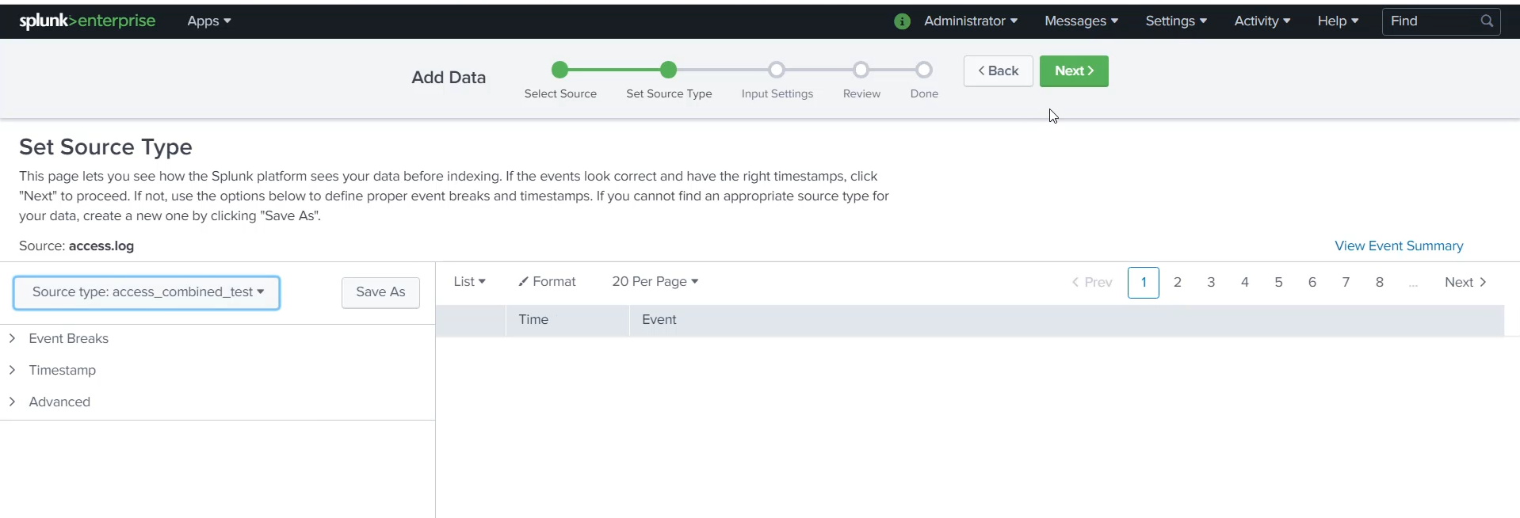  
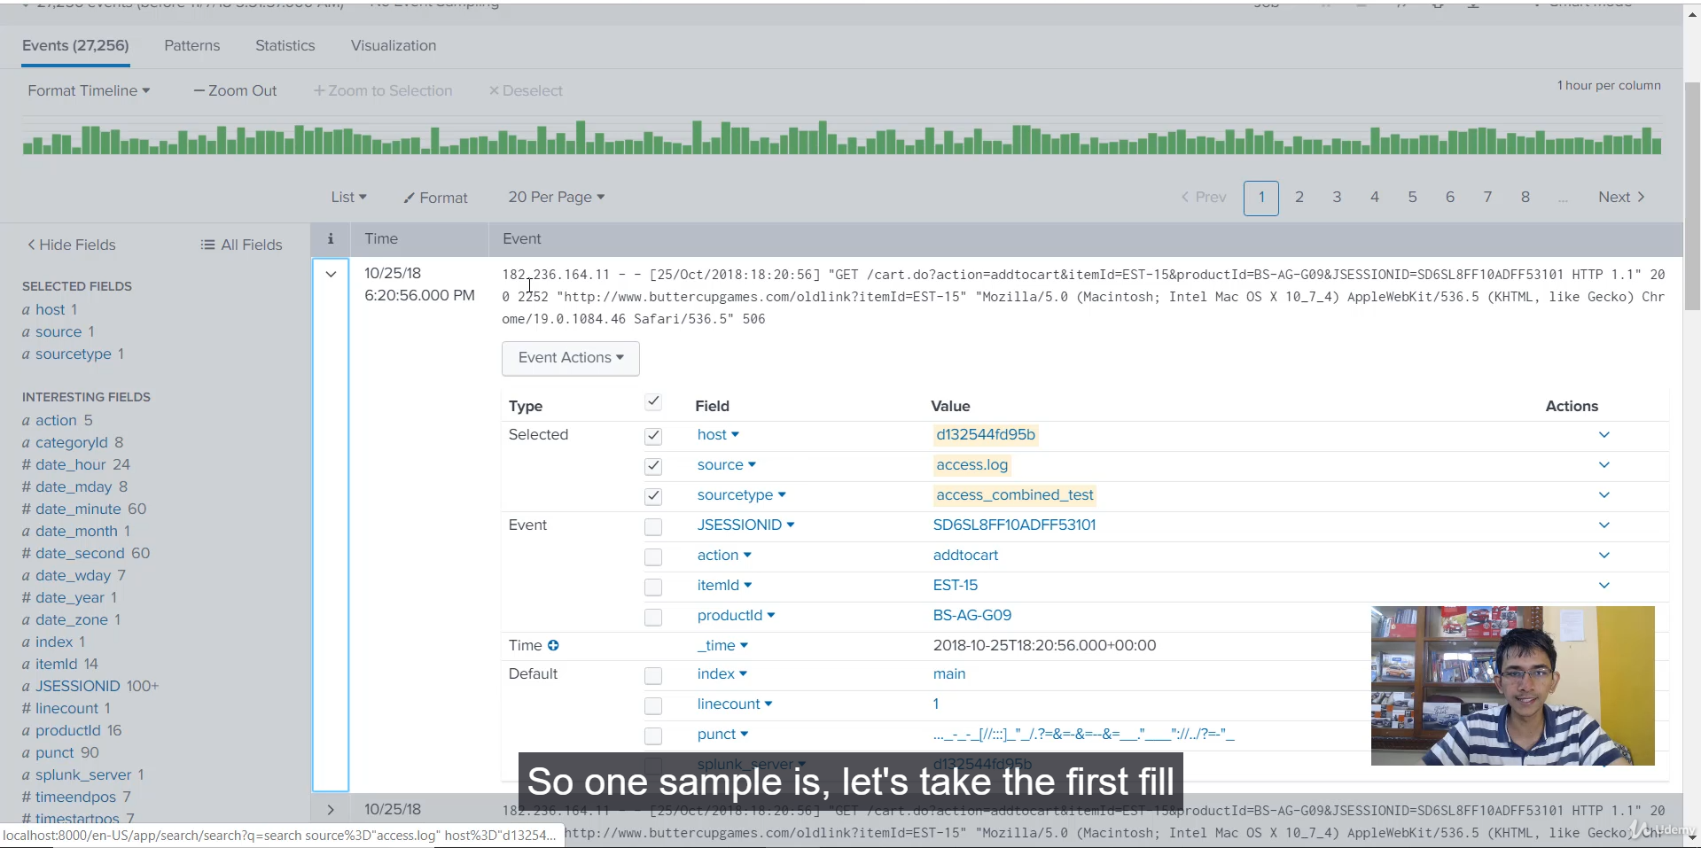

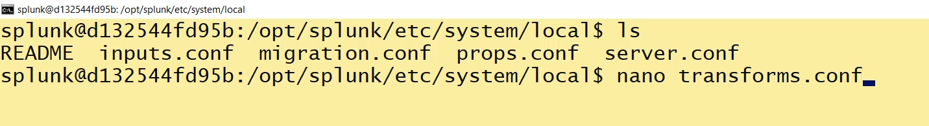

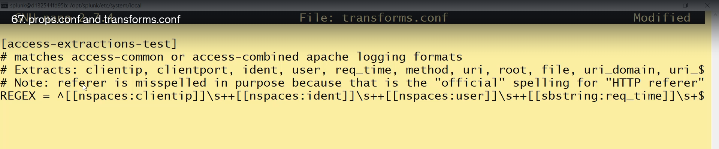  
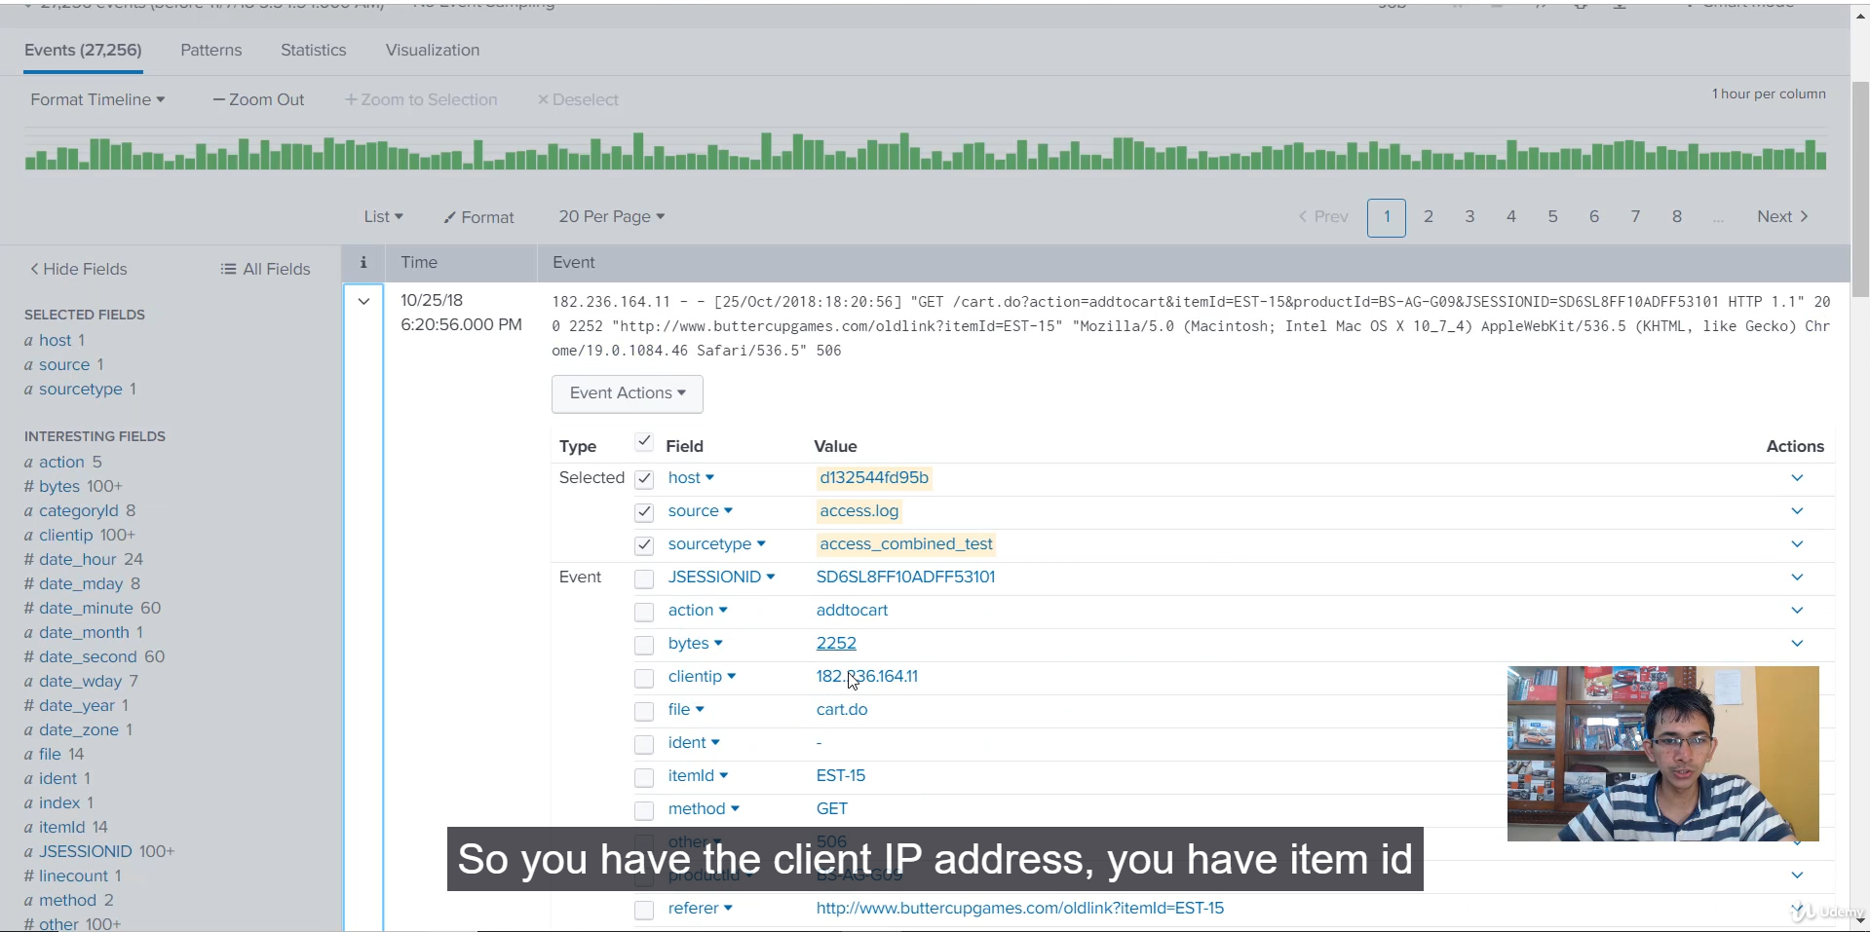

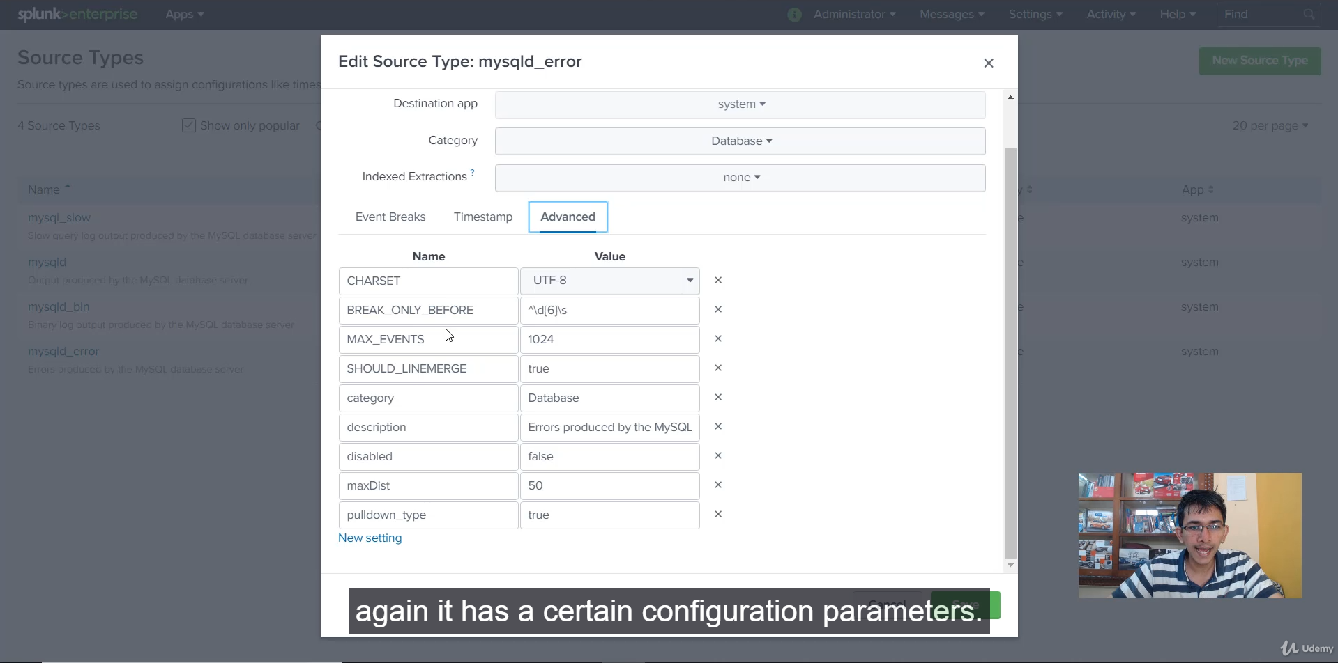

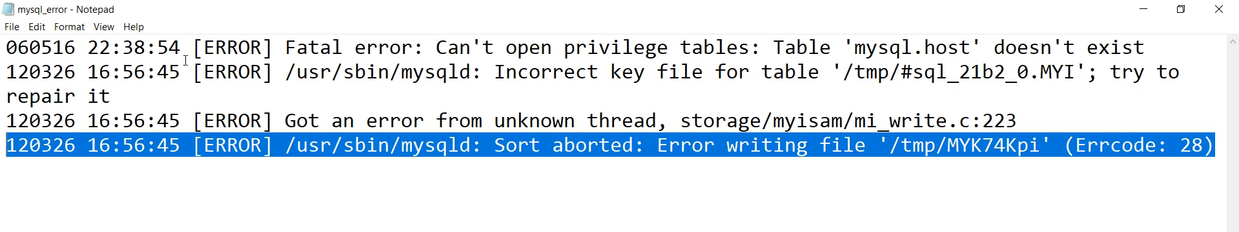

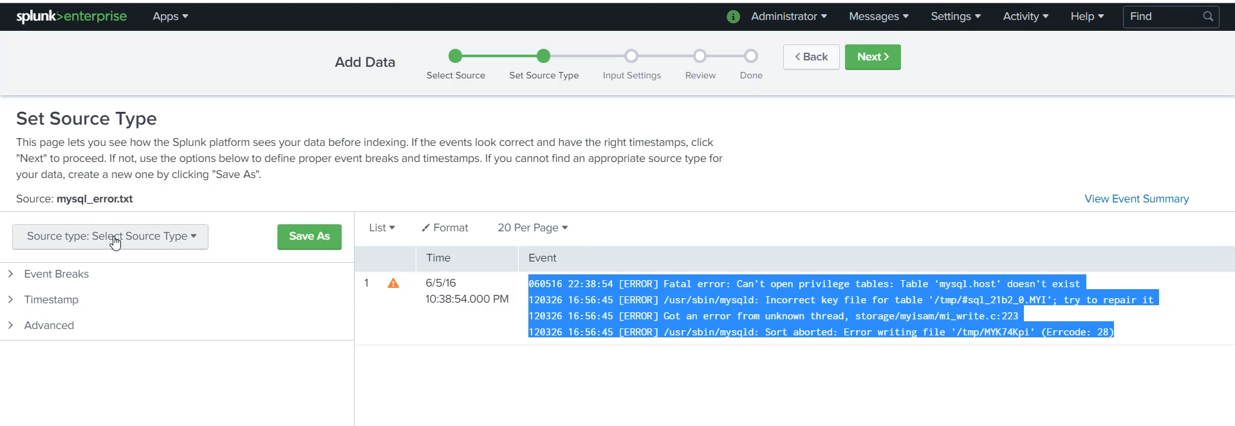

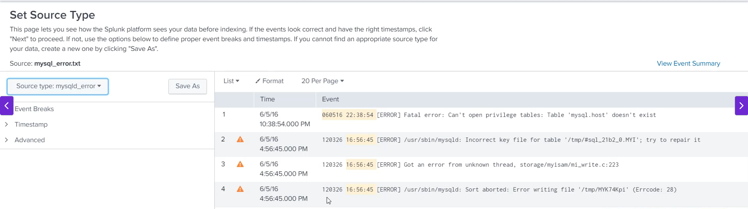

**Configuration Deep Dive: props.conf and transforms.conf**

**1. Core Concepts and Purpose**

* **Necessity:** When working in Splunk, especially when creating **custom sourcetypes**, you frequently interact with props.conf and transforms.conf.
* **Splunk Defaults:** Splunk provides many **default sourcetypes** (e.g., access_combined, catalina) and their associated configurations in the $SPLUNK_HOME/etc/system/default/ directory.
* **props.conf:** This file defines the **properties and settings** associated with a specific sourcetype. It acts as the *pointer* or *controller* for that sourcetype.
* **transforms.conf:** This file stores the actual **Regular Expressions (Regex)** and logic used to execute transformations and field extractions referenced by props.conf.

**2. Field Extraction Mechanism (The Best Practice)**

The video demonstrates the recommended way to link a sourcetype to its extraction rules:

1. **In props.conf:** A stanza is defined for the sourcetype (e.g., [access_combined]).
2. **The Pointer:** A configuration setting is used to link to the Regex logic:
   * **Syntax:** REPORT-<name> = <transform_stanza_name>
   * **Example:** REPORT-access = access-extractions
3. **In transforms.conf:** A corresponding stanza is defined to hold the Regex:
   * **Stanza:** [access-extractions]
   * **Content:** Contains the REGEX definition that performs the actual field extraction.

* **Benefit of Separation:** By separating the configuration into two files, a single Regex defined in transforms.conf can be easily **reused by multiple props.conf stanzas** (sourcetypes), promoting efficiency and best practice.

**3. Demonstration: Cloning and Linking (Access Logs)**

* **Action:** Cloned the default access_combined sourcetype via the UI to create a test version: access_combined_test.
* **props.conf Update (UI/Local):** This action automatically created a **local props.conf** file. The REPORT-access value was changed to point to a new, non-existent stanza: access-extractions-test.
* **Ingestion Failure:** When logs were uploaded using the new access_combined_test sourcetype, **field extraction failed** because the access-extractions-test stanza did not exist anywhere.
* **The Fix:** A local **transforms.conf** file was manually created. It copied the original Regex and defined the new stanza: [access-extractions-test].
* **Result:** After this configuration was created, the log data uploaded with sourcetype=access_combined_test was **extracted perfectly**, confirming the link between the two configuration files.

**4. Event Breaking and breakOnlyBefore**

* **Context:** The demonstration shifted to a different setting to illustrate how props.conf controls **event breaking**.
* **Log Type:** mysql-error.log (MySQL error logs).
* **The Challenge:** A single logical event can span multiple lines (e.g., error messages). Splunk needs to know where a new event *starts*.
* **Configuration Setting:** The default mysql_error sourcetype uses: BREAK_ONLY_BEFORE = <Regex>
* **How it Works:**
  + The Regex specifies a pattern (e.g., a 6-digit number \d{6}) found at the start of every new event line.
  + Splunk treats all subsequent lines as part of the current event **until** it encounters a line that matches the defined Regex.
* **Demo Result:** When uploading the MySQL error log with an *incorrect* or generic sourcetype, Splunk treated the **entire file as a single event**. When the correct mysql_error sourcetype (with BREAK_ONLY_BEFORE) was selected, the logs were correctly broken into individual events.

**5. Splunk Documentation Reference**

* **Tip:** When encountering an unfamiliar configuration parameter (like BREAK_ONLY_BEFORE), always refer to the **Splunk props.conf documentation**.
* **Access:** The documentation allows searching for any key-value pair, providing a clear explanation of its function and expected behavior.

===================================================================================

1. **Splunk Event Types:**

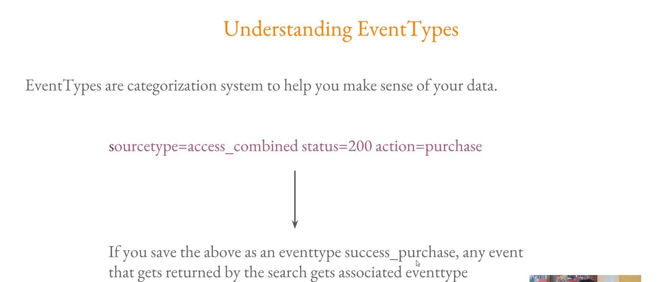

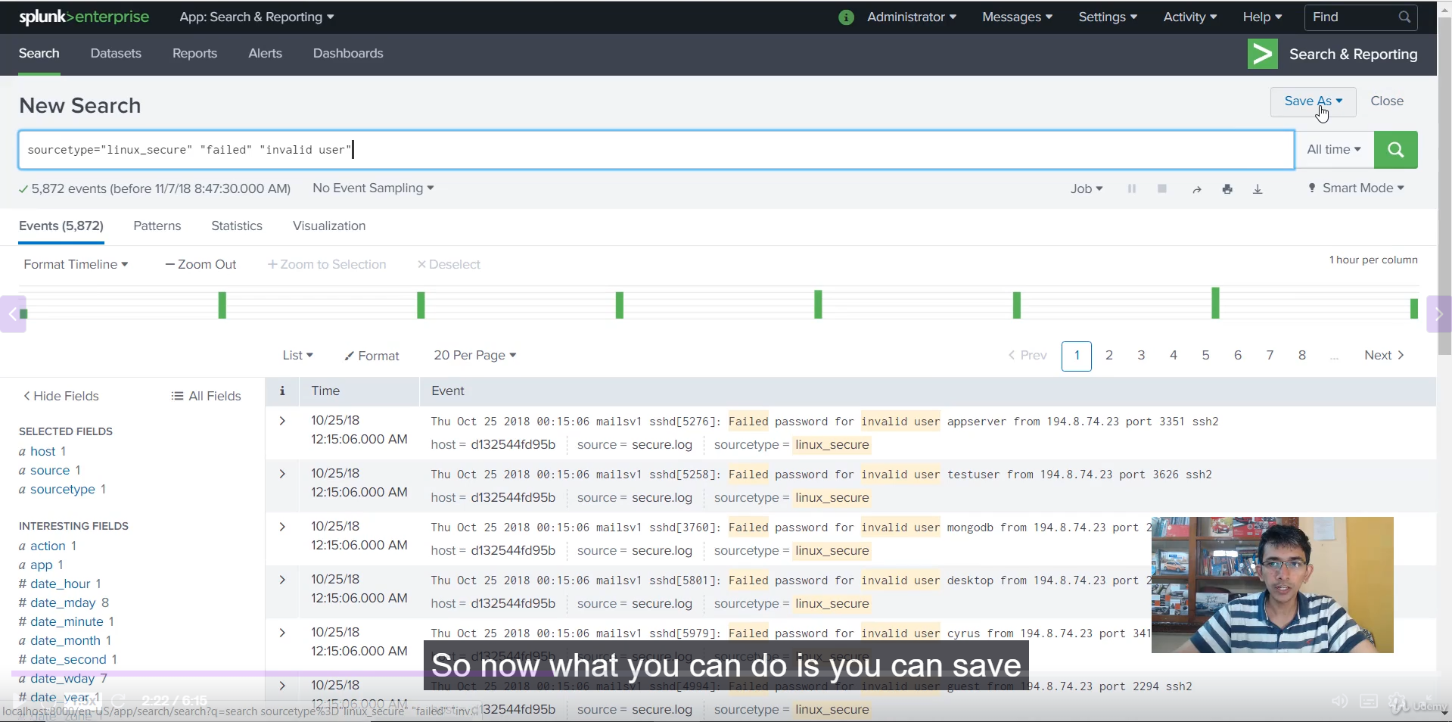

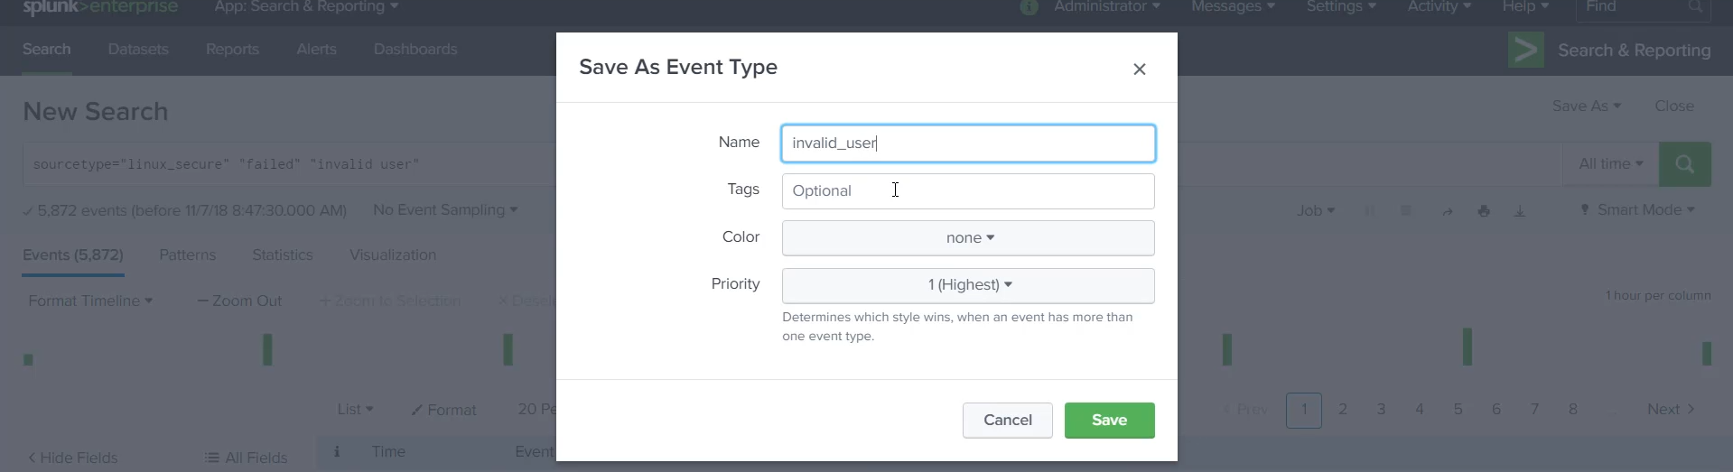

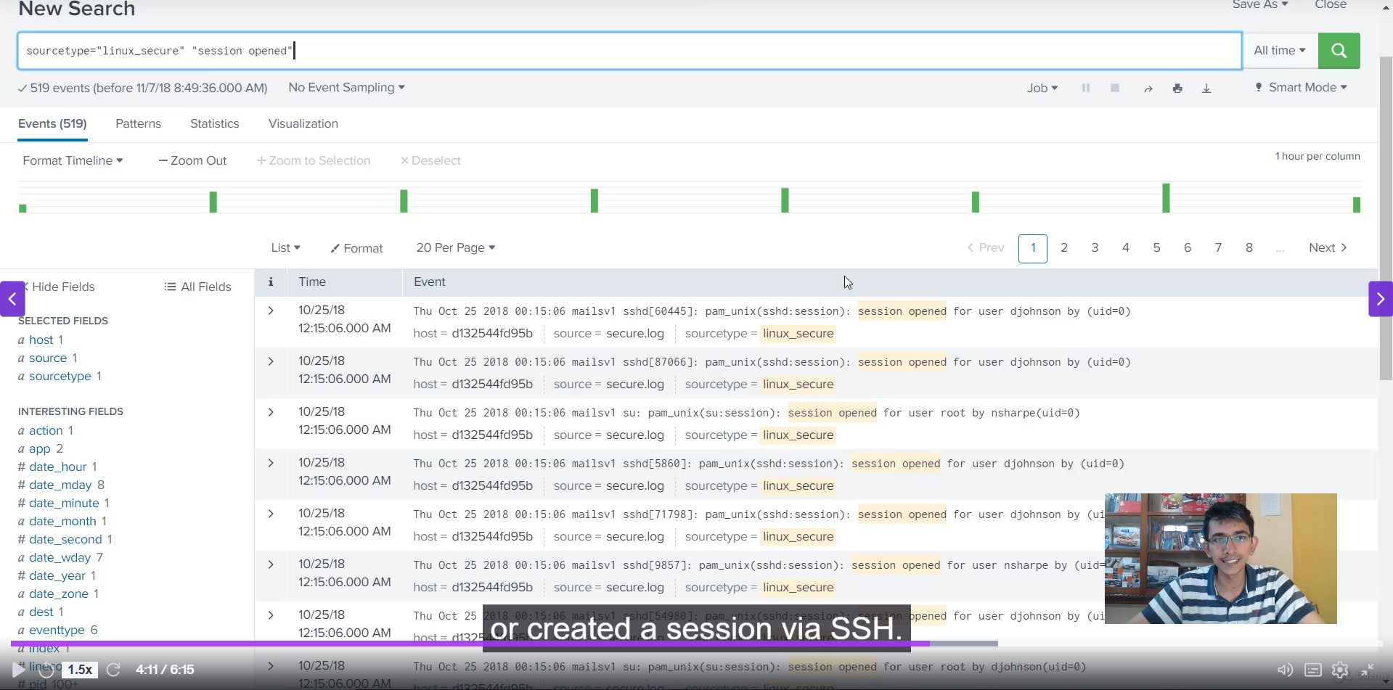

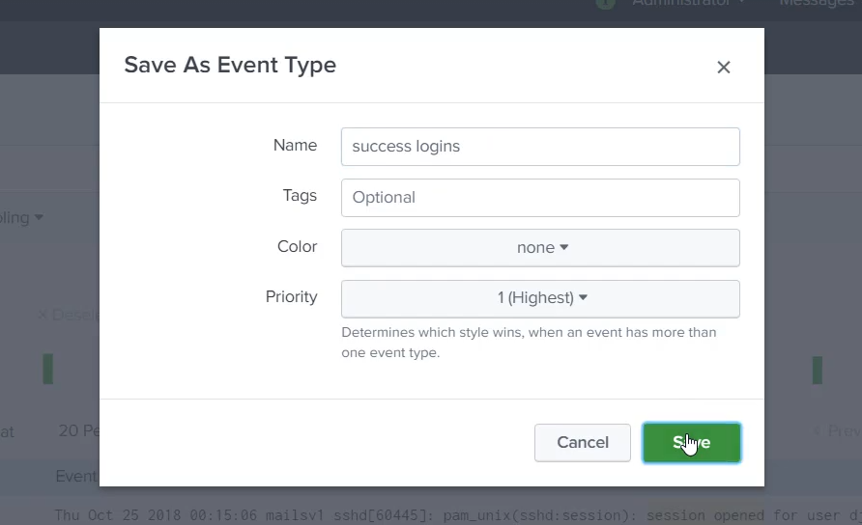

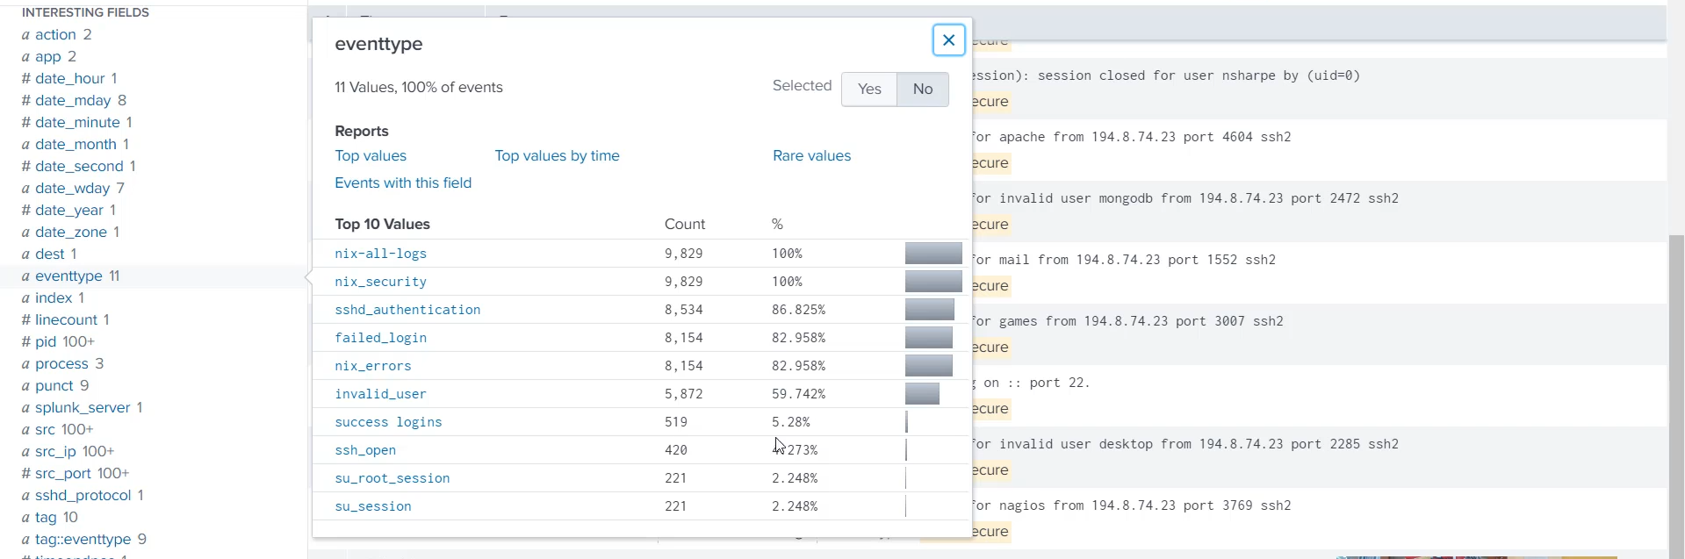

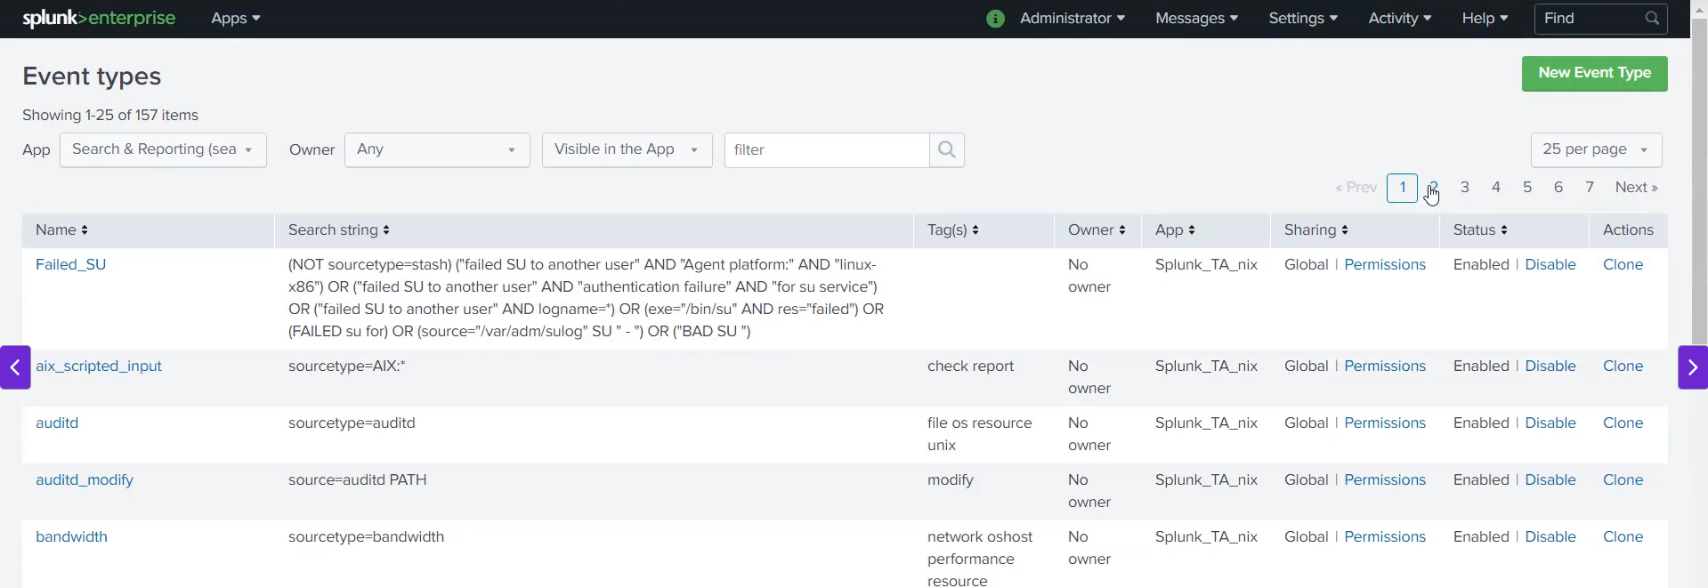

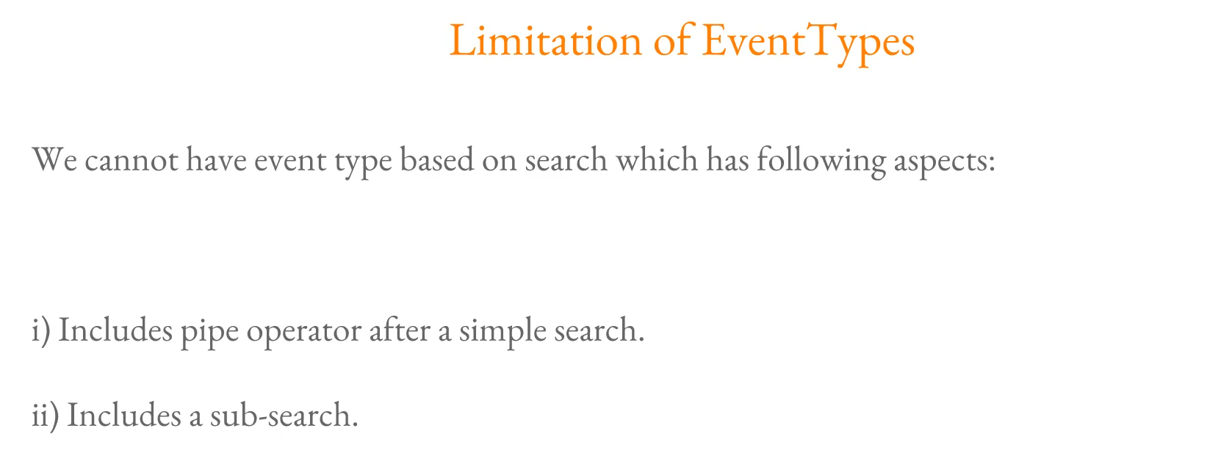

**Splunk Event Types: Categorizing Your Data**

**1. Event Types Defined**

* **Core Function:** Event types are **categorizations** that help you make sense of your data by assigning a tag to events that match a specific search query.
* **Analogy:** Instead of writing a complex query, you can save the query as a tag (the event type), allowing users to search the tag directly.
* **Key Distinction (vs. Saved Search):** Event types are **not** the same as saved searches.
  + **Saved Search:** Saves the query for later use/reporting.
  + **Event Type:** **Adds a field** (the event type name) to every event that matches the definition, allowing for instant filtering and summary visualization directly from the sidebar.

**2. Practical Demonstration: Linux Security Logs**

The demonstration used sourcetype=linux_secure logs to define and use event types:

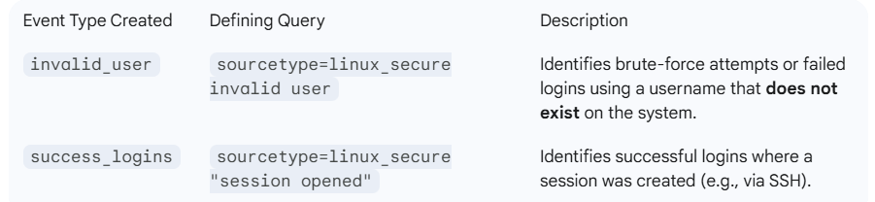

**3. Benefits of Using Event Types**

* **Quick Understanding:** By searching the sourcetype and looking at the **Event Types** panel in the sidebar, users can immediately see a breakdown of the categorized events.
  + **Example:** For sourcetype=linux_secure, the sidebar instantly showed that **59.7%** of logs were tagged as invalid_user and **5.28%** as success_logins.
* **Simplicity for Analysts:** Users can filter events using simple queries like eventtype=success_logins, eliminating the need to write complex or detailed searches.
* **Pre-built Types:** Splunk comes with many **pre-built event types** (e.g., failed_login, free_disk_space) that simplify analysis for common logs like Windows (WMI) or system logs.

**4. Event Type Limitations**

While powerful, Event Types have certain restrictions in their definition:

* **No Pipe Operator (|):** The search string defining an event type **cannot include the pipe operator** (|) to pass results to processing commands (like stats, table, etc.).
* **No Subsearches:** Event type definitions **cannot include subsearches**.

**5. Summary: Event Types vs. Raw Search**

The main benefit is the ability to easily aggregate and visualize categories:

"If you just do a sourcetype=linux_secure and you click on event type you can quickly see how many fail logins are there, how many successful logins are there. You don't really have to write any additional query. Everything comes from the event type."

===================================================================================

1. **Tags:**

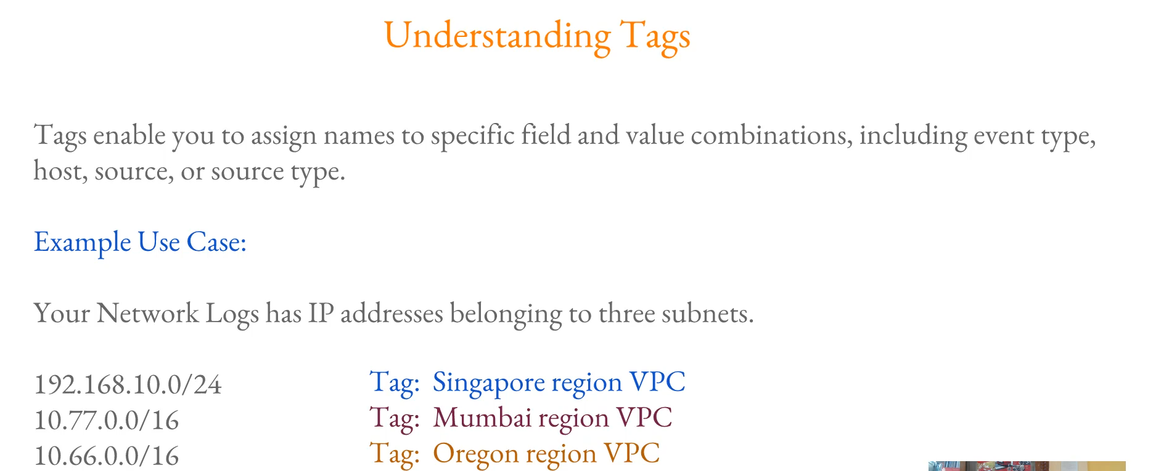

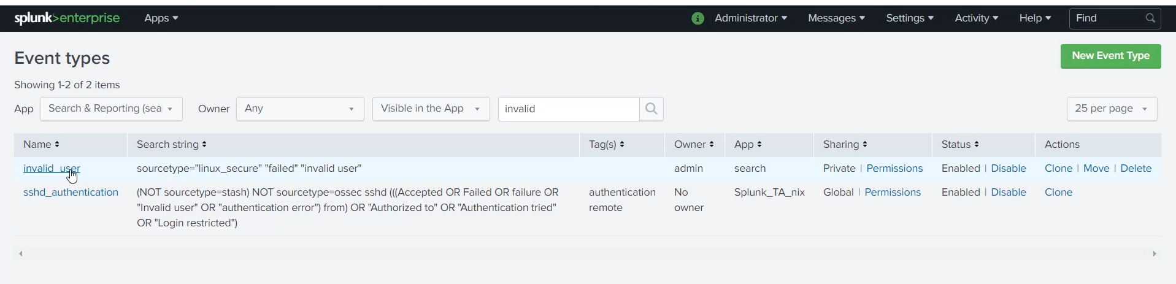

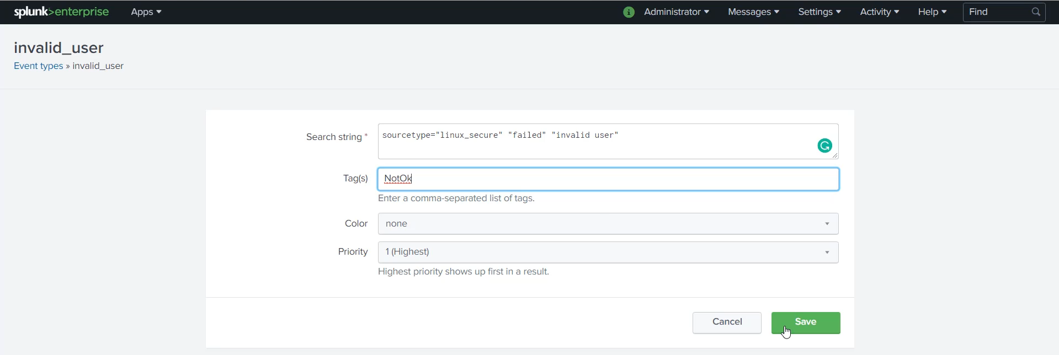

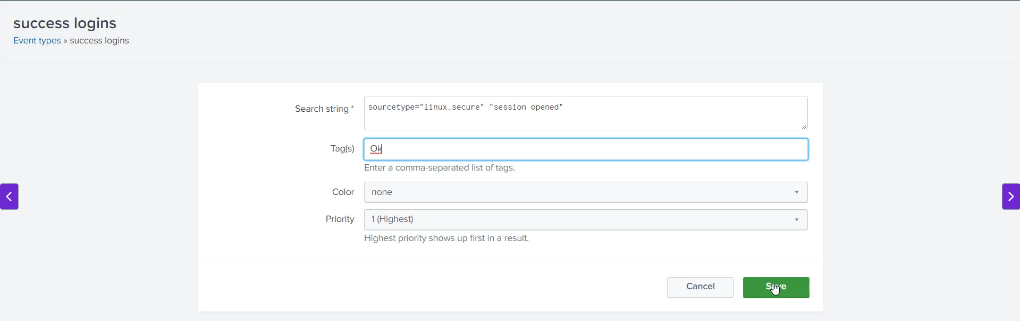

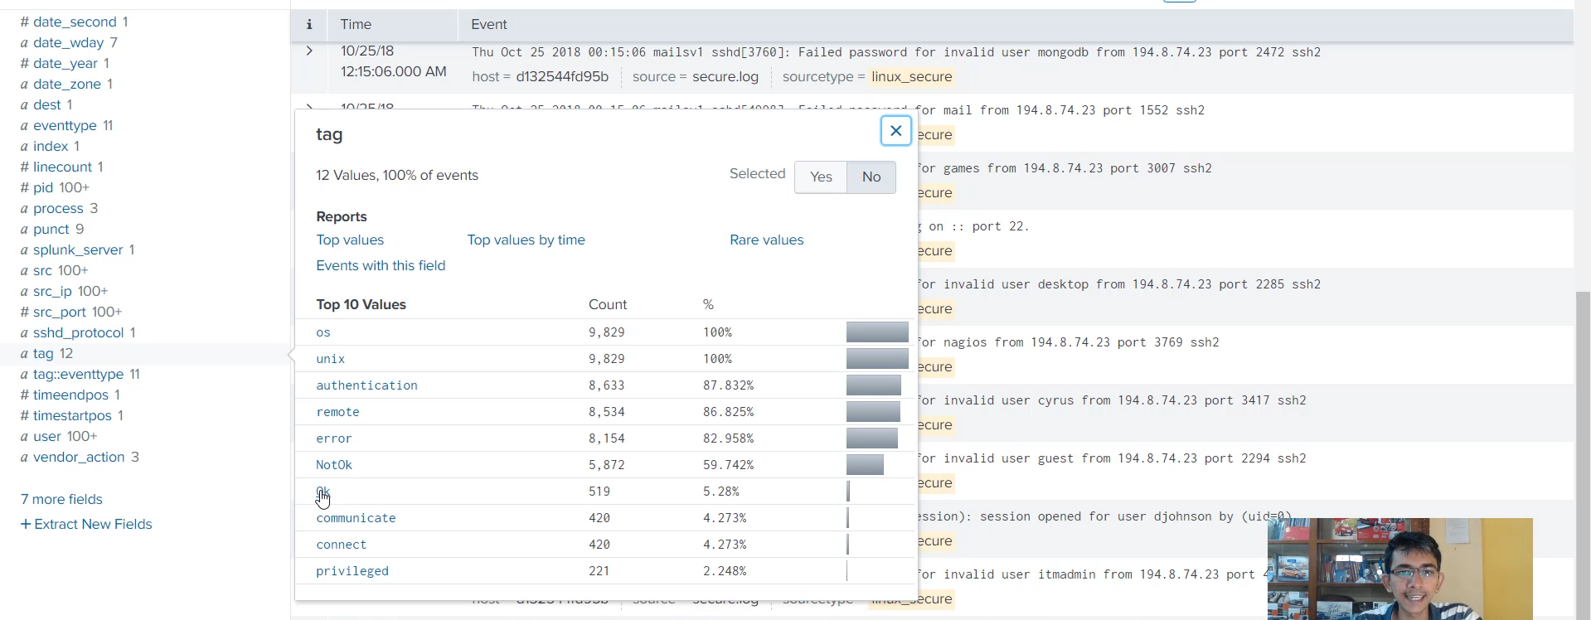

**Splunk Tags: Adding Contextual Labels**

**1. What are Splunk Tags?**

* **Definition:** A tag is a **name assigned to a specific field and value combination**.
* **Applicability:** Tags can be applied to many different fields, including:
  + eventtype (most common in the demo)
  + host
  + source
  + sourcetype
* **Goal:** To help analysts and users understand the data **immediately within Splunk**, without having to refer to external documentation (like a network IP address spreadsheet).

**2. Use Case: Providing Context (Networking Example)**

* **Problem:** A raw IP address (e.g., 10.77.0.16) or subnet is meaningless to a typical analyst.
* **Solution with Tags:** Tags can be applied to the ip_address field's value to add instant context:
  + 192.160.10.0 (IP subnet) $\rightarrow$ Tagged as **Singapore_VPC** and **Production**.
  + 10.77.0.16 (IP subnet) $\rightarrow$ Tagged as **Mumbai_VPC** and **Staging**.
* **Benefit:** An analyst can simply search tag=production to see all related events across different logs.

**3. Practical Demonstration: Security and Compliance Tags**

The instructor demonstrated applying tags to **Event Types** for security compliance:

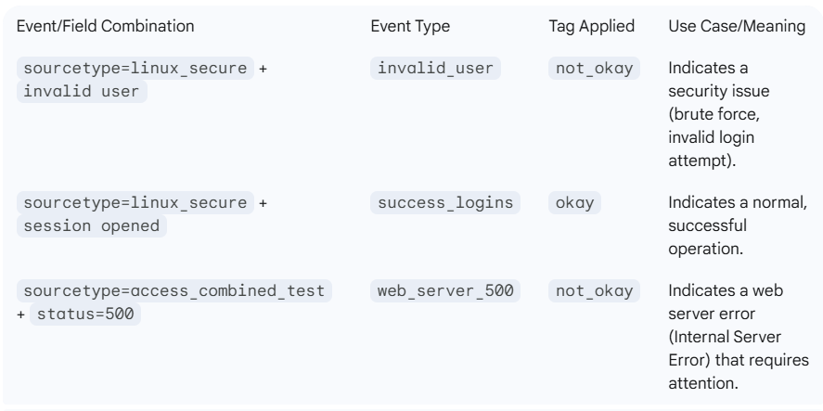

* **Demonstration Steps (for status=500):**
  1. Searched for sourcetype=access_combined_test | status=500.
  2. Saved the result as a new **Event Type** (web_server_500).
  3. Applied the tag **not_okay** to this new event type definition.

**4. Searching and Analysis with Tags**

* **Simplified Search:** Tags allow analysts to search across **disparate sourcetypes** using a common, high-level label.
* **Example Search:** tag=not_okay
* **Result:** This single search instantly pulls up all events from both the **linux_secure** logs (due to invalid users) and the **access_combined** logs (due to 500 errors), making cross-log analysis simple.
* **Use in Auditing:** Tags like compliant and not_compliant are extremely valuable for auditors and management to quickly assess overall security or operational compliance status.

===================================================================================

1. **Splunk event types priority and Coloring Scheme:**

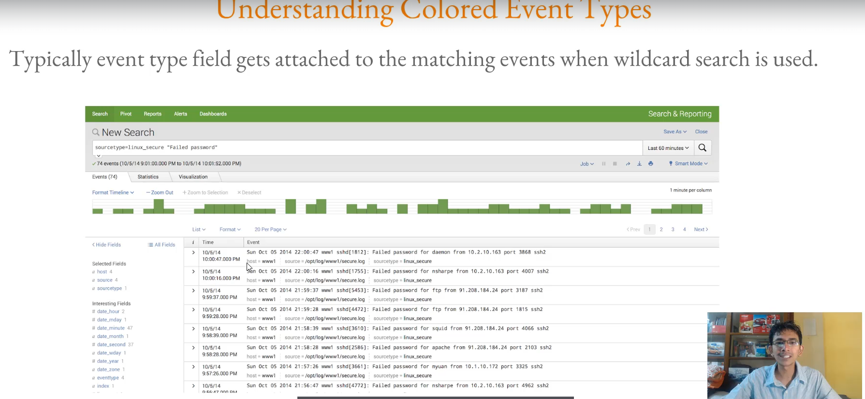

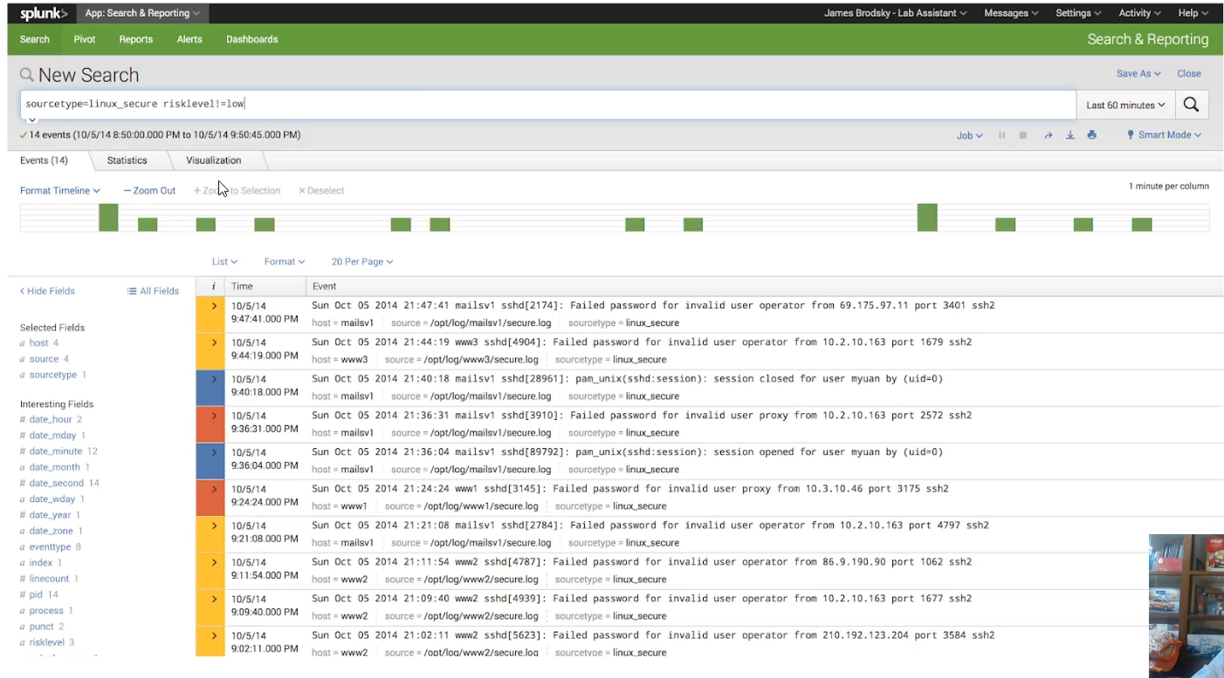

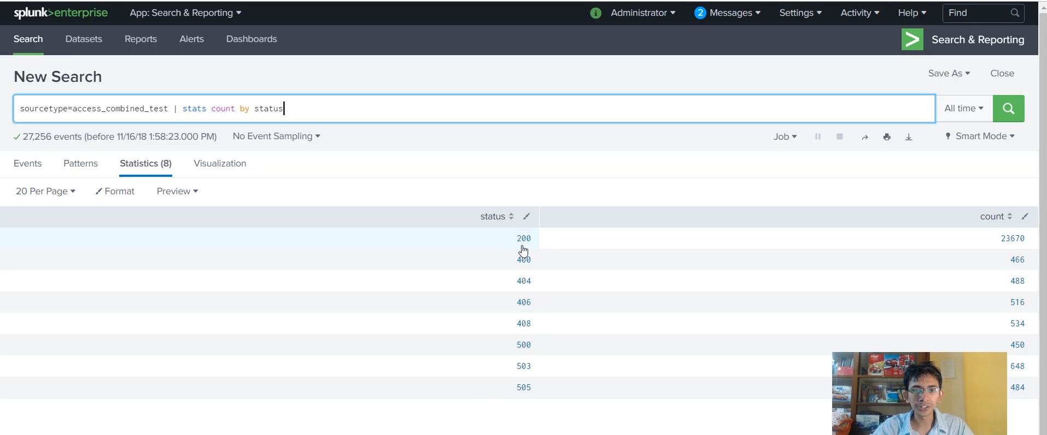

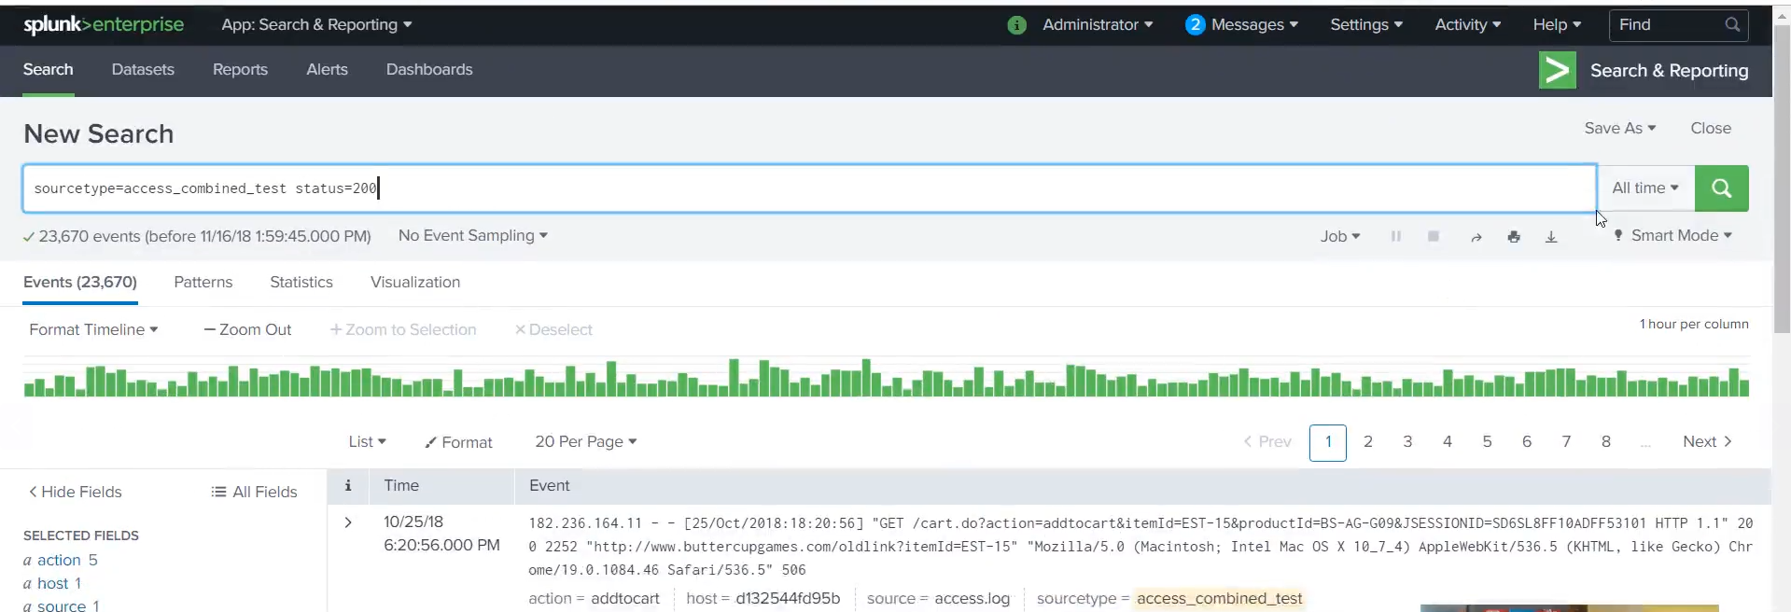

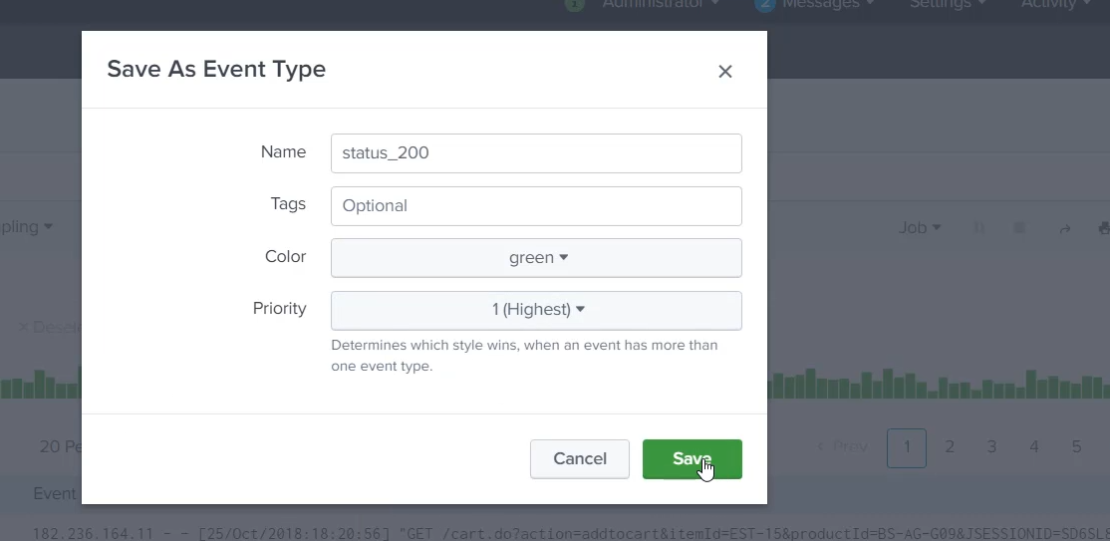

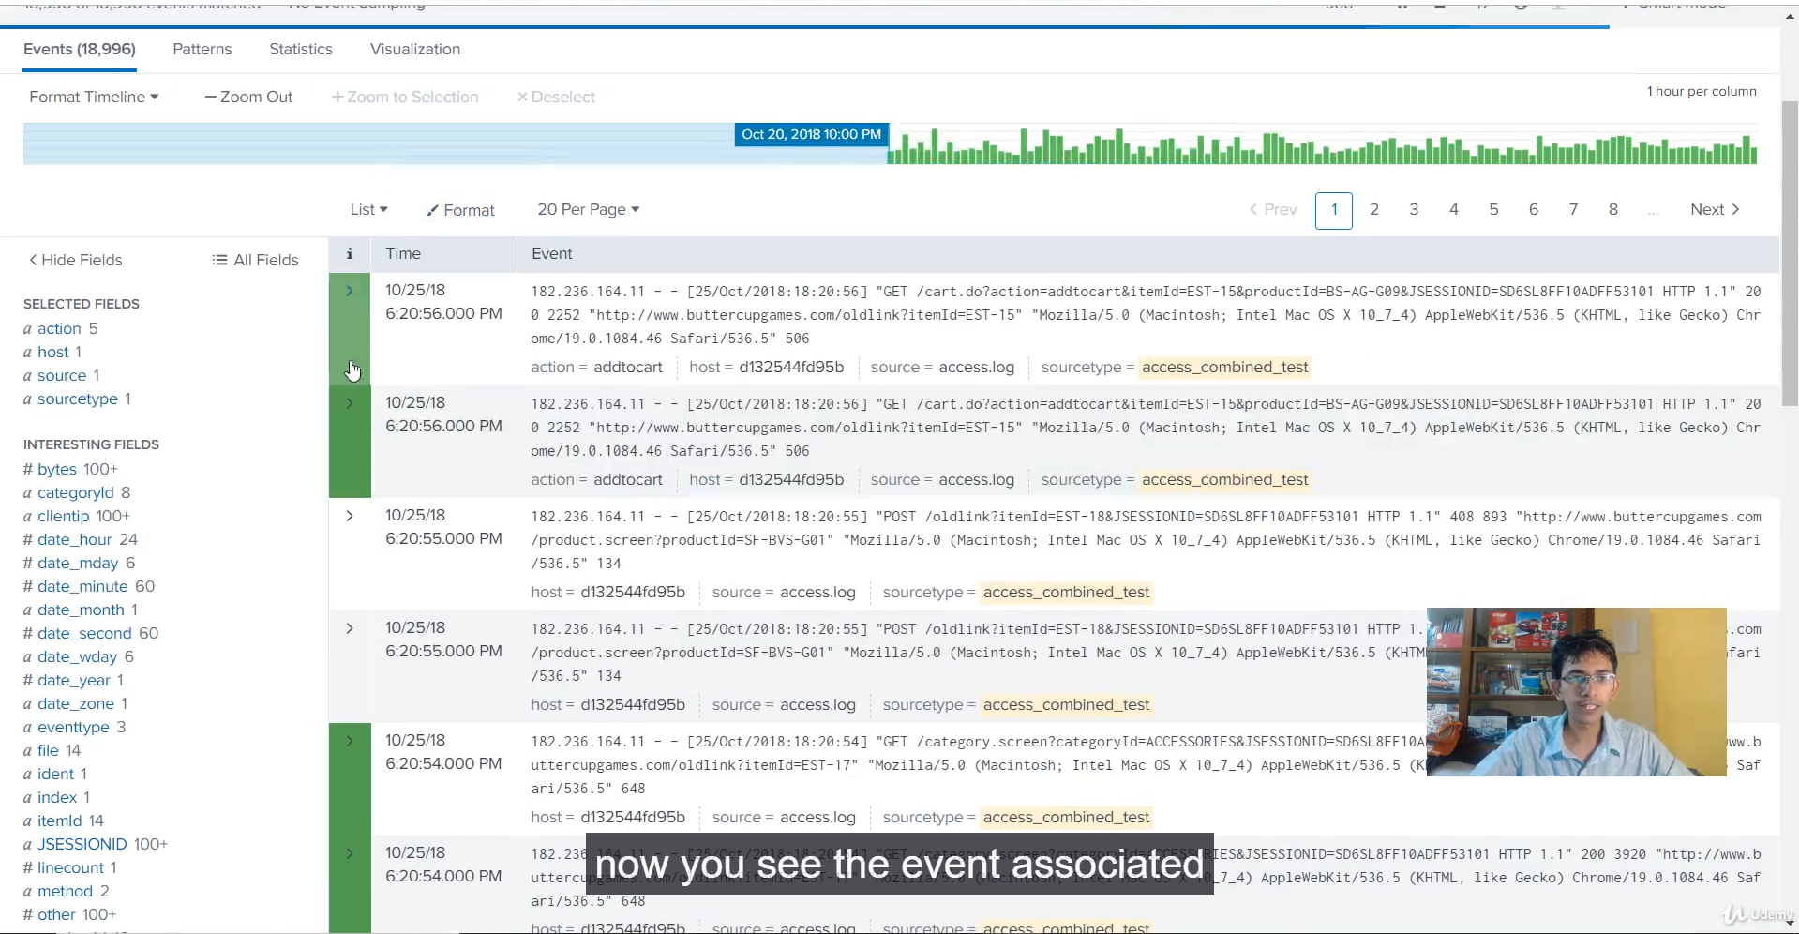

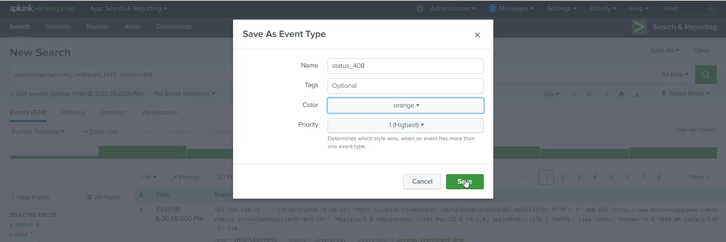

**Splunk Colored Events: Visualizing Priority**

**1. The Power of Colored Events**

* **Purpose:** To visually categorize events based on priority or severity, making rapid analysis much easier than reading text alone.
* **Analogy:** A dashboard can use colors for quick assessment:
  + **Red:** Dangerous / High Priority
  + **Orange:** Medium Priority
  + **Blue/Green:** Good / Normal / Low Priority
* **Mechanism:** Coloring is applied to events based on their assigned **Event Type**.

**2. Demonstration Setup and Goal**

* **Log Data:** Uses the sample access_combined_test logs.
* **Goal:** To color-code events based on the HTTP status code field.

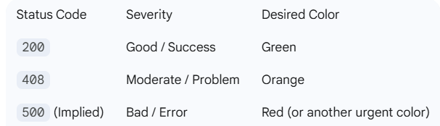

**3. Steps to Create Colored Events**

1. **Define the Search:** Write an SPL query that identifies the events you want to color.
   * *Example:* sourcetype=access_combined_test status=200
2. **Save as Event Type:** Click **"Save As"** and choose **"Event Type."**
3. **Set Name and Priority:**
   * **Name:** Give it a meaningful name (e.g., status_200).
   * **Priority:** Set the priority (1 is highest, 10 is lowest). **Priority is crucial for resolving color clashes.**
4. **Assign Color:** Select the desired color from the dropdown (e.g., Green).
5. **Save.**

**4. Resolving Color Clashes (The Importance of Priority)**

* **The Issue:** When the initial search was performed, *no events* were colored, even the status=200 events.
* **The Reason:** A clash existed with a default or app-provided event type (e.g., nix-all-logs) that was matching the same events but had no color assigned.
* **The Fix:**
  + Navigated to **Settings** $\rightarrow$ **Event Types**.
  + Searched for and **disabled** the conflicting, unneeded event type (nix-all-logs).
* **Result:** After disabling the conflict, the coloring worked correctly, with status=200 events showing up as green.

**5. Coloring a Moderate Event**

* A second event type was created for a problematic status code:
  + **Search:** sourcetype=access_combined_test status=408 (Request Timeout)
  + **Name:** status_408
  + **Color:** Orange
  + **Priority:** Set to a high priority (1) to ensure it overrides general event types.

**6. Conclusion and Key Benefit**

* **Visual Utility:** By applying colors, an analyst performing a basic search (index=*) can instantly spot high-priority events (red/orange) without reading a single log line.
* **Security Context:** This is **extremely useful for security logs** (SIEM) where high-priority alerts can be color-coded red for immediate action.

===================================================================================

1. **Splunk Lookups:**

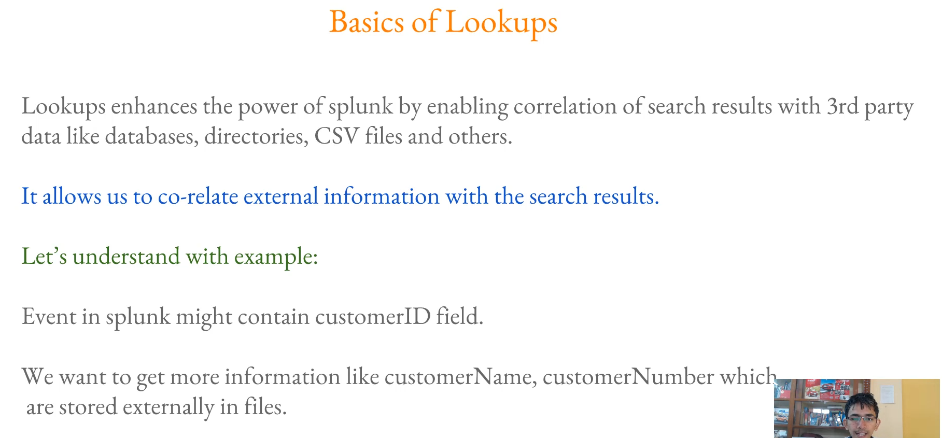

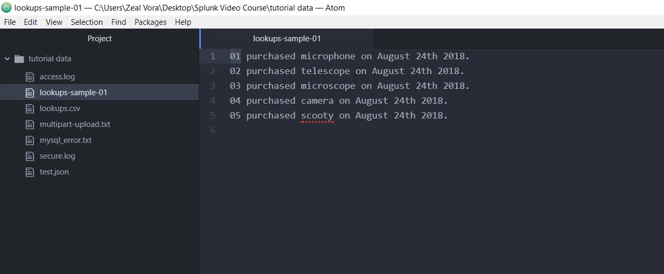

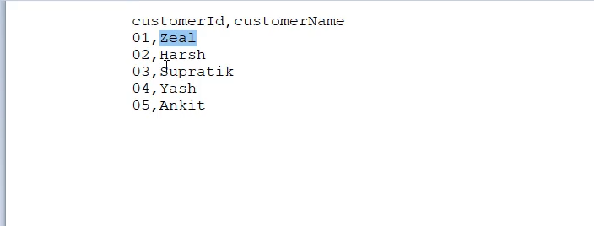

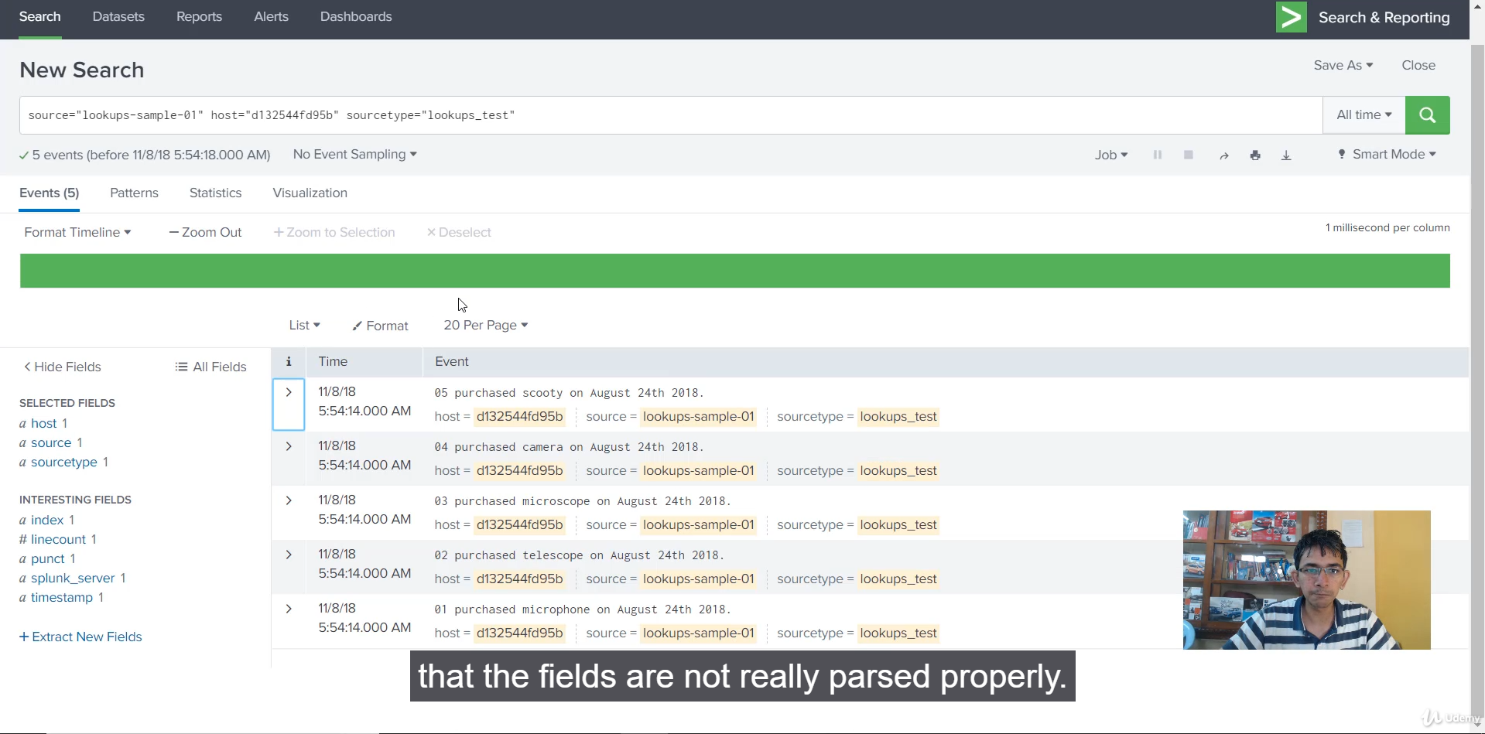

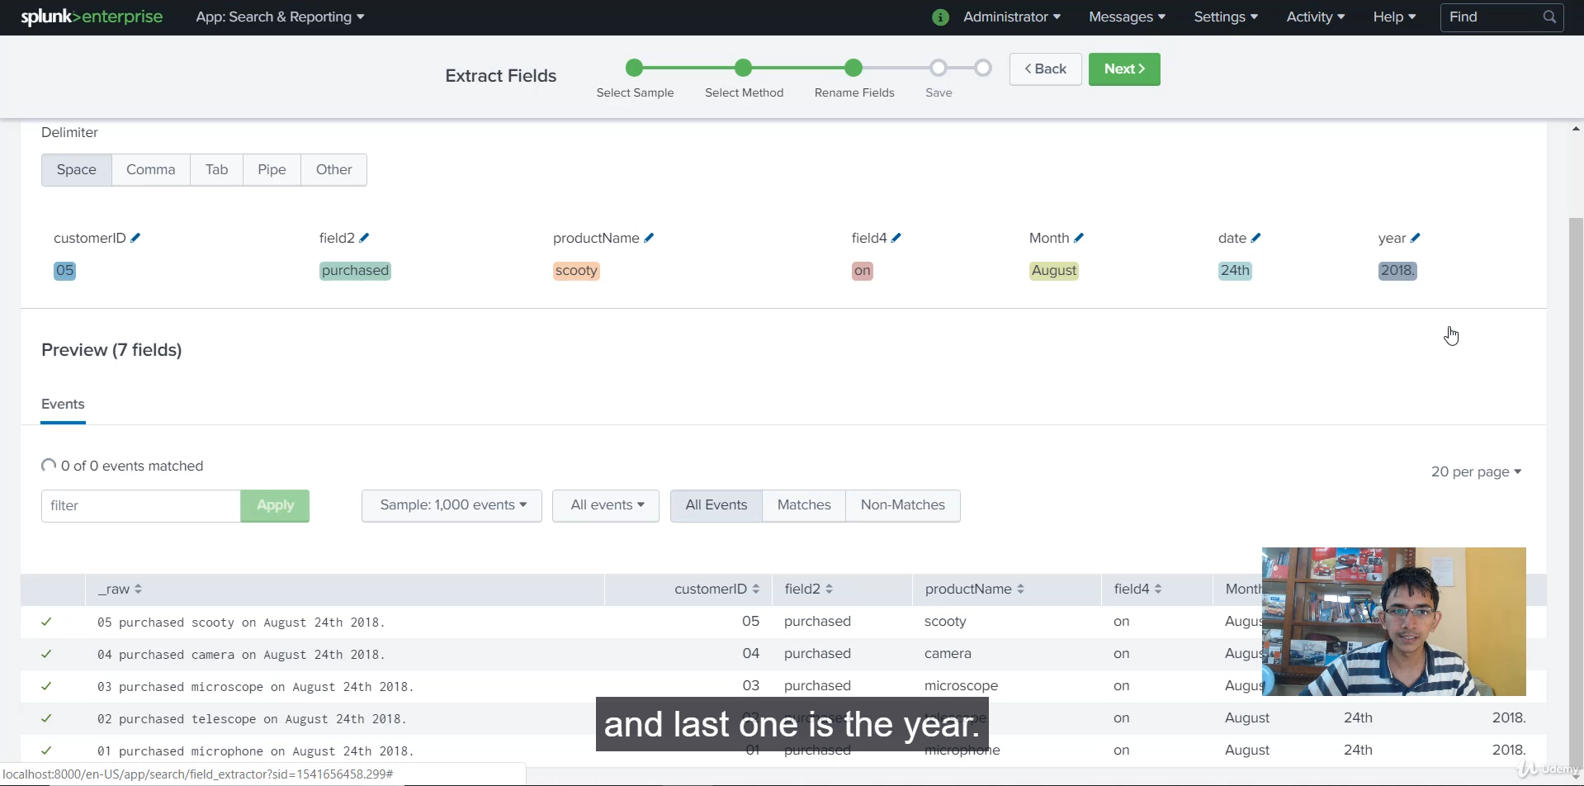

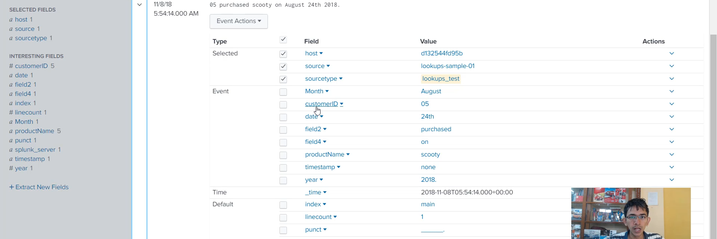

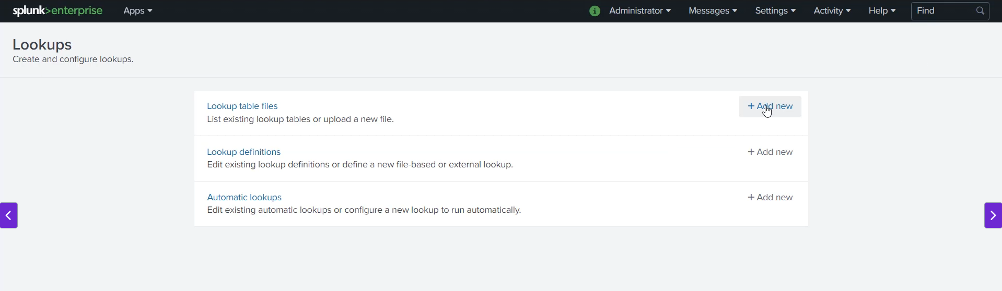

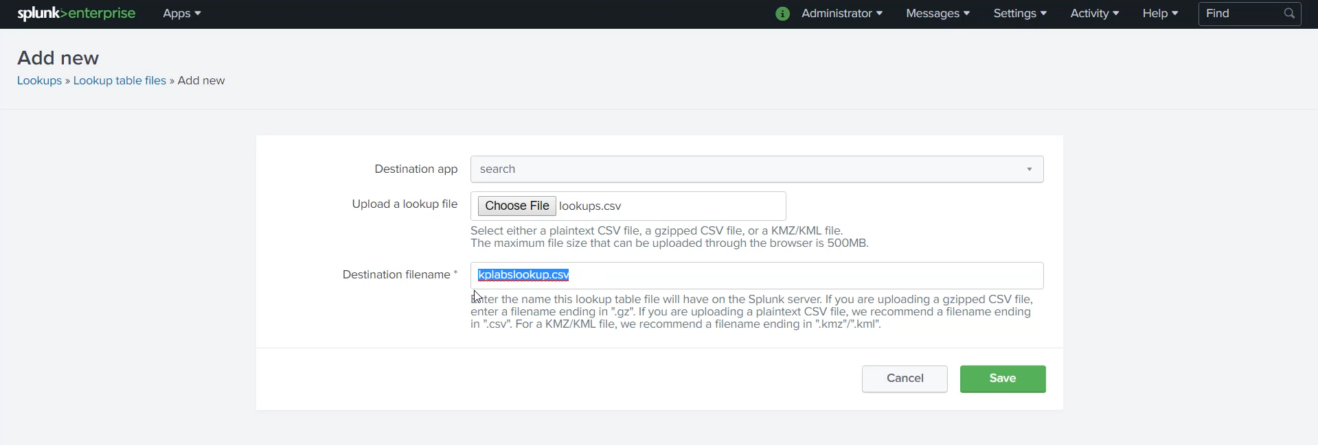

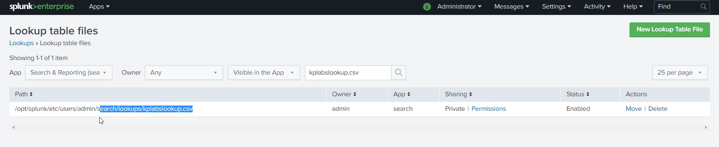

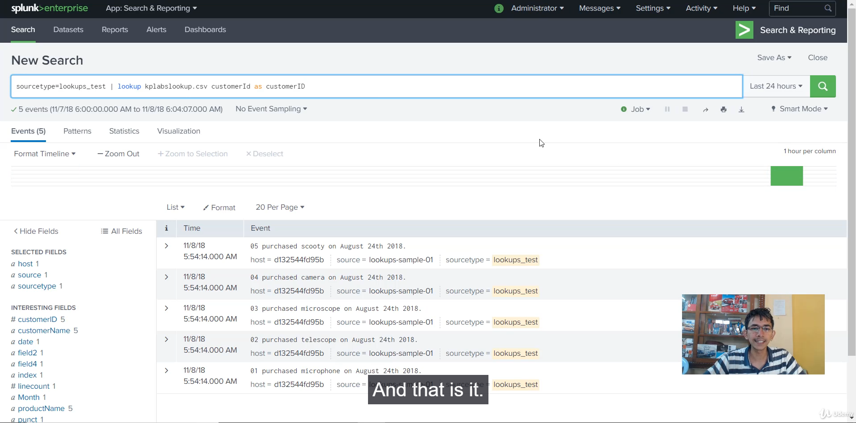

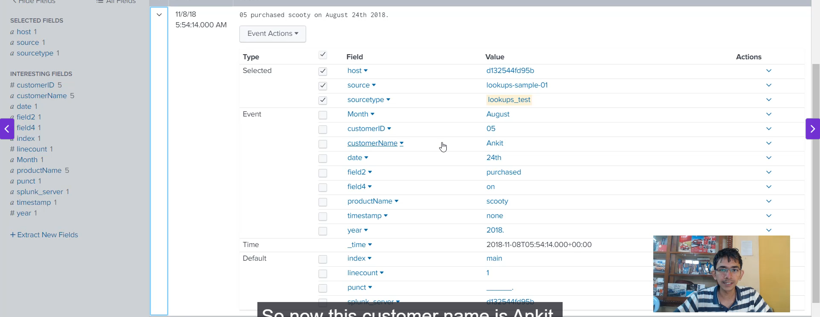

**Splunk Lookups: Data Enrichment and Correlation**

**1. Core Functionality of Lookups**

* **Definition:** Lookups are a Splunk knowledge object that **enhances search results** by correlating internal log data with external, third-party data.
* **External Data Sources:** This external data is commonly stored in:
  + CSV files (most common and used in the demo)
  + Databases
  + Directories
* **Purpose:** To turn raw, uninformative field values (like an ID) into meaningful, descriptive information (like a name or description) directly within the search interface.

**2. Demonstration 1: Mapping Customer IDs to Names**

This example showed how to correlate a customer ID found in a log with a full customer name from a separate CSV file.

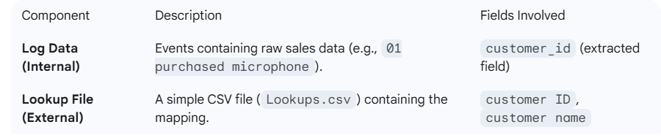

**Steps Taken:**

1. **Ingestion:** The sample log data was uploaded and assigned a new sourcetype: **Lookups_test**.
2. **Field Extraction:** The **Interactive Field Extractor (IFX)** was used to quickly parse the events and extract the Customer ID field.
3. **Lookup Upload:** The Lookups.csv file was uploaded to Splunk via **Settings** $\rightarrow$ **Lookups** and named **KP_Labs_Lookup.csv**.
4. **Lookup Execution (SPL):** The lookup command was executed to join the data:

sourcetype=Lookups_test | lookup KP_Labs_Lookup.csv customer ID AS customerID OUTPUT customer name

* •

**Explanation:** It matches the **customerID** field in the event with the **customer ID** field in the CSV and adds (outputs) the **customer name** field to the event.

• **Result:** When viewing the events, the new field **customer name** (e.g., "Zeal" or "Ankit") appeared, providing immediate context for the raw customerID field.

**3. Demonstration 2: Enriching HTTP Status Codes**

This example showed a real-world application where an Add-on provides Lookups to enrich technical data.

* **Scenario:** Analyzing web server logs (like Apache) where analysts need the description of a numeric HTTP status code (e.g., what is 406?).
* **Source:** The **Splunk TA Apache Add-on** was downloaded, which included a built-in Lookup file: **apache_http_status.csv**.
* **Lookup File Fields:** This CSV contained the fields: status, status_description, and status_type.

**Steps Taken:**

1. **Accessing Lookup:** The pre-built Lookup file was identified within the Add-on's directory structure.
2. **Lookup Execution (SPL):** The lookup command was executed on the web logs:

sourcetype=access_combined_test | lookup apache_http_status.csv status AS status OUTPUT status_description, status_type

1. **Result:** The events were enriched with two new, descriptive fields:
   1. **status_description** (e.g., "OK")
   2. **status_type** (e.g., "Successful")

**4. Summary of Benefits**

Lookups drastically simplify analysis by:

* **Eliminating External Tools:** Analysts no longer need to use databases or external documentation (like Google) to understand technical fields.
* **Centralized Information:** All relevant information is available within the single Splunk interface.

******************************************************************************************************************************************************************************************************************************************************************************************

**Section 7: Security Primer:**

1. **Access Control:**

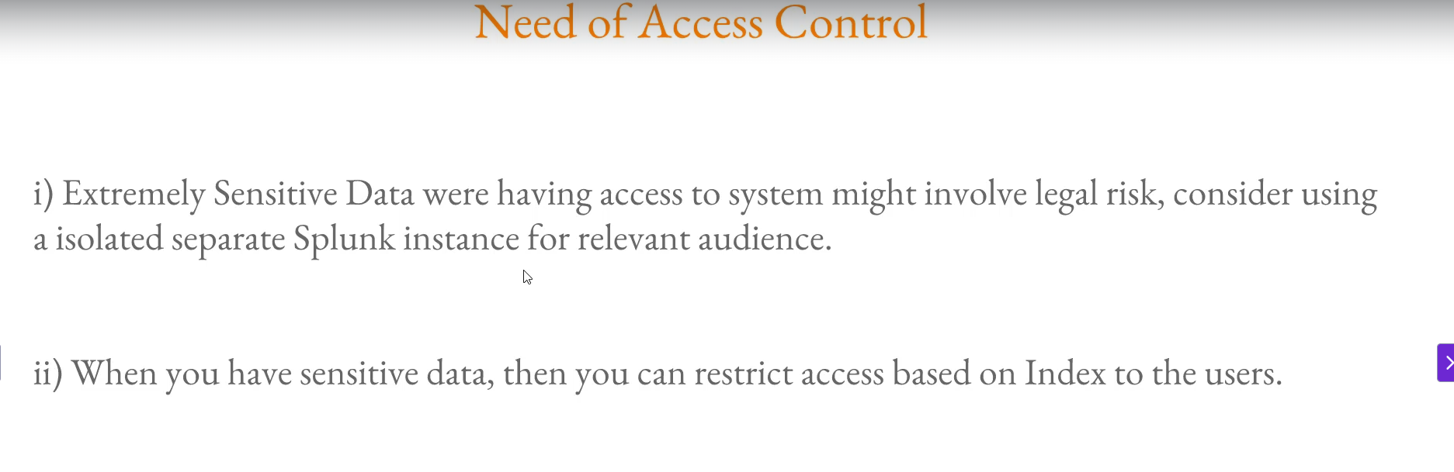

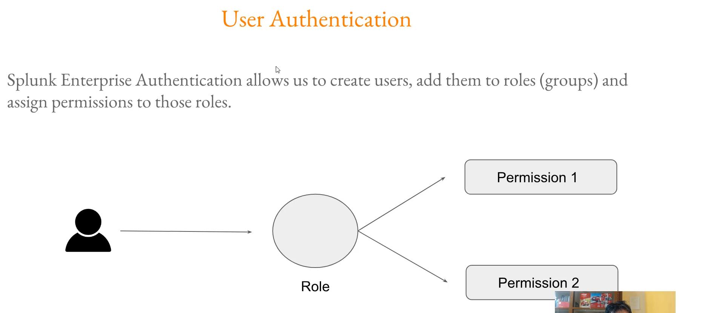

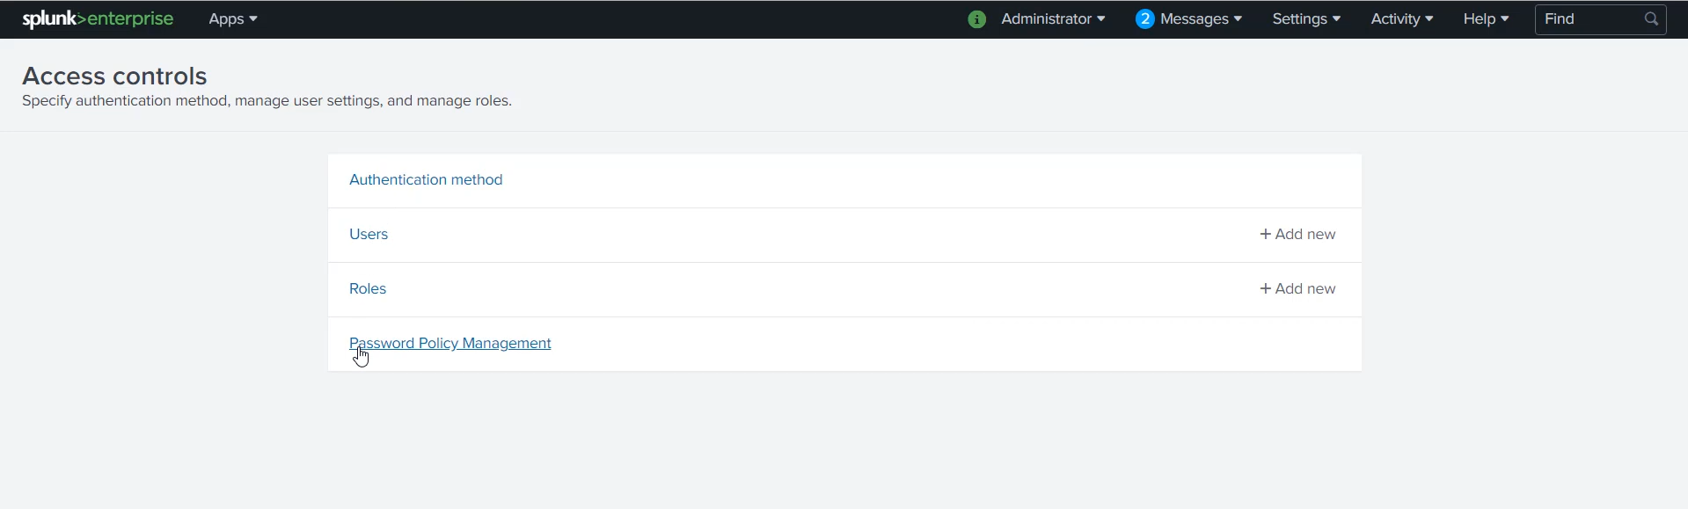

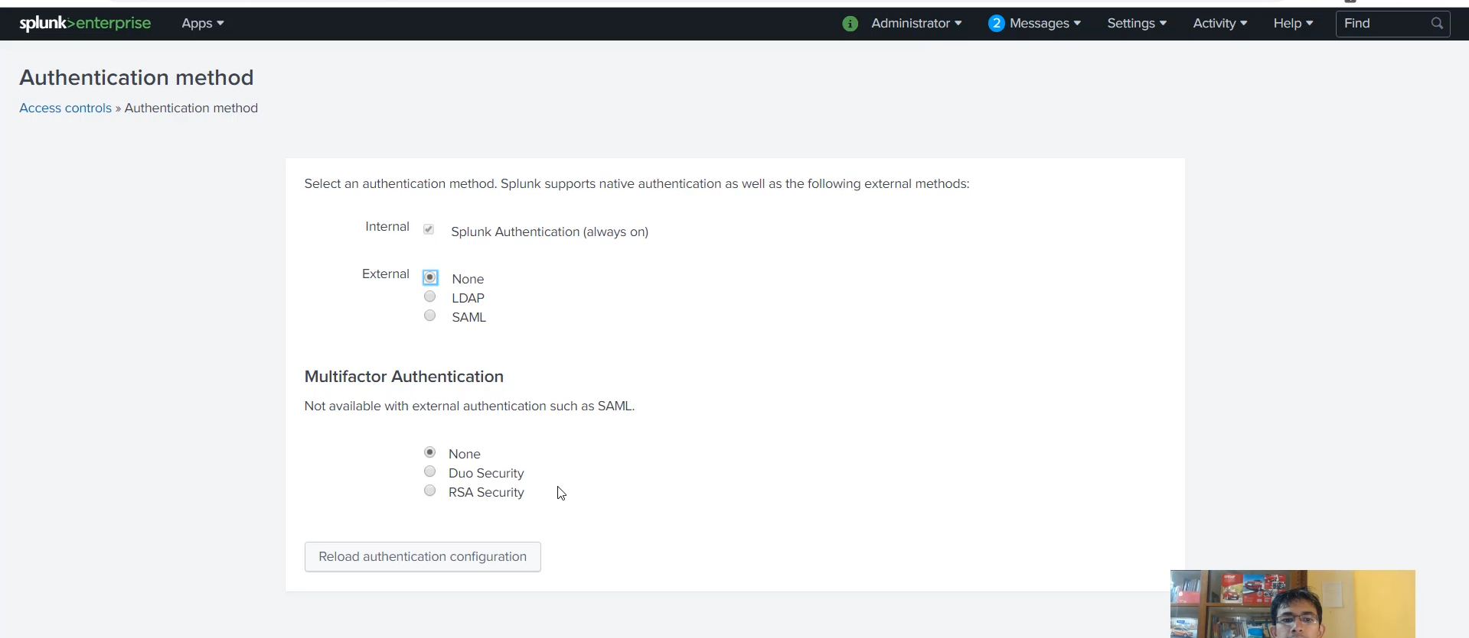

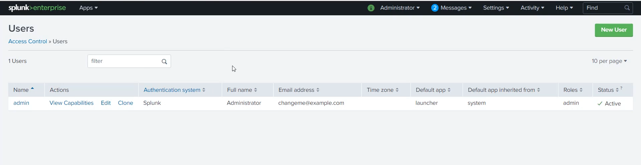

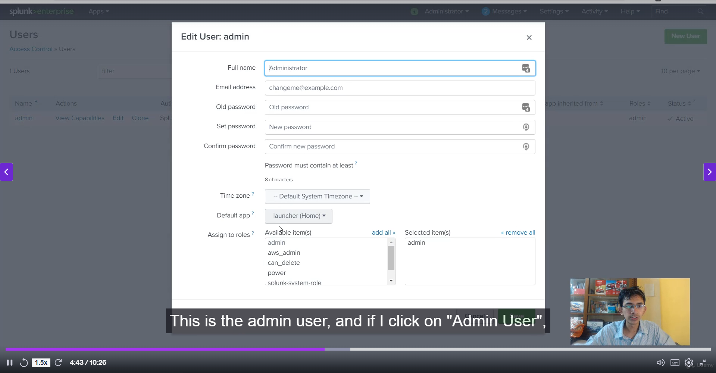

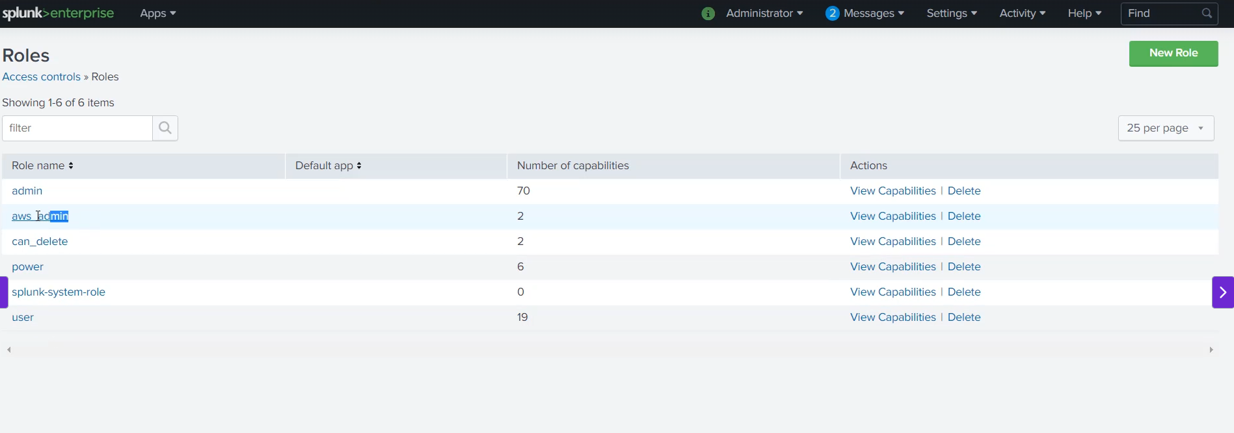

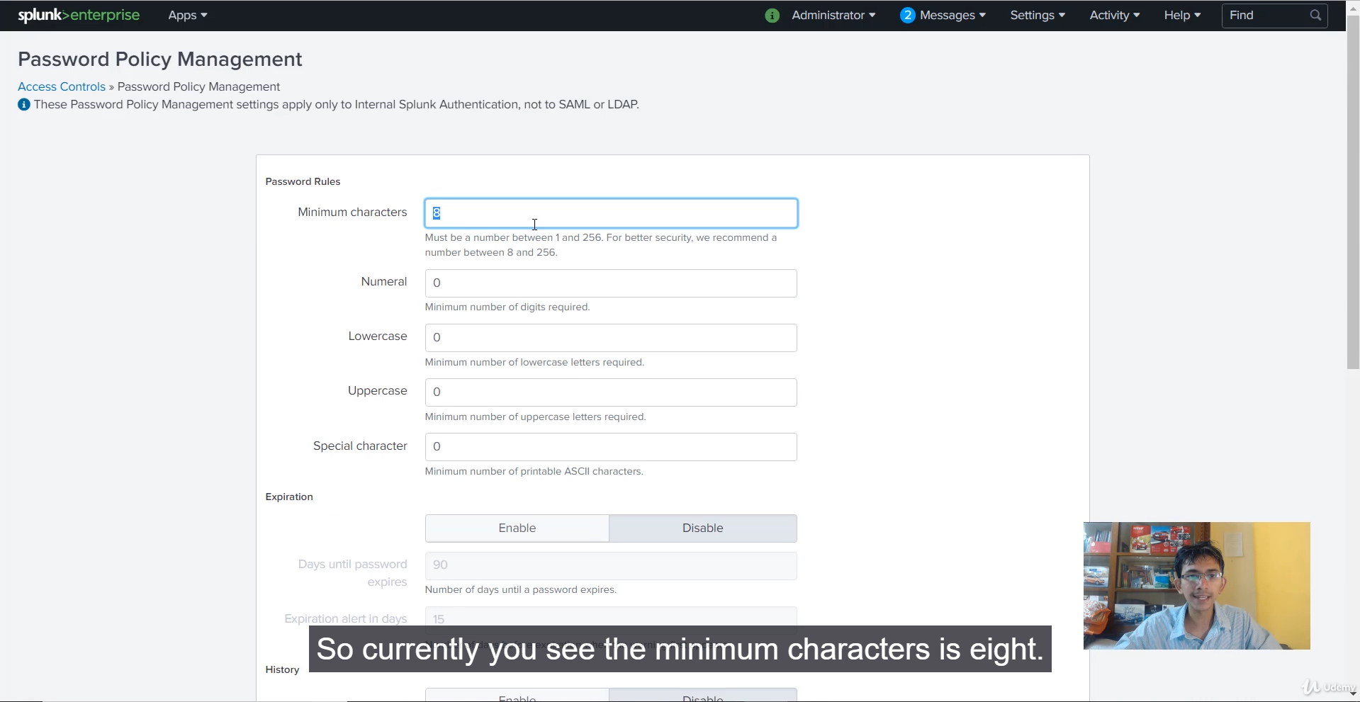

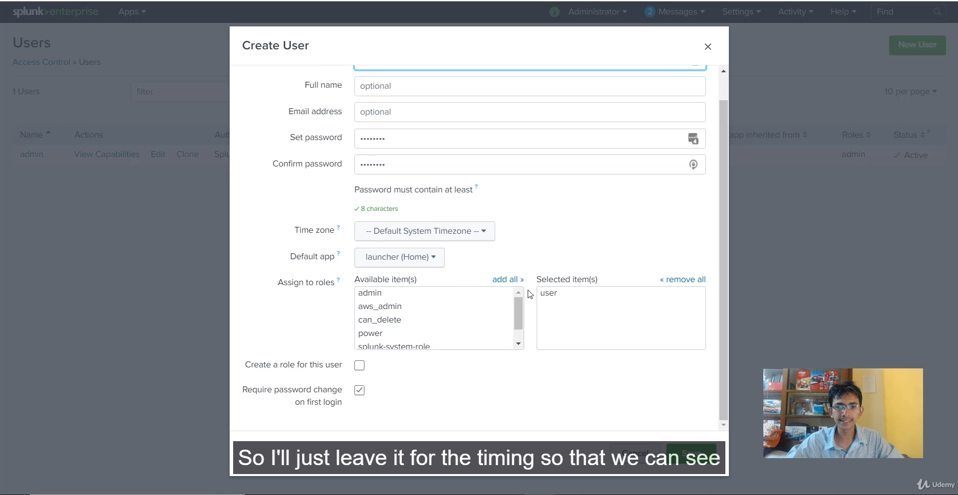

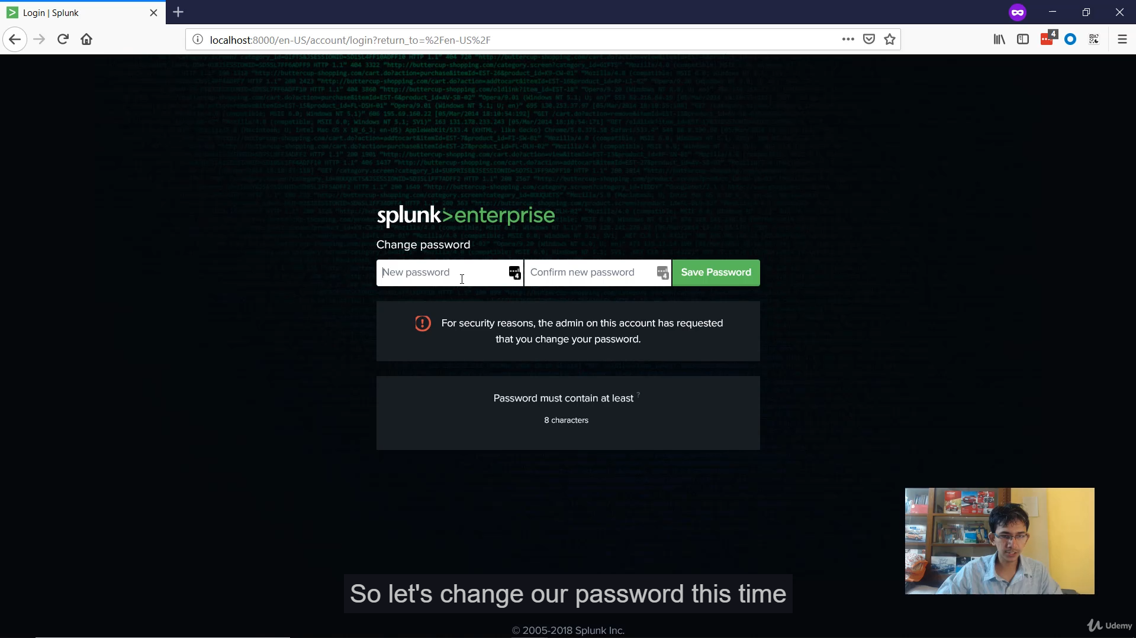

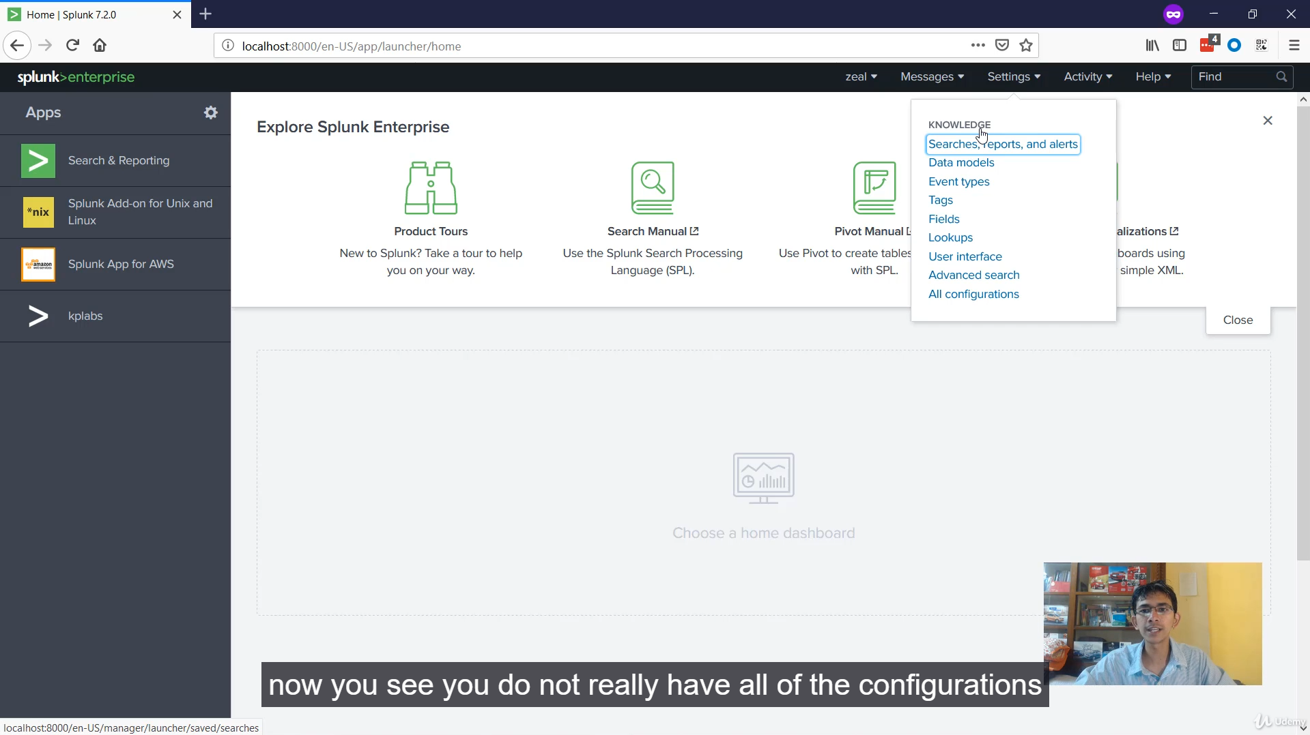

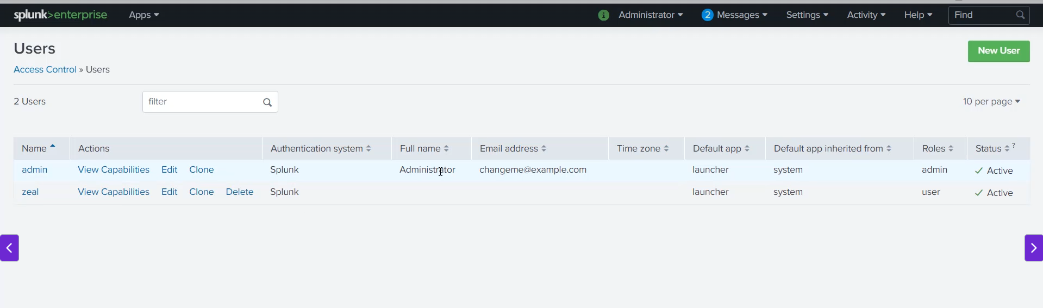

**Splunk Access Control: Users, Roles, and Capabilities**

**1. Access Control Strategy for Sensitive Data**

The approach to access control depends on the data's sensitivity:

* **Extremely Sensitive Data (High Legal Risk):** It is recommended to use an **isolated, separate Splunk instance** dedicated only to the relevant, privileged audience. Access might require a separate VPN or other secure network segment.
* **Sensitive but Manageable Data:** Access can be restricted at the index level, ensuring users can only search data they are explicitly allowed to see (a feature set up within the role configuration).

**2. The Three Pillars of Splunk Authentication**

Splunk uses a hierarchical system for access control:

1. **Users:** Individual accounts created to access the Splunk system.
2. **Roles (Groups):** A collection of permissions/capabilities. **Users are assigned to Roles.**
3. **Permissions (Capabilities):** The specific actions a user can perform (e.g., *search*, *edit_roles*, *admin_all_objects*). **Roles inherit Capabilities.**

**Principle of Inheritance:** Any user connected to a Role will automatically inherit all the permissions/capabilities associated with that Role.

**3. Authentication Methods**

Splunk supports various ways to authenticate users:

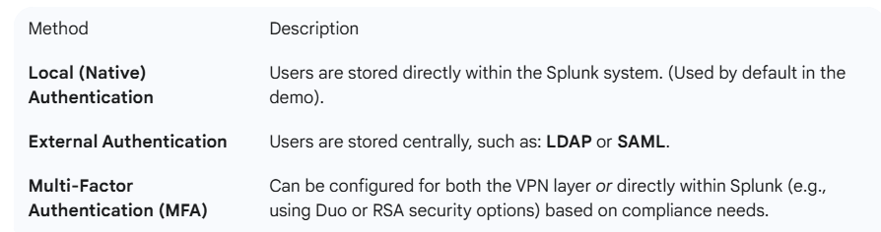

**4. Access Control Configuration in Splunk Web**

The Access Control settings are managed via **Settings $\rightarrow$ Access Controls**.

**A. Users**

* Shows a list of all defined users (e.g., admin, and the newly created Z).
* The primary configuration here is assigning one or more **Roles** to the user.4

**B. Roles**

* Contains a list of pre-defined roles (admin, power, user, can_delete, etc.) and any custom or app-provided roles (e.g., AWS admin).5
* **Admin Role:** Has the largest set of capabilities, allowing full configuration and management of the Splunk instance.
* **User Role:** Has basic capabilities (e.g., run searches, edit own preferences, create event types) but is restricted from system-level settings.
* **Role Configuration:** Allows setting capabilities, index access (searchable and default indexes), and resource limits (e.g., maximum concurrent searches).6

**C. Password Policy Management**

This section enforces security rules for passwords:

* **Minimum Characters:** (e.g., 8 characters)
* **Complexity Requirements:** (e.g., must contain numeral, uppercase, special characters).
* **Password Expiration:** (e.g., change every 90 days).
* **Account Lockout:** (e.g., lockout for 30 minutes after 5 failed login attempts).

**5. Practical Demonstration: Creating a Limited User**

The instructor created a new user to show the impact of roles:

* **User Created:** Z
* **Role Assigned:** Default **user** role.
* **Mandatory Change:** The option "Require password change on first login" was selected.
* **Result:** When User Z logs in, they are immediately prompted to change the password and, crucially, when they access **Settings**, the list of available configurations is significantly shorter, reflecting the **limited capabilities** of the user role compared to the admin role.

===================================================================================

1. **Create custom roles and capabilities:**

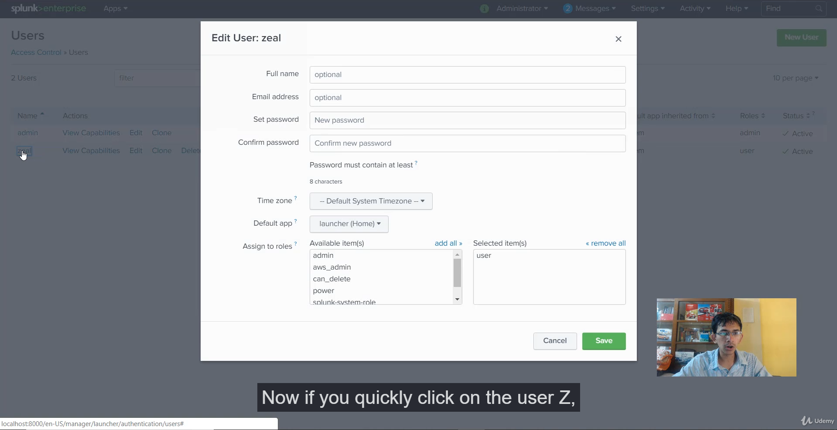

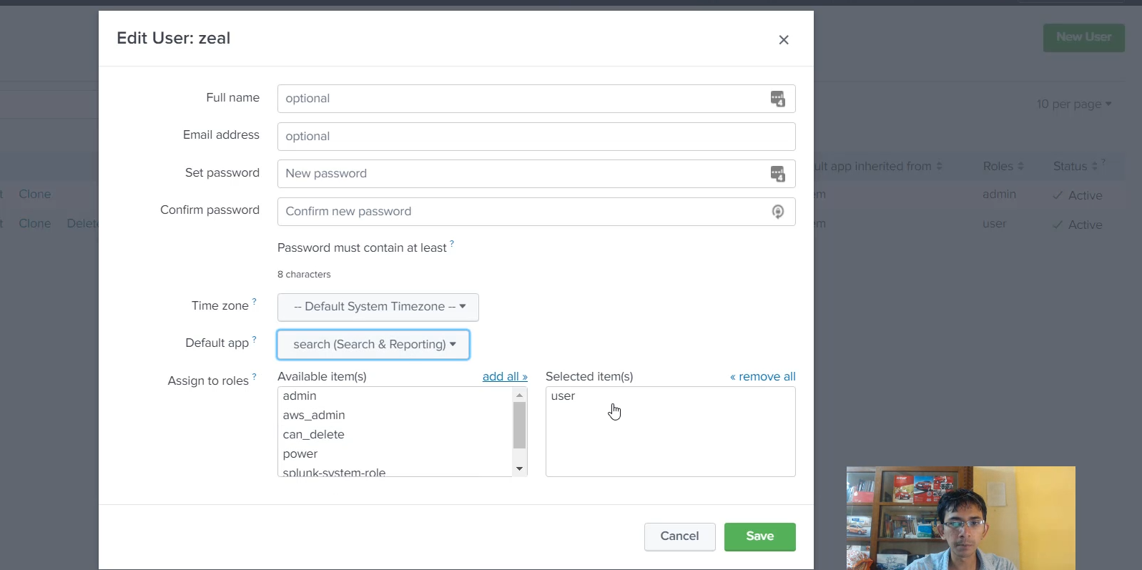

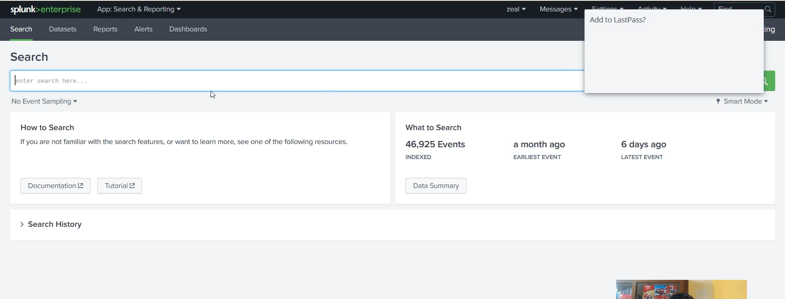

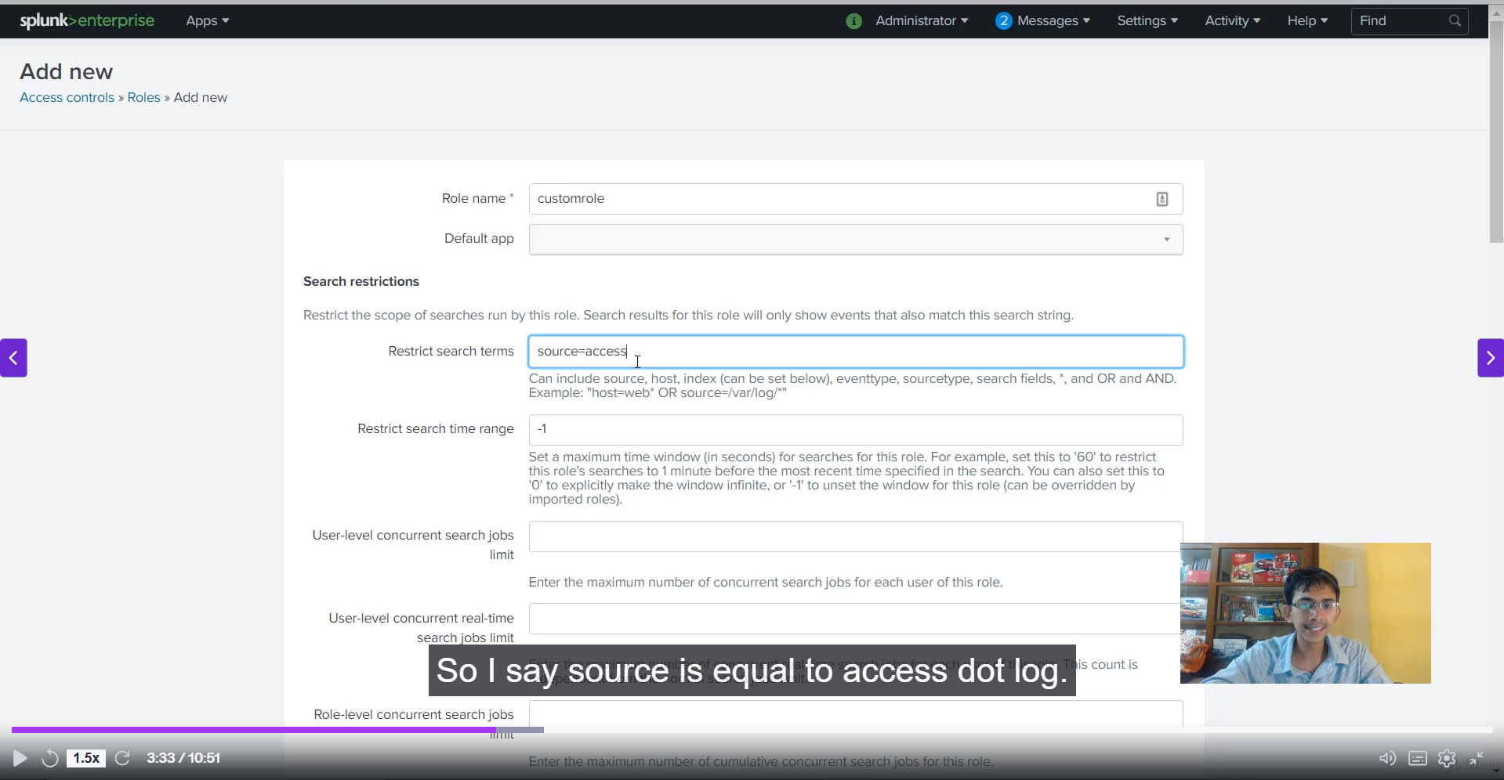

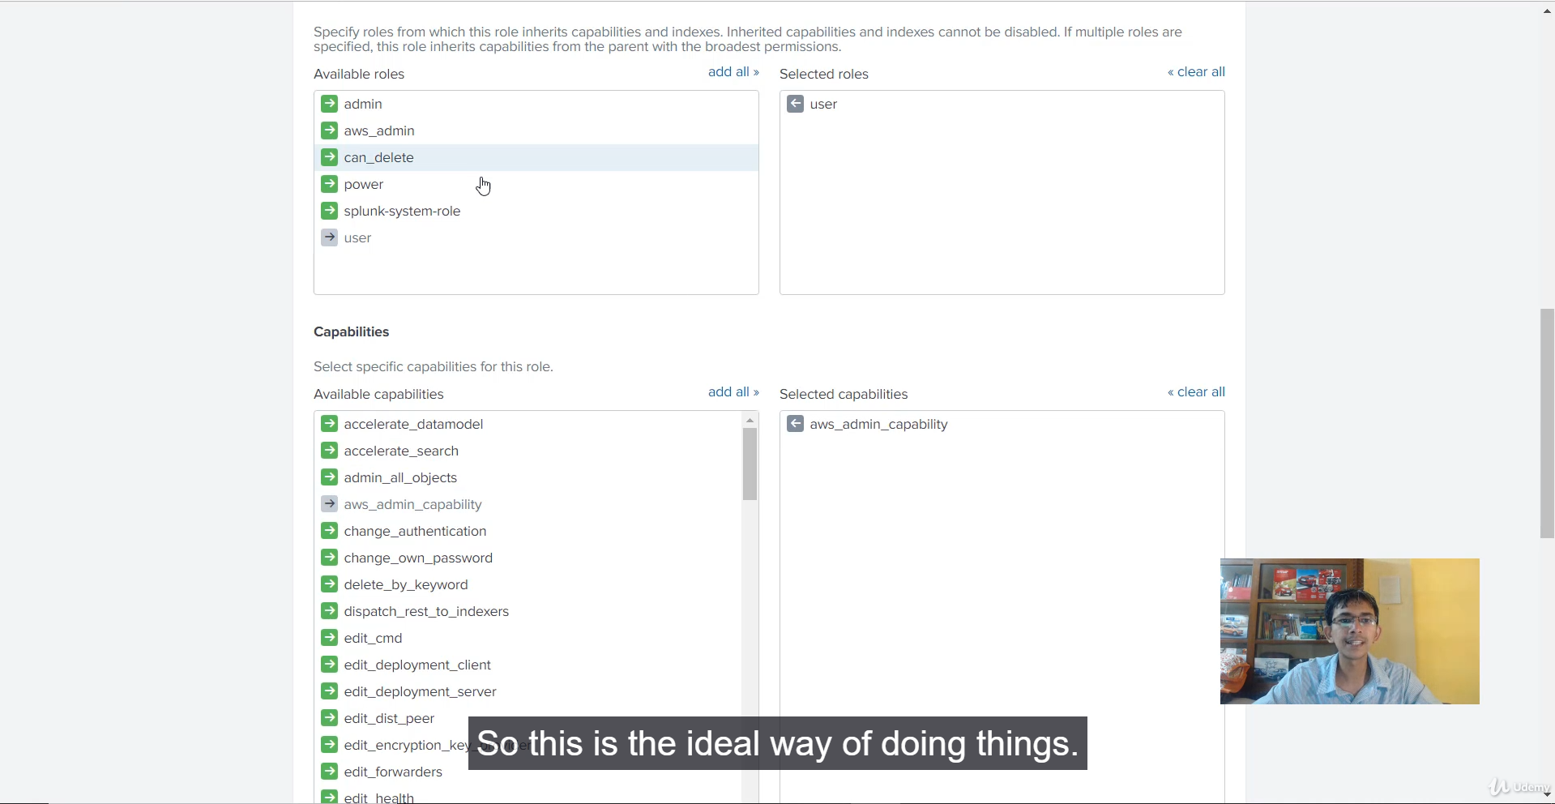

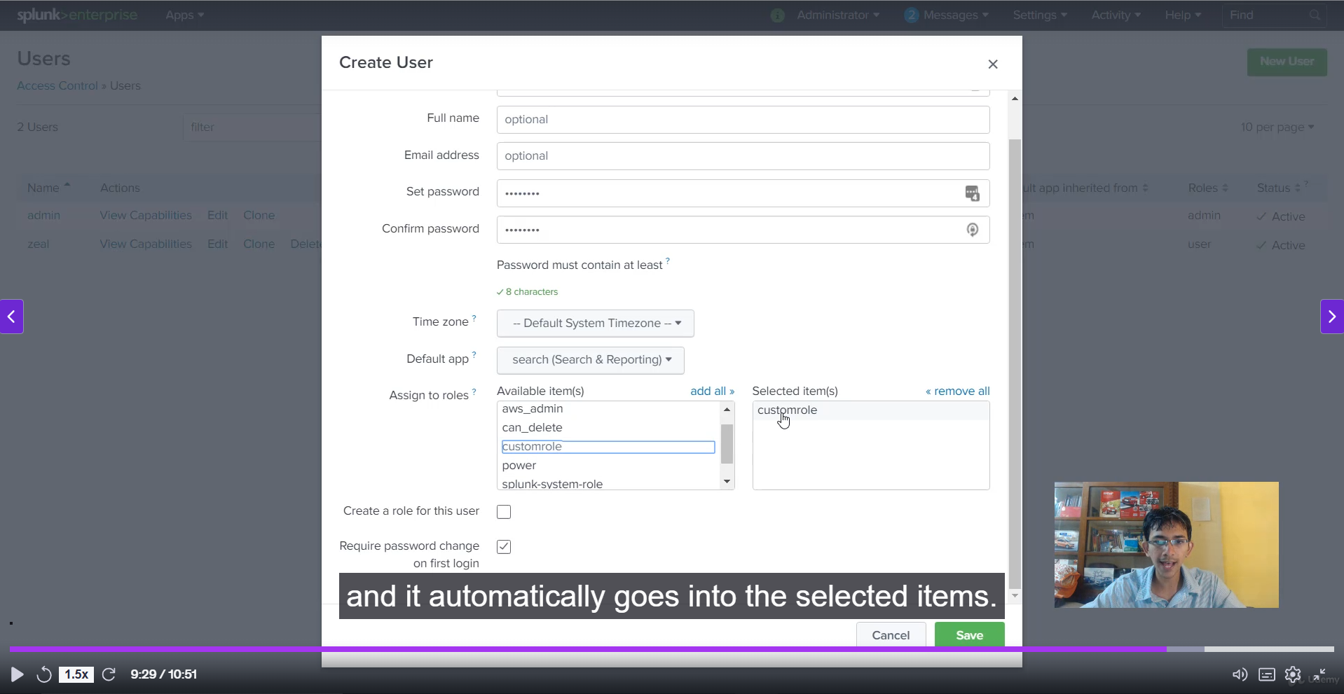

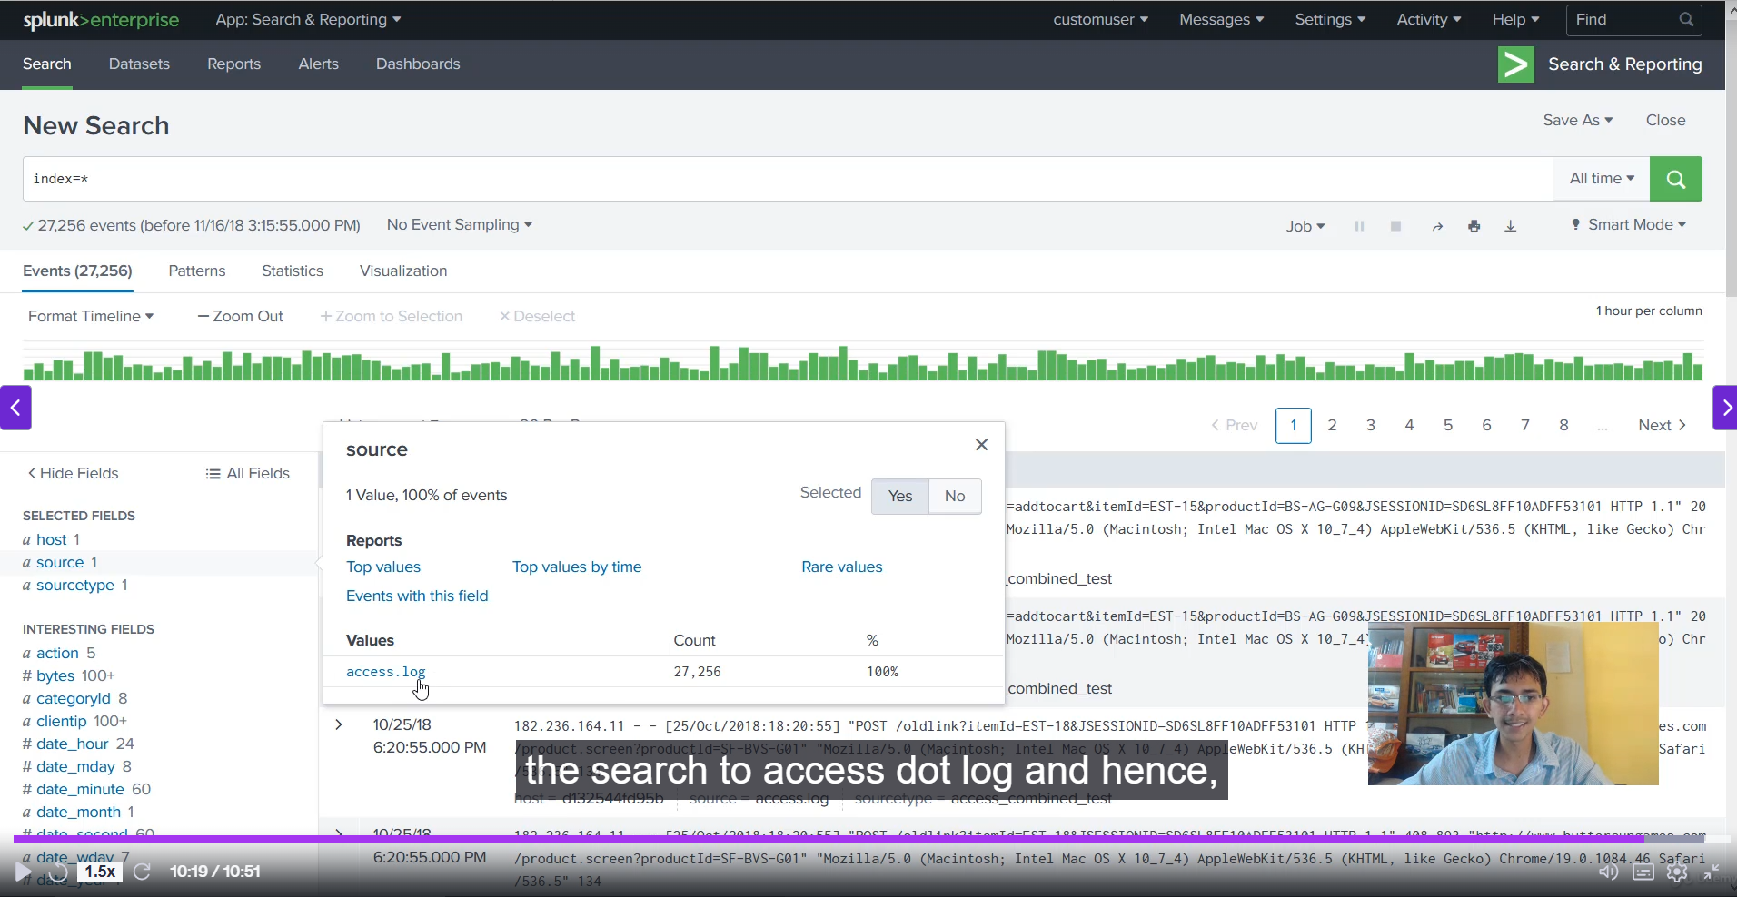

**Splunk Access Control: Key Concepts**

**1. Default App Setting (User Experience)**

* **Purpose:** To control the initial application a user lands on immediately after logging in.
* **Benefit:** Improves user efficiency by directing them straight to their primary workspace (e.g., **Search & Reporting**, or a dedicated app like "Splunk app for AWS"), bypassing the main **Launcher** home page.
* **Demonstration:** Changing the default app for user 'Z' from launcher to search and reporting.

**2. Creating a Custom Role**

Creating a custom role is a best practice for granular access control, allowing you to fine-tune permissions without modifying the pre-built default roles (like user or power).

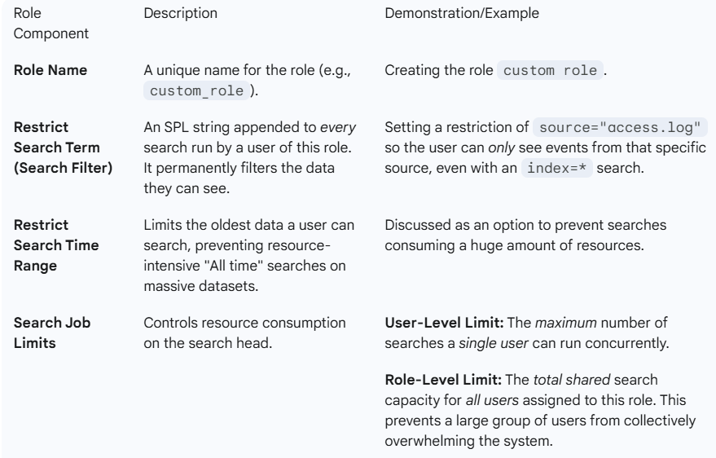

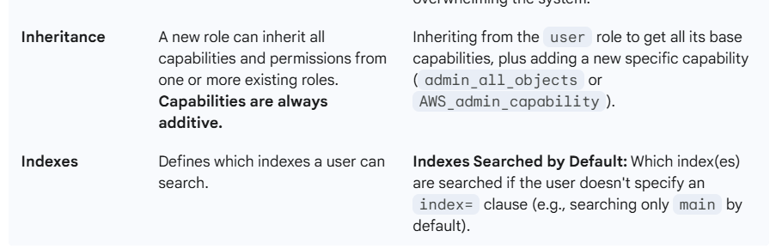

**3. User Assignment**

* A new user (custom_user) was created.
* The user was explicitly assigned to the new custom_role instead of the default user role.

**4. Verification**

* Logging in as the custom_user verified the **default app** setting (landing on Search & Reporting).
* Running a broad search (index=*) verified the **restrict search term** by only returning events from source="access.log".

******************************************************************************************************************************************************************************************************************************************************************************************